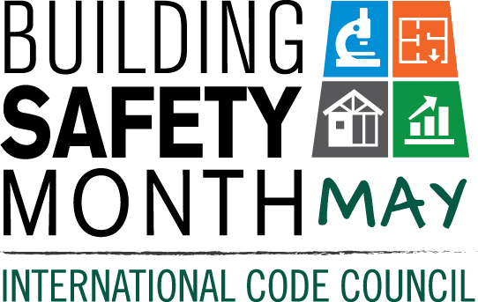
Proclamation
Building Safety Month — May, 2016

Whereas, our (City’s, Town’s, County’s, State’s) continuing efforts to address the critical issues of safety, energy efficiency, water conservation, and resilience in the built environment that affect our citizens, both in everyday life and in times of natural disaster, give us confidence that our structures are safe and sound, and;

Whereas, our confidence is achieved through the devotion of vigilant guardians––building safety and fire prevention officials, architects, engineers, builders, tradespeople, laborers and others in the construction industry––who work year-round to ensure the safe construction of buildings, and;

Whereas, these guardians—dedicated members of the International Code Council—use a governmental consensus process that brings together local, state and federal officials with expertise in the built environment to create and implement the highest-quality codes to protect Americans in the buildings where we live, learn, work, worship, play, and;

Whereas, the International Codes, the most widely adopted building safety, energy and fire prevention codes in the nation, are used by most U.S. cities, counties and states; these modern building codes also include safeguards to protect the public from natural disasters such as hurricanes, snowstorms, tornadoes, wildland fires, floods and earthquakes, and;

Whereas, Building Safety Month is sponsored by the International Code Council, to remind the public about the critical role of our communities’ largely unknown guardians of public safety––our local code officials––who assure us of safe, efficient and livable buildings, and;

Whereas, “Building Codes: Driving Growth through Innovation, Resilience and Safety” the theme for Building Safety Month 2016, encourages all Americans to raise awareness of the importance of building safe and resilient construction; fire prevention; disaster mitigation, water safety and conservation; energy efficiency and new technologies in the construction industry. Building Safety Month 2016 encourages appropriate steps everyone can take to ensure that the places where we live, learn, work, worship and play are safe and sustainable, and recognizes that countless lives have been saved due to the implementation of safety codes by local and state agencies, and,

Whereas, each year, in observance of Building Safety Month, Americans are asked to consider projects to improve building safety and sustainability at home and in the community, and to acknowledge the essential service provided to all of us by local and state building departments, fire prevention bureaus and federal agencies in protecting lives and property.

NOW, THEREFORE, I, _______________________________, (Mayor, Supervisor, Commissioner, Governor) of the (City, Town, County, State) of ____________________________, do hereby proclaim the month of May 2016 as Building Safety Month. Accordingly, I encourage our citizens to join with their communities in participation in Building Safety Month activities.

_________________________________________________________________________
Signature

