3-1 – 12
301.3 (New)

Proposed Change as Submitted

Proponent: Hope Reed, New Mexico Governor’s Commission on Disability (NMGCD)

Add new text as follows:

301.3 Children’s Standards. Children standards are provided as exceptions to adult standards in order to provide facilities for children’s use. Where children are the primary user group children’s standards can be applied. The specifications of the chosen age group shall be applied consistently in the area, room, or space.

Reason: Provide a clear statement for application of children’s standards. Standards must be written to ‘support’ those who are expected to enforce those standards.
input.doc

Committee Action

Disapproved

Committee Reason: This proposal was considered in conjunction with other proposal regarding children’s standards. There was even an attempt to modify this proposal. The Committee remains concerned that putting children’s standards in the Standard will result in confusion in application unless it is done with very clear direction in the adopted text. The term ‘primary user’ is troubling and the issue of overlapping age groups which often use the same facility.

3-2 – 12
302.1, 303.1

Proposed Change as Submitted

Proponent: Ed Roether, representing the ADA/A117 Harmonization Task Group

Revise as follows:

302.1 General. Floor surfaces shall be stable, firm, and slip resistant, and shall comply with Section 302. Changes in level in floor surfaces shall comply with Section 303.

EXCEPTIONS:

1. Within animal containment areas not exempted by Section 1101.2.1, floor and ground surfaces shall not be required to be stable, firm, and slip resistant.

2. Within areas of sports activity exempted in Chapter 11, the floor and ground surfaces shall not be required to comply with this section.

303.1 General. Changes in level in floor surfaces shall comply with Section 303.

EXCEPTIONS:

- Animal containment areas not exempted by Section 1101.2.1 shall not be required to comply with this section.

2. Within areas of sports activity exempted in Chapter 11, the changes in level shall not be required to comply with this section.

Reason: The ADA/A117 Harmonization Task Group (HTG) was created as a task group of the A117.1 Committee to compare the 2010 ADA with the 2009 A117.1 Standard. The HTG has recommend a series of changes through a set of change proposals. The HTG is recommending changes, for the most part, address where the ADA was viewed as more stringent than the A117. Where the A117 contained provisions not addressed in the ADA, these were not considered a conflict needing action to amend the A117. In addition there are a number of places where the ADA and A117.1 are different as a result of specific actions, by the A117.1 Committee during the development of the 2009 edition, to remain or create a difference where, in the judgment of the committee the ADA was deficient.

The changes reflect new ADA provisions not in A117. Provides clarity and coordination with exceptions found in Chapter 11.
input.doc

Committee Action

Approved

Committee Reason: Provides better reference to provisions contained in Chapter 11. Provides consistency with the ADA 2010.

3-3 – 12
302.1

Proposed Change as Submitted

Proponent: Russell Kendzior, The National Floor Safety Institute (NFSI), representing NFSI and the ANSI B101 Committee on slip, trip and fall prevention

Revise as follows:

302.1 General. Floor surfaces shall be stable, firm, and slip resistant, High-Traction, and shall comply with Section 302. Changes in level in floor surfaces shall comply with Section 303.

Reason: - Per ANSI/NFSI B101.1-2009 (wet SCOF) or ANSI/NFSI B101.3-2012 (wet DCOF)
The term slip-resistant is not defined within the A117.1 standard nor is the term adequately defined in any other national standard (ANSI, ASTM, NFPA, etc.) and because of such has been the source of great confusion for both property owners as well as pedestrians and should be removed from the revised A117.1 standard. Prior to 2009, there was no nationally recognized test method by which a property owner can perform as to confirm the slip resistance of their accessible routes/walkways making it difficult to actually insure that such routes/walkways were in compliance with the slip resistant requirement set forth by the A117.1 standard.

In 2009 the ANSI B101 “committee on slip, trip and fall prevention” published a new standard, which addresses this very issue. The ANSI/NFSI B101.1-2009 standard and the recently published ANSI/NFSI B101.3-2012 standards have replaced the term slip resistant with that of “High-Traction” to which both standards provide a specific test method, wet SCOF and DCOF respectively, as well as a table to which the resultant data is defined by one of three “Traction Ranges” to which the High-Traction range provides the highest level of slip resistance and the least level of risk for a slip-and-fall event.
The replacement of the term slip resistant with High-Traction provides clarity to the user of the A117.1 standard and will serve to harmonize the A117.1 standard with that of the newly released ANSI standards.
input.doc

Committee Action

Disapproved

Committee Reason: The Committee had a number of concerns regarding the proposal and the potential to reference the standards referenced in the proponent’s Reason statement. The term ‘high-traction’ was not defined in the proposal. Without definition, application would be unclear. There is concern that the standards may allow only one test method and the testing doesn’t result in replicable results. The Committee was concerned about the enforceability of the standard in the field. There were questions regarding how this affected persons with different disabilities. Finally there was concern that there lacked consensus in the industry of these materials and the testing of slip resistance, and that such should be resolved before a proposal focusing on one method be brought before the A117.1 Committee.

Staff note: The proponent’s intent to have the NSFI standards referenced in the A117.1 standard was unclear to staff, therefore the standards were not provided to the Committee members for their consideration. If the proponent seeks reconsideration of their proposal, the materials appropriate to their reconsideration will be made available.

3-4 – 12
303.3

Proposed Change as Submitted

Proponent: Kim Paarlberg, International Code Council

Revise as follows:

Add a new figure which is similar to the existing figure (a). Have the new figure show that the bottom ¼ inch can be beveled and that the ¼ inch vertical change of elevation can be at the top of the figure.

Similar to this configuration.

Reason: The quantity of change proposals submitted by International Code Council is reflective of three elements of our work: 1. ICC is the Secretariat for the Standard and some changes reflect inconsistencies or improvements suggested by staff; 2. ICC develops and publishes a Commentary on the standard and writing the commentary illuminates issues of the text and figures; and 3. ICC provides an interpretation service for the standard which results in the observation of provisions the users find most confusing.
The addition of a third figure may help eliminate some questions that have been received regarding the correct application of the change in level requirements. This type of arrangement with the beveled portion of the level change in the lower ¼ inch and the ¼ inch vertical portion located in the upper portion of the ½ inch maximum level change corresponds to what is used for most thresholds.
When reading the text of Section 303.3 it indicates that “Changes in level greater than ¼ inch in height and not more than ½ inch maximum in height shall be beveled. Unfortunately that language is sometimes being interpreted to limit the ¼ inch vertical change to being the bottom or first change and not allowing the vertical change to occur between the height of ¼ and ½ inches from the floor.
Providing this new configuration will show that the ¼ inch vertical is permitted at any point in the ½ inch level change.
Unfortunately I have also received calls which indicate that Sections 303.2 and 303.3 cannot be combined [as shown in Figure 303.3(a)] and that Section 303.3 requires any level change which is greater than ¼ inch in height to be done only by a beveled slope.
While we will never eliminate all potential bad interpretations, showing the various options will eliminate most confusion and debate.
If the committee would prefer to change the text of the standard, an option would be as follows.

303.3.1 Beveled and vertical change. Changes in level not more than ½ inch (13 mm) maximum in height shall be permitted to be done by a combination of a beveled change complying with Section 303.3 and vertical change complying with Section 303.2. The vertical change may occur at any location within the ½ inch maximum height that is allowed by Section 303.3.

I don’t believe a change in text is needed and would probably prefer that the committee did not take this option.
input.doc

Committee Action

Disapproved

Committee Reason: The Committee concluded that the proposed figure doesn’t reflect the intent of the section. The provisions should not be interpreted to reach this conclusion. Such a figure would encourage misunderstanding of the standard.

3-5 – 12
304.2, 305.2, 404.2.3.1, 404.2.4, 405.4, 405.7.1, 502.5, 503.4, 504.4, 802.2,

Proposed Change as Submitted

Proponent: Ed Roether, representing the ADA/A117 Harmonization Task Group

Revise as follows:

304 Turning Space

304.2 Floor Surface. Floor surfaces of a turning space shall have a slope not steeper than 1:48 and shall comply with Section 302. Changes in level exceeding that permitted by Section 303.3 are not permitted within the turning space.

EXCEPTION: Slopes not steeper than 1:48 shall be permitted.

305 Clear Floor or Ground Space

305.2 Floor Surfaces. Floor surfaces of a clear floor space shall have a slope not steeper than 1:48 and shall comply with Section 302. Changes in level exceeding that permitted by Section 303.3 are not permitted within the clear floor space.

EXCEPTION: Slopes not steeper than 1:48 shall be permitted.

403 Walking Surfaces

403.4 Changes in Level. Changes in level shall comply with 303.

404.2 Manual doors

404.2.3.1 Floor Surface. Floor surface within the maneuvering clearances shall have a slope not steeper than 1:48 and shall comply with Section 302. Changes in level exceeding that permitted by Section 303.3 are not permitted within the maneuvering clearances.

404.2.4 Thresholds. If provided, thresholds at doorways shall be ¹/2 inch (13 mm) maximum in height. Raised thresholds and changes in level at doorways shall comply with Sections 302 and 303.

EXCEPTION: An existing or altered threshold shall be permitted to be ³/4 inch (19 mm) maximum in height provided that the threshold has a beveled edge on each side with a maximum slope of 1:2 for the height exceeding ¹/4 inch (6.4 mm).

404.3 Automatic doors

404.3.3 Thresholds. Thresholds and changes in level at doorways shall comply with Section 404.2.4.

405 Ramps

405.4 Floor Surfaces. Floor surfaces of ramp runs shall comply with Section 302. Changes in level exceeding that permitted by Section 303.3 other than the running slope and cross slope are not permitted on ramp runs.

405.7.1 Slope. Landings shall have a slope not steeper than 1:48 and shall comply with Section 302. Changes in level exceeding that permitted by Section 303.3 are not permitted within the landings.

407.4 Elevator Cars

407.4.2 Floor Surfaces. Floor surfaces in elevator cars shall comply with Section 302.

408.4 LULA cars

408.4.2 Floor Surfaces. Floor surfaces in elevator cars shall comply with Section 302.

409.4 Private residence elevator cars

409.4.2 Floor Surfaces. Floor surfaces in elevator cars shall comply with Section 302.

410.2 Platform lifts

410.3 Floor Surfaces. Floor surfaces of platform lifts shall comply with Section 302.

502 Parking spaces

502.5 Floor Surfaces. Parking spaces and access aisles shall comply with Section 302 and have surface slopes not steeper than 1:48. Access aisles shall be at the same level as the parking spaces they serve. Changes in level exceeding that permitted by Section 303.3 are not permitted within the parking spaces and access aisles.

503 Passenger loading zones

503.4 Floor Surfaces. Vehicle pull–up spaces and access aisles serving them shall comply with Section 302 and shall have slopes not steeper than 1:48. Access aisles shall be at the same level as the vehicle pull–up space they serve. Changes in level exceeding that permitted by Section 303.3 are not permitted within the vehicle pull-up spaces and access aisles.

504 Stairways

504.4 Tread Surface. Stair treads shall comply with Section 302 and shall have a slope not steeper than 1:48. Changes in level exceeding that permitted by Section 303.3 are not permitted within the stair tread.

802 Wheelchair spaces

802.2 Floor Surfaces. The floor surface of wheelchair space locations shall have a slope not steeper than 1:48 and shall comply with Section 302. Changes in level exceeding that permitted by Section 303.3 are not permitted within the floor surface of wheelchair space locations.

1103 Recreational Boat Launches

1103.2.1 Boat Slips. An accessible route shall serve boat slips.

Exceptions:
8. Changes in level complying with 303.3 and 303.4 shall be permitted on the surfaces of gangways and boat launch ramps.

Reason: The ADA/A117 Harmonization Task Group (HTG) was created as a task group of the A117.1 Committee to compare the 2010 ADA with the 2009 A117.1 Standard. The HTG has recommend a series of changes through a set of change proposals. The HTG is recommending changes, for the most part, address where the ADA was viewed as more stringent than the A117. Where the A117 contained provisions not addressed in the ADA, these were not considered a conflict needing action to amend the A117. In addition there are a number of places where the ADA and A117.1 are different as a result of specific actions, by the A117.1 Committee during the development of the 2009 edition, to remain or create a difference where, in the judgment of the committee the ADA was deficient.

Reason statement for change of level: The preceding sections are where the phrase “changes in level are not permitted” is used, or there is a specific reference to 303. The idea is to try and allow surfaces such as tile and deck boards, but not a threshold or other ¼” to ½” change in vertical surface that will be a ‘hitch’ in access. I included titles to help put the sections into context. There is also the issue of consistently using the 1:48 within the requirement or as an exception. Suggested revisions in legislative text are based on emails, consistency throughout for A117.1 and the Access Board advisory.

ADA Advisory 304.2 Floor or Ground Surface Exception. As used in this section, the phrase “changes in level” refers to surfaces with slopes and to surfaces with abrupt rise exceeding that permitted in Section 303.3. Such changes in level are prohibited in required clear floor and ground spaces, turning spaces, and in similar spaces where people using wheelchairs and other mobility devices must park their mobility aids such as in wheelchair spaces, or maneuver to use elements such as at doors, fixtures, and telephones. The exception permits slopes not steeper than 1:48.
input.doc

Committee Action

Approval as Modified

Modification

All portions of the original proposal were approved with the exception of the proposed revision to Section 405.4

Ramps.

405.4 Floor Surfaces. Floor surfaces of ramp runs shall comply with Section 302. Changes in level exceeding that permitted by Section 303.3 other than the running slope and cross slope are not permitted on ramp runs.

Committee Reason: The proposal addresses in multiple locations the change in level language and provides consistency between the Standard and the ADA advisory regarding the text also used in the ADA 2010. The proposal affecting the ramp provisions were of concern to the Committee in that it might allow materials which would be difficult to negotiate travel across.

3-6 – 12
304.3.1

Proposed Change as Submitted

Proponent: Gina Hilberry and David Collins, Co-Chairs Wheeled Mobility Task Group

Revise as follows:

304.3.1 Circular Space. The turning space shall be a circular space with a 60- 67 inch (1525 1700 mm) minimum diameter. The turning space shall be permitted to include knee and toe clearance complying with Section 306.

Reason: The Wheeled Mobility Task Group (WMTG) was created as a task group of the A117.1 Committee to analyze the results of the anthropometric study of a variety of mobility device users conducted by The Center for Inclusive Design and Environmental Access (IDeA) at the University at Buffalo, SUNY recently completed an anthropometric study of 500 wheeled manual and powered mobility device users. The study indicates that the technical provisions contained in the A117.1 standard do not address the needs of the full range of users of mobility devices. The work of the WMTG is ongoing, but it has submitted a series of proposed changes to the base building blocks of the A117.1 standard. If the changes to the building blocks are adopted by the Committee, then additional changes will need to be made in other portions of the standard.
This increase is as recommended by the IDEA Final Report and is expected to increase the percentage of manual and power wheelchair users accommodated from 80 to 95 % and almost double the percentage of scooters served.

Discussion:

The IDEA team provided very helpful diagrams illustrating the 5 different 180 turns used by the subjects in the IDEA report. The Spot and Pivot turning techniques appear to need a width just a few inches greater than the diagonal of the user's wmd. The Shuffle turn uses whatever space is available though repeated short back and forth shuffles while turning around incrementally. The Three Point turn is a T turn with upraised arms. It was the Full U turn where both wheels move forward but the outside wheel moves faster that required the most width. The Pivot and Three Point turns use a 'corner'. The subjects were allowed to choose their preferred method for turning, but the IDEA report does not identify who used which technique, so a question exists as to who needs the extra space to successfully turn or to avoid excessive energy expenditure and who could function with less space than they used.
Further, we were informed that the best shape for an 180 turning space is a lozengen. The IDEA team recommended that the long dimension be 88 inches and the short dimension be 68 inches. Because the shape only works if a user enters the space through one of the short ends, a turning space that could be entered from either the long or short sides would have to be 88 inches along both sides.
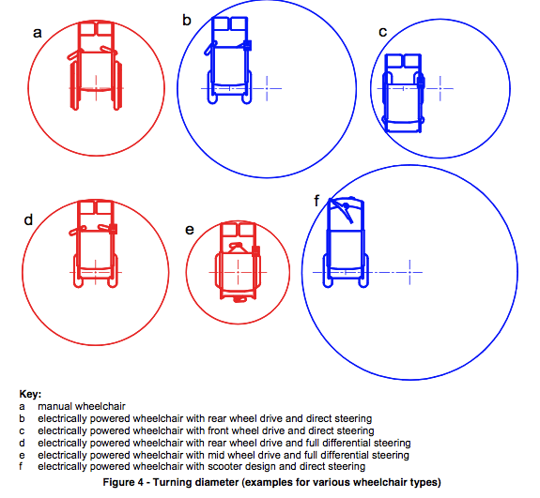
In examining what design features were driving the space to be so large it became apparent that lack of differential steering in scooters and some power chairs was a major factor. Differential steering, as found in manual wheelchairs and center wheel power wheelchairs, is the ability to drive one drive wheel forward while the other goes backward. Where both wheels are driven by a common motor or direct drive transmission both wheels must go in the same direction, hence the turning radia are much larger.

From The Working Area of Wheelchairs by Johann Ziegler
This observation raises the question – should the built environment be changed to accommodate poorly designed wmds or ought those choosing poorly designed wmds be informed that their vehicle may not be well accommodated? The analogy is the parking lot at the grocery store. If you choose to drive a stretch limo, RV, bus, or other vehicle that is bigger than a typical parking space you are welcome to shop, but don't expect a parking space near the entry. Ultimately this is a political and not a technical question.
input.doc

Committee Action

Approved

Committee Reason: The WMTG was able to bring forth 2 key proposals as a result of its review of the studies of persons using wheeled mobility devices. This is one of the proposals; the other found in 3-13-12 addresses the clear floor space. Many Committee members were unsure of approving either change without knowing the implications in the balance of the Standard. The WMTG a working decision on this proposal and 3-13-12 before considering the balance of the Standard and where additional correlating changes would be needed. Those changes developed between the August and January meetings are reflected in proposals 3-6A-12 through 3-6F-12 and 3-13A-12 through 3-13K-12.
A significant discussion was made regarding the impact a 67 inch turning circle would have on the design of dwelling units. The potential to develop exceptions for dwelling units either in this section or Chapter 10 were considered. No action as accepted by the Committee to amend 3-6-12 for dwelling units. It was pointed out in the discussion that the Type B standards do not include a turning space requirement.
The Committee discussed the growing use of powered chairs and scooters which are larger in size and have differing maneuvering capabilities. The Committee debated whether the Standard should be changed to accommodate changes in the technologies or wheeled mobility or whether the manufacturers of the devices needed to be designed equipment to work within the standard. Of concern is not just the current mix of equipment being used, but trying to anticipate what will be of use through the life of buildings being designed and built today.
The Committee recognized that increasing the base dimensions of the circular turning space and the clear floor space have space and therefore cost implications throughout a building design and the design of site features, Specifically mentioned during the debate were dwelling units, kitchens and single occupant toilet/bathrooms.

3-6A – 12
405.7.4

Proposed Change as Submitted

Proponent: Gina Hilberry and David Collins, Co-Chairs Wheeled Mobility Task Group

Revise as follows:

405.7.4 Change in Direction. Ramps that change direction at ramp landings shall be sized to provide a turning space complying with Section 304.3 67 inches (1700 mm) minimum in width and 67 inches (1700 mm) minimum in length.

Reason: The Wheeled Mobility Task Group (WMTG) was created as a task group of the A117.1 Committee to analyze the results of the anthropometric study of a variety of mobility device users conducted by The Center for Inclusive Design and Environmental Access (IDeA) at the University at Buffalo, SUNY recently completed an anthropometric study of 500 wheeled manual and powered mobility device users. The study indicates that the technical provisions contained in the A117.1 standard do not address the needs of the full range of users of mobility devices. The work of the WMTG is ongoing, but it has submitted a series of proposed changes to the base building blocks of the A117.1 standard. If the changes to the building blocks are adopted by the Committee, then additional changes will need to be made in other portions of the standard.

Rationale for 3-6A: Addresses concern that encroachments on a minimum square turning space will obstruct turning.
.

input.doc

Committee Action

Disapproved

Committee Reason: The Committee preferred the action taken through the approval of Proposal 4-40-12

3-6B – 12
Table 407.4.1

Proposed Change as Submitted

Proponent: Gina Hilberry and David Collins, Co-Chairs Wheeled Mobility Task Group

Revise as follows:

Table 407.4.1—Minimum Dimensions of Elevator Cars
Door Location | Door Clear  Opening Width | Inside Car, Side to  Side | Inside Car, Back  Wall to Front Return | Inside Car, Back  Wall to Inside Face  of Door
Centered | 42 inches (1065 mm) | 80 inches (2030 mm) | 51 inches (1295 mm) | 54 inches (1370 mm)
Side (Off Center) | 36 inches (915 mm)1 | 68 inches (1725 mm) | 51 inches (1295 mm) | 54 inches (1370 mm)
Any | 36 inches (915 mm)1 | 54 inches (1370 mm) | 80 inches (2030 mm) | 80 inches (2030 mm)
Any | 36 inches (915 mm)1 | 60 inches (1525 mm)2 | 60 inches (1525 mm)2 | 60 inches (1525 mm)2
1A tolerance of minus⁵/8 inch (16 mm) is permitted.
²Other car configurations that provide a 36-inch (915mm) door clear opening width and a 60 inch (1525 mm) turning space complying with Section 304 with the door closed are permitted.

Reason: The Wheeled Mobility Task Group (WMTG) was created as a task group of the A117.1 Committee to analyze the results of the anthropometric study of a variety of mobility device users conducted by The Center for Inclusive Design and Environmental Access (IDeA) at the University at Buffalo, SUNY recently completed an anthropometric study of 500 wheeled manual and powered mobility device users. The study indicates that the technical provisions contained in the A117.1 standard do not address the needs of the full range of users of mobility devices. The work of the WMTG is ongoing, but it has submitted a series of proposed changes to the base building blocks of the A117.1 standard. If the changes to the building blocks are adopted by the Committee, then additional changes will need to be made in other portions of the standard.

Rationale for 3-6B: An elevator car that can provide a 60 inch diameter turning space with the doors closed is larger than the cars permitted by Table 407.4.1 and should still be permitted. Increasing the size to a 67 inch diameter would in all probability increase the elevator car capacity and thus increase the cost of the elevator system and related structural support of the building. There is no evidence that cars providing a 60 inch diameter are unusable to persons using larger wheeled mobility devices.

input.doc

Committee Action

Approved as Modified

²Other car configurations that provide a 36-inch (915mm) door clear opening width and a 60 inch (1525 mm) turning diameter space with the door closed are permitted.

Committee Reason: The intent is to clarify that the space within the elevator car is not specifically a turning space, but provides space to reach the controls.

3-6C – 12
502.4.2

Proposed Change as Submitted

Proponent: Gina Hilberry and David Collins, Co-Chairs Wheeled Mobility Task Group

Revise as follows:

502.4.2 Width. Access aisles serving car and van parking spaces shall be 60 67 inches (xxx mm) minimum in width.

Reason: The Wheeled Mobility Task Group (WMTG) was created as a task group of the A117.1 Committee to analyze the results of the anthropometric study of a variety of mobility device users conducted by The Center for Inclusive Design and Environmental Access (IDeA) at the University at Buffalo, SUNY recently completed an anthropometric study of 500 wheeled manual and powered mobility device users. The study indicates that the technical provisions contained in the A117.1 standard do not address the needs of the full range of users of mobility devices. The work of the WMTG is ongoing, but it has submitted a series of proposed changes to the base building blocks of the A117.1 standard. If the changes to the building blocks are adopted by the Committee, then additional changes will need to be made in other portions of the standard.

Rationale for 3-6C: This reflects our previous action changing the changing the size of a turning circle (Section 304) to 67 inches.

input.doc

Committee Action

Approved

Committee Reason: The increased size of a turning circle needs to be included in the access aisle for parking spaces. Turning around in such spaces is commonplace.

3-6D – 12
503.3.2

Proposed Change as Submitted

Proponent: Gina Hilberry and David Collins, Co-Chairs Wheeled Mobility Task Group

Revise as follows:

503.3.2 Width. Access aisles serving vehicle pull-up spaces shall be 60 67 inches (1525 1700 mm) minimum in width.

Reason: The Wheeled Mobility Task Group (WMTG) was created as a task group of the A117.1 Committee to analyze the results of the anthropometric study of a variety of mobility device users conducted by The Center for Inclusive Design and Environmental Access (IDeA) at the University at Buffalo, SUNY recently completed an anthropometric study of 500 wheeled manual and powered mobility device users. The study indicates that the technical provisions contained in the A117.1 standard do not address the needs of the full range of users of mobility devices. The work of the WMTG is ongoing, but it has submitted a series of proposed changes to the base building blocks of the A117.1 standard. If the changes to the building blocks are adopted by the Committee, then additional changes will need to be made in other portions of the standard.

Rationale for 3-6D: Accommodate 67 inch (1700) turning diameter.
input.doc

Committee Action

Approved

Committee Reason: Consistent with the action to approve proposal 3-6C-12.

3-6E – 12
804.2.2

Proposed Change as Submitted

Proponent: Gina Hilberry and David Collins, Co-Chairs Wheeled Mobility Task Group

Revise as follows:

804.2.2 U-Shaped Kitchens. In kitchens enclosed on three contiguous sides, clearance between all opposing base cabinets, countertops, appliances, or walls within kitchen work areas shall be 60 67 inches (1525 1700 mm) minimum.

Reason: The Wheeled Mobility Task Group (WMTG) was created as a task group of the A117.1 Committee to analyze the results of the anthropometric study of a variety of mobility device users conducted by The Center for Inclusive Design and Environmental Access (IDeA) at the University at Buffalo, SUNY recently completed an anthropometric study of 500 wheeled manual and powered mobility device users. The study indicates that the technical provisions contained in the A117.1 standard do not address the needs of the full range of users of mobility devices. The work of the WMTG is ongoing, but it has submitted a series of proposed changes to the base building blocks of the A117.1 standard. If the changes to the building blocks are adopted by the Committee, then additional changes will need to be made in other portions of the standard.

Rationale for 3-6E: Accommodate 67 inch (1700) turning diameter.
input.doc

Committee Action

Approved

Committee Reason: The provision applies many to kitchens other than those within a dwelling unit. There was concern over the space demands that this dimension would impose.

3-6F – 12
1003.12.1.2

Proposed Change as Submitted

Proponent: Gina Hilberry and David Collins, Co-Chairs Wheeled Mobility Task Group

Revise as follows:

1003.12.1.2 U-Shaped Kitchens. In kitchens with counters, appliances, or cabinets on three contiguous sides, clearance between all opposing base cabinets, countertops, appliances, or walls within kitchen work areas shall be 60 67 inches (1525 1700 mm) minimum.

Reason: The Wheeled Mobility Task Group (WMTG) was created as a task group of the A117.1 Committee to analyze the results of the anthropometric study of a variety of mobility device users conducted by The Center for Inclusive Design and Environmental Access (IDeA) at the University at Buffalo, SUNY recently completed an anthropometric study of 500 wheeled manual and powered mobility device users. The study indicates that the technical provisions contained in the A117.1 standard do not address the needs of the full range of users of mobility devices. The work of the WMTG is ongoing, but it has submitted a series of proposed changes to the base building blocks of the A117.1 standard. If the changes to the building blocks are adopted by the Committee, then additional changes will need to be made in other portions of the standard.

Rationale for 3-6F: Accommodate 67 inch (1700) turning diameter.
.
input.doc

Committee Action

Disapproved

Committee Reason: The Committee was not convinced that a full 67 inch turning circle needed to be accommodated in kitchens of Type A dwellings.

3-7 – 12
304.3.1, Figure 304.3(a)

Proposed Change as Submitted

Proponent: Edward Steinfeld, IDEA Center, School of Architecture and Planning, University at Buffalo, State University of New York

Revise as follows:

304.3.1 Circular Space. The turning space shall be a circular space with a 60-inch 67-inch (1525 1700 mm) minimum diameter. The turning space shall be permitted to include knee and toe clearance complying with Section 306.3.

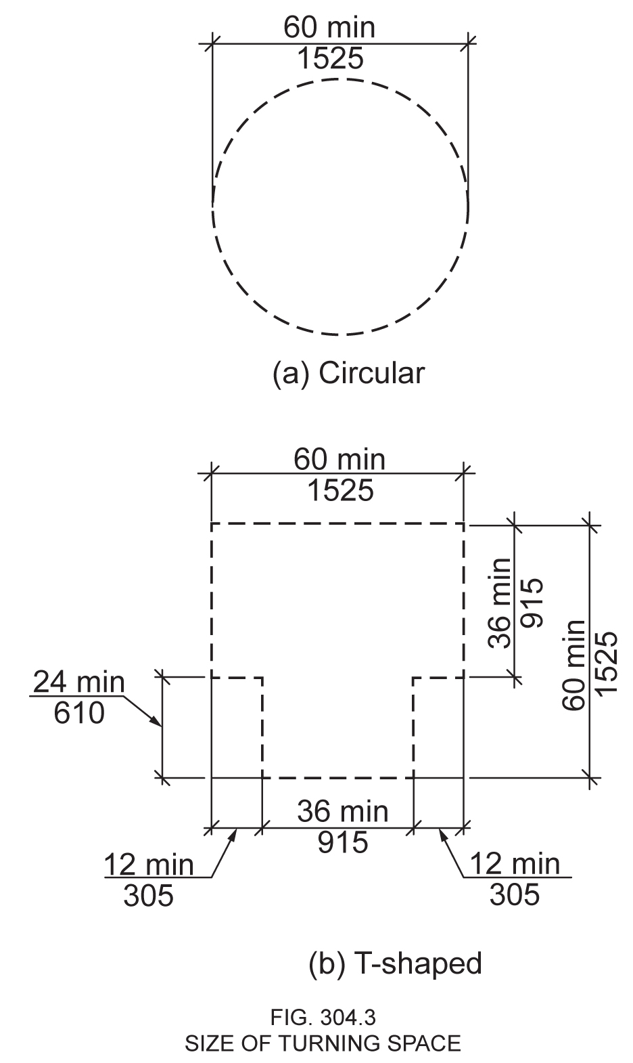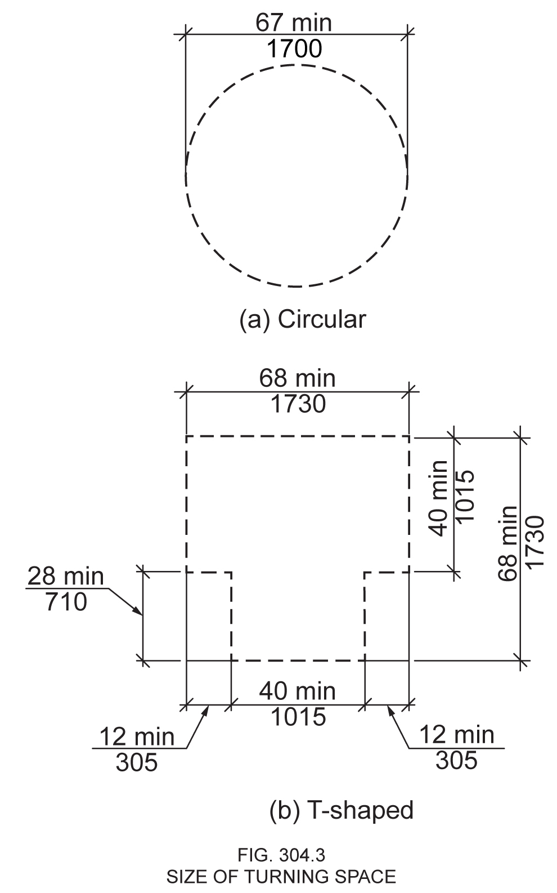
Figure 304.3(a) Figure 304.3(a)
SIZE OF TURNING SPACE SIZE OF TURNING SPACE

Reason: Many of the technical requirements of the ICC/ANSI A117.1 (2009) Accessible and Usable Buildings and Facilities (ICC/ANSI) designed to accommodate wheeled mobility users are based on research completed from 1974 to 1978 using a research sample that included about 60 individuals who used manual wheelchairs (Steinfeld et al., 1979).
The Center for Inclusive Design and Environmental Access (IDeA) at the University at Buffalo, SUNY recently completed an anthropometric study of 500 wheeled manual and powered mobility device users (Steinfeld, et al., 2010). Measurements of body and device size were captured in three dimensions. The functional anthropometric measurements required measuring reaching ability, grip strength and the minimum space needed for turning. It is the most extensive anthropometric study of wheeled mobility device users in the United States. Additional information about the study can be found at http://www.udeworld.com/ansi-standards-review. The proposed revisions are based on new anthropometric information that was generated from the database of anthropometric measurements developed as part of the study.

Analysis

The results of our analysis suggest that the existing standard on clear floor space (60” diameter) does not accommodate the occupied lengths and widths of the wheeled mobility user population and excludes powered wheeled mobility device users disproportionately as compared to manual device users. A diameter of 60” accommodates only 75% of manual and power wheelchair users when performing a 180-degree turn. A 180-degree turn diameter of 67 inches would accommodate 95% of manual and power wheelchair users.
The analysis was summarized in the Final Project Report to the U.S. Access Board and in a memorandum entitled “Evaluation of Clear Floor Space Requirements,” that was submitted to the ICC/ANSI A117 Task Force on Anthropometry of Wheeled Mobility Subcommittee on Clear Floor Space Clearances.

References (See http://www.udeworld.com/ansi-standards-review)

Steinfeld, E., Paquet, V., D’Souza, C., Joseph, C, and Maisel, J. (2010). Final Report: Anthropometry of Wheeled Mobility Project. Washington, DC: U.S. Access Board.

Steinfeld, E. Schroeder, S. and Bishop, M. (1979). Accessible buildings for people with walking and reaching limitations. Washington, DC: U.S. Department of Housing and Urban Development.
input.doc

Committee Action

Disapproved

Committee Reason: The Committee’s action to approve 3-6-12 is not affected by the action on this proposal. This proposal made additional changes to the turning circle which the Committee did not accept. The Committee concluded that the flexibility of allowing knee and toe clearances to be included in the measurement of the circle was essential, especially in light of changing the dimension from 60 to 67 inches.

3-8 – 12
304.3.1

Proposed Change as Submitted

Proponent: Kimberly Paarlberg, International Code Council

Revise as follows:

304.3.1 Circular Space. The turning space shall be a circular space with a 60-inch (1525 mm) minimum diameter. The turning space shall be permitted to include knee and toe clearance complying with Section 306 only on one side of the circle and not encompass more than 90 degrees of the arc of the circle.

Reason: The quantity of change proposals submitted by International Code Council is reflective of three elements of our work: 1. ICC is the Secretariat for the Standard and some changes reflect inconsistencies or improvements suggested by staff; 2. ICC develops and publishes a Commentary on the standard and writing the commentary illuminates issues of the text and figures; and 3. ICC provides an interpretation service for the standard which results in the observation of provisions the users find most confusing.
The T-turn limits you to one arm, so it seems appropriate to not allow for using knee and lot clearance on more than one side of the circle. The double underline is a choice if the committee would also like to limit the extent of ‘one side.’
input.doc

Committee Action

Disapproved

Committee Reason: While the intent of the proposal found favor among Committee members, the language of the proposal was found wanting. Questions were raised about whether the 90 degree limit worked, or how one had one side of a circle.

3-9 – 12
304.3.2

Proposed Change as Submitted

Proponent: Gina Hilberry and David Collins, Co-Chairs Wheeled Mobility Task Group

Revise as follows:

304.3.2 T–Shaped Space. The turning space shall be a T–shaped space within a 60 inch (1525 mm) minimum in depth by 68 inch (1730 mm) minimum in width space, with arms 40 inches (1015 mm) minimum in width and base 36 inches (915 mm) minimum in width. The space shall be entered and exited throught the base. Each arm of the T shall be clear of obstructions 12 16 inches ( 305 405 mm) minimum in each direction, and the base shall be clear of obstructions 24 inches (610 mm) minimum. The turning space shall be permitted to include knee and toe clearance complying with Section 306 only at the end of either the base or one arm.

EXCEPTION: Where the interior corners of the intersection where the base and arms meet are chamfered for 8 inches (205 mm) minimum along both walls; both legs of the arms shall be 36 inches (915 mm) minimum in width.

Reason: The Wheeled Mobility Task Group (WMTG) was created as a task group of the A117.1 Committee to analyze the results of the anthropometric study of a variety of mobility device users conducted by The Center for Inclusive Design and Environmental Access (IDeA) at the University at Buffalo, SUNY recently completed an anthropometric study of 500 wheeled manual and powered mobility device users. The study indicates that the technical provisions contained in the A117.1 standard do not address the needs of the full range of users of mobility devices. The work of the WMTG is ongoing, but it has submitted a series of proposed changes to the base building blocks of the A117.1 standard. If the changes to the building blocks are adopted by the Committee, then additional changes will need to be made in other portions of the standard.
input.doc

Committee Action

Approval as Modified

Modification Text not prepared. Need the text to reflect the 3 diagrams
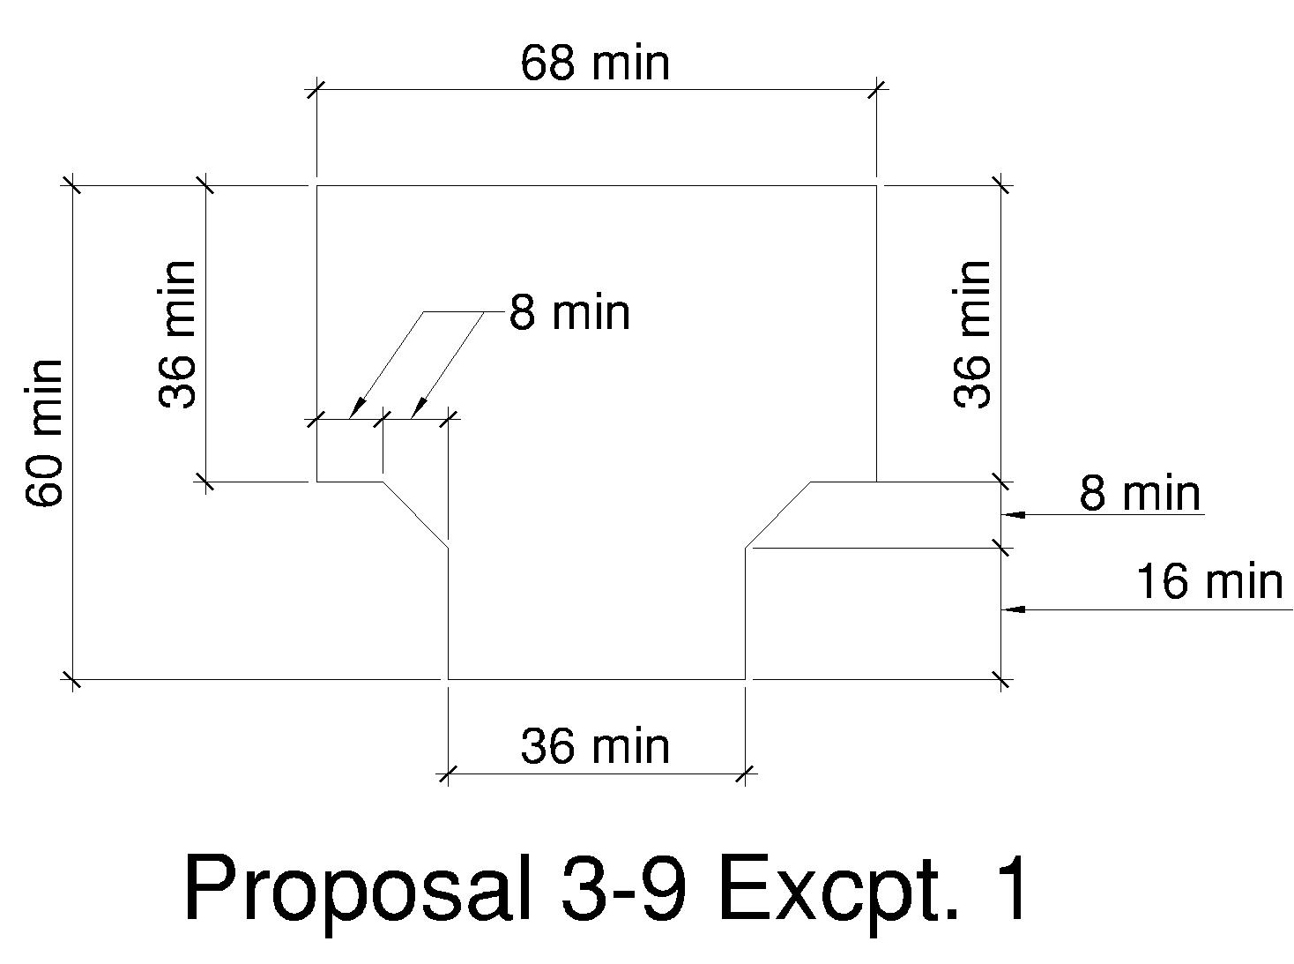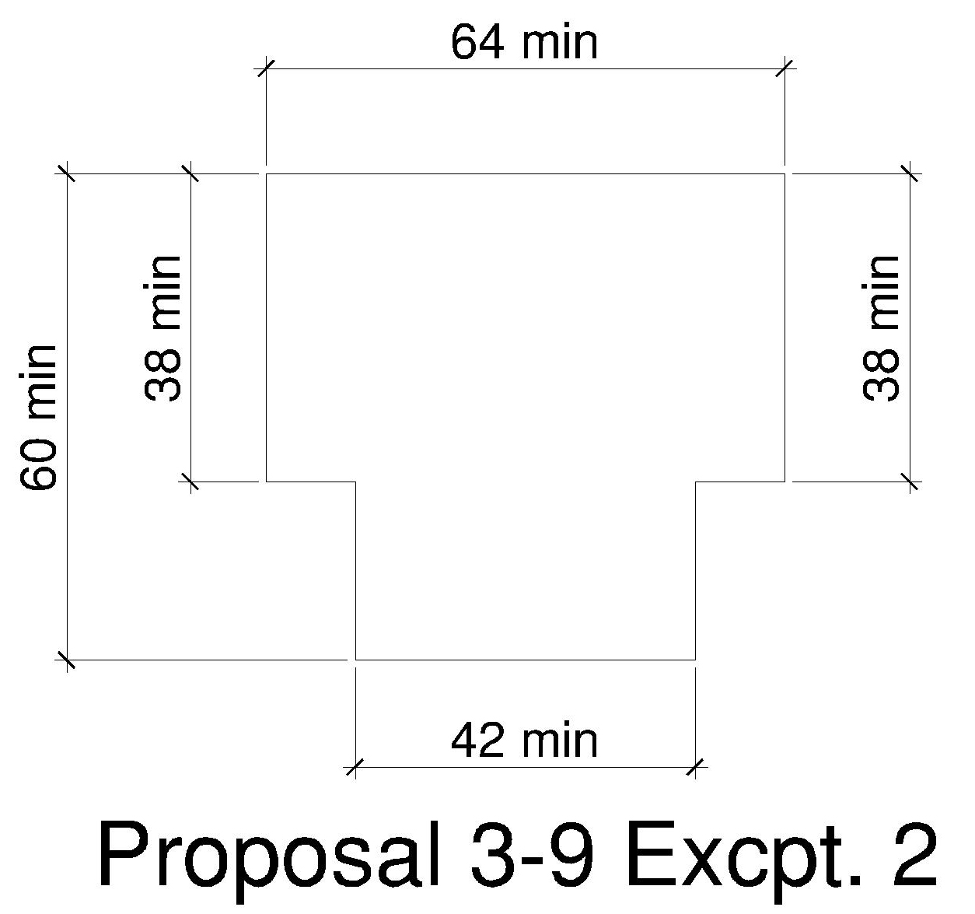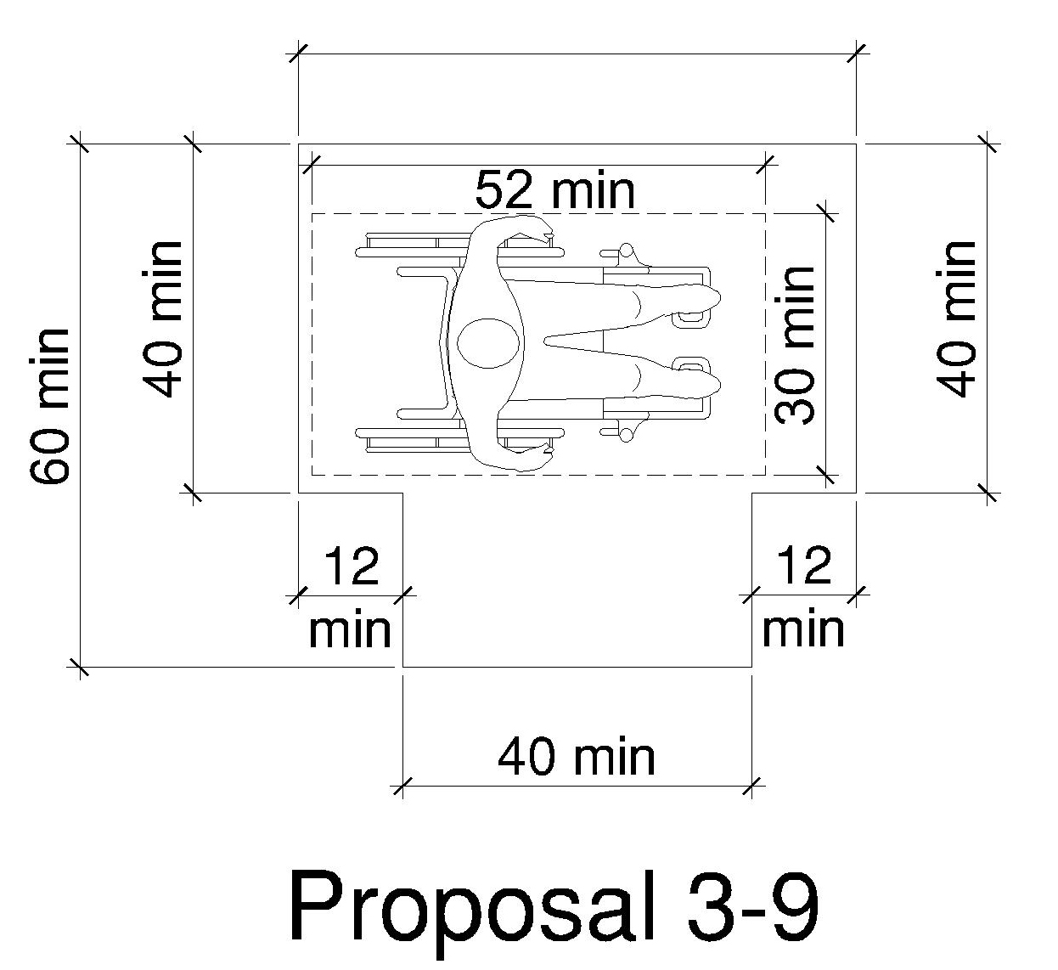

Committee Reason: The Committee explored the various options and limitations for regarding making the T-shaped turn. While the dimensions shown in the figure labeled Proposal 3-9 were the base of the discussions, the Committee concluded that the 3 designs should be shown in the text (perhaps in a table) as 3 equal options for design the space. The Committee approved the figures; asked staff to develop text.

3-10 – 12
304.3.2, 1003.3.2

Proposed Change as Submitted

Proponent: Todd Andersen, representing the CFS in motion subcommittee

Revise as follows:

304.3.2 T-Shaped Space. The turning space shall be a T-shaped space within a 60-inch (1525 mm) minimum square, with arms and base 36 inches (915 mm) minimum in width. Each arm of the T shall be clear of obstructions 12 inches (305 mm) minimum in each direction, and the base shall be clear of obstructions 24 inches (610 mm) minimum. The turning space shall be permitted to include knee and toe clearance complying with Section 306 only at the end of either the base or one arm.

1003.3.2 Turning Space. All rooms served by an accessible route shall provide a turning space complying with Section 304.

EXCEPTIONS:
- A turning space is not required in toilet rooms and bathrooms that are not required to comply with Section 1003.11.2.
- A turning space is not required within closets or pantries that are 48 inches (1220 mm) maximum in depth.
- The turning space shall be permitted to include knee and toe clearance complying with Section 306 only at the end of either the base or one arm.

Reason: Dropping permission to let part of a T turn slip under obstructions serves two groups – some power wheelchair users and scooter users. The geometry of scooters does not allow them to take advantage of floor areas that are under fixed objects (eg the front tiller and the seat back are in the way). Figure 3-6 of of the IDEA report shows that approximately 20 percent of power chair users sit too high to make use of space beneath obstructions 27 inches aff (ie the lowest a knee space permitted). Where the space beneath the obstruction is 29 inches aff. Approximately 95 percent of them would fit under. Thus requiring the T turn space to extend to 80 inches aff will serve approximately 20 percent of power chair users. The exemption for Type A dwellings is based on the idea that users of scooters have greater control over the use of alternative mobility devices and the arrangement of furnishings in their homes than they do in public.
input.doc

Committee Action

Disapproved

Committee Reason: The Committee felt the proposal was too restrictive and would result in expansions of floor space devoted to such turning spaces. It would affect dwelling units as well as non-residential buildings. The impact needs to be narrowed.

3-11 – 12
304.3.2

Proposed Change as Submitted

Proponent: Jonathan White, representing himself

Revise as follows:

304.3.2 T-Shaped Space. The turning space shall be a T-shaped space within a 60-inch 68-inch (1525 1725 mm) minimum square, with arms and base 36 40 inches (915 1015 mm) minimum in width. Each arm of the T shall be clear of obstructions 12 14 inches (305 355 mm) minimum in each direction, and the base shall be clear of obstructions 24 28 inches (610 710 mm) minimum. The turning space shall be permitted to include knee and toe clearance complying with Section 306 only at the end of either the base or one arm.

EXCEPTIONS:

1. Where the arms of the T-shaped space are 42 inches (1065 mm) minimum in width, the base of the T shall be permitted to be 38 inches (965 mm) minimum in width, with the arms of the T clear of obstructions 15 inches (380 mm) minimum in each direction.

2. Where the arms of the T-shaped space are 44 inches (1115 mm) minimum in width, the base of the T shall be permitted to be 36 inches (915 mm) minimum in width, with the arms of the T clear of obstructions 16 inches (405 mm) minimum in each direction.

Reason: Many of the technical requirements of the ICC/ANSI A117.1 (2009) Accessible and Usable Buildings and Facilities (ICC/ANSI) designed to accommodate wheeled mobility users are based on research completed from 1974 to 1978 using a research sample that included about 60 individuals who used manual wheelchairs (Steinfeld et al., 1979).
The Center for Inclusive Design and Environmental Access (IDeA) at the University at Buffalo, SUNY recently completed an anthropometric study of 500 wheeled manual and powered mobility device users (Steinfeld, et al., 2010). Measurements of body and device size were captured in three dimensions. The functional anthropometric measurements required measuring reaching ability, grip strength and the minimum space needed for turning. It is the most extensive anthropometric study of wheeled mobility device users in the United States. Additional information about the study can be found at http://www.udeworld.com/ansi-standards-review. The proposed revisions are based on new anthropometric information that was generated from the database of anthropometric measurements developed as part of the study.

Analysis

The results of our analysis suggest that the existing standard on a T-turn does not accommodate the occupied lengths and widths of the wheeled mobility user population and excludes powered wheeled mobility device users disproportionately as compared to manual device users. This is based on the IDEA center’s 90-degree turn data in Final Report: Anthropometry of Wheeled Mobility Project. Fewer than 75% of manual and power wheelchair users could negotiate a L-turn that was 36 inches width (pg. 154). A width of 40 inches would accommodate 94% of manual wheelchair users, 99% of power wheelchair users, and 92% of scooter users.
The exceptions are the results of estimated percentages by the IDEA center in a memorandum by Edward Steinfeld, to the ANSI subcommittee on Turning. The estimated percentages for Option B, C and D are the actual percentages for the narrower 90 degree turns. In other words, we tested a 90 degree turn of 38 x 38 without a chamfer. We are using that data to estimate the minimum percentage accommodated by the chamfered version. Thus, this is a conservative estimate because widening one side and adding the chamfer would clearly increase the percentage accommodated.

The table in the memorandum is below:

Proportion of the sample accommodated in each of the four alternatives for a L-turn

% Accommodated | Data Source | Manual (n=208) | Power (n=150) | Scooter (n=23)
Option A (40”x40”) | Measured data for 40” x 40” | 94% | 99% | 92%
Option B (42”x38”) | Estimate based on data for 38”x38” | Min. 85% | Min. 87% | Min. 67%
Option C (44”x36”) | Estimate based on data for 36”x36” | Min. 71% | Min. 71% | Min. 46%
Option D (36”x36” w/chamfer) | Estimate based on data for 36”x36” | Min. 71% | Min. 71% | Min. 46%

The analysis was summarized in the Final Project Report to the U.S. Access Board and in a memorandum entitled “Evaluation of Clear Floor Space Requirements,” that was submitted to the ICC/ANSI A117 Task Force on Anthropometry of Wheeled Mobility Subcommittee on Clear Floor Space Clearances.

References (See http://www.udeworld.com/ansi-standards-review)

Steinfeld, E. (2012). Summary of Turning Discussion and Responses and Recommended Dimensions for Turning Spaces. A memorandum submitted to the ICC/ANSI A117 Task Force on Anthropometry of Wheeled Mobility Subcommittee on Turning Spaces.

Steinfeld, E., Paquet, V., D’Souza, C., Joseph, C, and Maisel, J. (2010). Final Report: Anthropometry of Wheeled Mobility Project. Washington, DC: U.S. Access Board.

Steinfeld, E. Schroeder, S. and Bishop, M. (1979). Accessible buildings for people with walking and reaching limitations. Washington, DC: U.S. Department of Housing and Urban Development.
input.doc

Committee Action

Disapproved

Committee Reason: The Committee preferred the maneuvering space dimensions approved in proposal 3-9-12.

3-12 – 12
304.4

Proposed Change as Submitted

Proponent: Kim Paarlberg, International Code Council

Delete without substitution as follows:

304.4 Door Swing. Unless otherwise specified, doors shall be permitted to swing into turning spaces.

Reason: The quantity of change proposals submitted by International Code Council is reflective of three elements of our work: 1. ICC is the Secretariat for the Standard and some changes reflect inconsistencies or improvements suggested by staff; 2. ICC develops and publishes a Commentary on the standard and writing the commentary illuminates issues of the text and figures; and 3. ICC provides an interpretation service for the standard which results in the observation of provisions the users find most confusing.
Since the general overlap statement was moved to 301.2, it seems logical that this section also be deleted since it is already addressed.
input.doc

Committee Action

Disapproved

Committee Reason: The Committee was concerned that even if this language is redundant, that clarity in the use of the Standard could be lost without this section.

3-13 – 12
305.3, 305.7.2

Proposed Change as Submitted

Proponent: Gina Hilberry and David Collins, Co-Chairs Wheeled Mobility Task Group

Revise as follows:

305.3 Size. The clear floor space shall be 48 inches (1220 mm) 52 inches (1320 mm) minimum in length and 30 inches (760 mm) minimum in width.

305.7.2 Forward Approach. Where the clear floor space is positioned for a forward approach, the alcove shall be 36 inches (915 mm) minimum in width where the depth exceeds 24 20 inches (610 508 mm).

Reason: The Wheeled Mobility Task Group (WMTG) was created as a task group of the A117.1 Committee to analyze the results of the anthropometric study of a variety of mobility device users conducted by The Center for Inclusive Design and Environmental Access (IDeA) at the University at Buffalo, SUNY recently completed an anthropometric study of 500 wheeled manual and powered mobility device users. The study indicates that the technical provisions contained in the A117.1 standard do not address the needs of the full range of users of mobility devices. The work of the WMTG is ongoing, but it has submitted a series of proposed changes to the base building blocks of the A117.1 standard. If the changes to the building blocks are adopted by the Committee, then additional changes will need to be made in other portions of the standard.

For 305.3 While never explicitly stated in ANSI 1980, either ADAAG or our current standard, all four show the clear floor space as being wider and longer than the wmd itself. The IDEA report indicates this is not true for significant percentages of wmd users. 22% of occupied wmds are longer and 12% are wider than today's mimima. However, when unoccupied wmds are considered the percentages drop to less than 12% for length and less than 4% for width. Based on these findings we have several options. One approach is to increase the width to accommodate 90% of unoccupied wmds and add 2 inches on either side for knuckles etc. An alternative approach would be to revise the concept of clear floor space width to represent the solid wmd solely and revise the forward approach alcove trigger condition. This proposal advocates the second approach as the inclusion of power chairs and scooters distorts the potential impact on manual wheelchair users (ie the group whose knuckles are at risk). Thus, no change to cfs width is proposed. Clear floor space length is a different matter as the percentages of those not served are higher and it can be imagined that the user has less ability to significantly change his/her length. Increasing the cfs to 52 inches will accommodate more than 95% of unoccupied and 89% of occupied wmds. All the scenarios described above also were studied to see what would happen if in the future power chair and scooter uses were to double at the expense of manual wheelchairs. Occupied width accommodation drops one percent to 87% and occupied length drops to 88%.

For 305.7.2 By defining a cfs width as representing the space taken up by an occupied wmd without allowance for additional space for knuckles and elbows, it becomes necessary to consider situations where such knuckle etc space are needed to successfully enter and exit an alcove. This proposal is largely driven by consideration of situations where access to the push rims of manual wheelchairs is required. From Figure 4-3 (page 92) of the IDEA Final Report we learn that the 25 centile manual wheelchair user's torso to toe dimension is about 22 inches. The report does not describe the length of corresponding wmd, but until such time as toe space depth is modified, underlap is restricted to 19 inches. The proposed dimension of 20 inches is a compromise of these two observations.
input.doc

Committee Action

Approved

Committee Reason: The Committee debated the need to increase the clear floor space (CFS) by discussing proposals 3-13-12 and 3-14-12 at the same time. CFS is one of the key building blocks which, if changed, will have implications in the balance of the standard. Changes to its width and its length impact different provisions throughout the balance of the Standard.
The discussion focused on the size of wheeled mobility devices including powered chairs and scooters, the percentages of the target populations which are not served by the current standard because of the size of the devices.
The consensus was that wheeled mobility devices are getting larger. To accommodate a wider range of the devices the CFS needed to be increased. The Committee was not of a consensus on the size CFS needed to be increased to. This dimension was approved.

3-13A – 12
405.7.3

Proposed Change as Submitted

Proponent: Gina Hilberry and David Collins, Co-Chairs Wheeled Mobility Task Group

Revise as follows:

405.7.3 Length. Landings shall have a clear length of 60 64 inches (1525 1625 mm) minimum

Reason: The Wheeled Mobility Task Group (WMTG) was created as a task group of the A117.1 Committee to analyze the results of the anthropometric study of a variety of mobility device users conducted by The Center for Inclusive Design and Environmental Access (IDeA) at the University at Buffalo, SUNY recently completed an anthropometric study of 500 wheeled manual and powered mobility device users. The study indicates that the technical provisions contained in the A117.1 standard do not address the needs of the full range of users of mobility devices. The work of the WMTG is ongoing, but it has submitted a series of proposed changes to the base building blocks of the A117.1 standard. If the changes to the building blocks are adopted by the Committee, then additional changes will need to be made in other portions of the standard.

Rationale for 3-13A: Add 4 inches (100 mm) to landing length to reflect increase in clear floor space.

input.doc

Committee Action

Disapproved

Committee Reason: The landing size should be tied to the wheelbase of the wheeled mobility devices. It is understood that the overall device length is longer, but there is not data provided to indicate that 60 inch landing isn’t still sufficient.

3-13B – 12
409.4.1

Proposed Change as Submitted

Proponent: Gina Hilberry and David Collins, Co-Chairs Wheeled Mobility Task Group

Revise as follows:

409.4.1 Inside Dimensions. Elevator cars shall provide a clear floor area 36 inches (915 mm) minimum in width and 48 52 inches (1220 1322 mm) minimum in depth.

Reason: The Wheeled Mobility Task Group (WMTG) was created as a task group of the A117.1 Committee to analyze the results of the anthropometric study of a variety of mobility device users conducted by The Center for Inclusive Design and Environmental Access (IDeA) at the University at Buffalo, SUNY recently completed an anthropometric study of 500 wheeled manual and powered mobility device users. The study indicates that the technical provisions contained in the A117.1 standard do not address the needs of the full range of users of mobility devices. The work of the WMTG is ongoing, but it has submitted a series of proposed changes to the base building blocks of the A117.1 standard. If the changes to the building blocks are adopted by the Committee, then additional changes will need to be made in other portions of the standard.

Rationale for 3-13B: Update requirement to coordinate with proposed changes to 305.3 Size (Clear Floor Space).

input.doc

Committee Action

Approved

Committee Reason: Consistent with the action on Proposal 3-13-12 to increase the clear floor space.

3-13C – 12
410.5, 410.5.1

Proposed Change as Submitted

Proponent: Gina Hilberry and David Collins, Co-Chairs Wheeled Mobility Task Group

Revise as follows:

410.5 Clear Floor Space. Clear floor space of platform lifts in new construction shall comply with Section 410.5.

410.5.1 Lifts with Single Doors or Doors on Opposite Ends. Platform lifts with a single door or doors on opposite ends shall provide a clear floor width of 36 inches (915 mm) minimum and a clear floor depth of 48 52 inches (1220 1322 minimum).

Exception: Incline platform lifts with passenger restraining arms, shall be permitted to provide a clear floor width of 36 inches (915 mm) minimum and a clear floor depth of 48 inches (1220) mm.

Reason: The Wheeled Mobility Task Group (WMTG) was created as a task group of the A117.1 Committee to analyze the results of the anthropometric study of a variety of mobility device users conducted by The Center for Inclusive Design and Environmental Access (IDeA) at the University at Buffalo, SUNY recently completed an anthropometric study of 500 wheeled manual and powered mobility device users. The study indicates that the technical provisions contained in the A117.1 standard do not address the needs of the full range of users of mobility devices. The work of the WMTG is ongoing, but it has submitted a series of proposed changes to the base building blocks of the A117.1 standard. If the changes to the building blocks are adopted by the Committee, then additional changes will need to be made in other portions of the standard.

Rationale for 3-13C: Update the basic requirement to coordinate with proposed changes to 305.3 Size (Clear Floor Space). The exception was added to deal with the special circumstances involving inclined platform lifts with passenger restraining arms. Because inclined platform lifts are typically installed on existing staircases, any increase in size may result in the inability to install the lift which would actually reduce the accessibility of the building. Also, inclined platform lifts with passenger restraining arms consist of a platform with ramps that typically angle up at approximately 45 degrees and passenger restraining arms around the perimeter at a height of 38 inches. Since the area in between in open and the ramps angle out, the wheeled mobility device can overhang the platform (over the ramps) allowing a larger device to fit onto a 36 x 48 platform.
input.doc

Committee Action

Approved

Committee Reason: The Committee discussed briefly that the wheelbase of the device would be important, but as platform lifts with enclosing doors need to accommodate the whole device, the longer length is essential. There was a request that an exception for existing buildings be developed.

3-13D – 12
802.5.1

Proposed Change as Submitted

Proponent: Gina Hilberry and David Collins, Co-Chairs Wheeled Mobility Task Group

Revise as follows:

802.5.1 Overlap. A wheelchair space location shall not overlap the required width of an aisle.

Exception: The wheelchair space shall be permitted to overlap the aisle a maximum of 4 inches (100 mm).

Reason: The Wheeled Mobility Task Group (WMTG) was created as a task group of the A117.1 Committee to analyze the results of the anthropometric study of a variety of mobility device users conducted by The Center for Inclusive Design and Environmental Access (IDeA) at the University at Buffalo, SUNY recently completed an anthropometric study of 500 wheeled manual and powered mobility device users. The study indicates that the technical provisions contained in the A117.1 standard do not address the needs of the full range of users of mobility devices. The work of the WMTG is ongoing, but it has submitted a series of proposed changes to the base building blocks of the A117.1 standard. If the changes to the building blocks are adopted by the Committee, then additional changes will need to be made in other portions of the standard.

Rationale for 3-6D: Accommodate 67 inch (1700) turning diameter.
input.doc

Committee Action

Approval as Modified

802.5.1 Overlap. A wheelchair space location shall not overlap the required width of an aisle.

Exception: The depth of the wheelchair space shall be permitted to overlap the aisle a maximum of 4 inches (100 mm).

Committee Reason: The Committee had considerable discussion regarding allowing the wheelchair space to overlap the aisle. There is concern that such would cause people to view persons in wheelchairs and other mobility devices as obstructions in the operation of a theater. Without considering the overlap, site line requirements would cause substantial redesign of theaters and stadiums. The proposal was amended to clarify that it would be the length of the clear floor space allowed to overlap.

3-13E – 12
802.7.2

Proposed Change as Submitted

Proponent: Gina Hilberry and David Collins, Co-Chairs Wheeled Mobility Task Group

Revise as follows:

802.7.2 Companion Seat Alignment. In row seating, the companion seat shall be located to provide shoulder alignment with the wheelchair space occupant. The shoulder of the wheelchair space occupant is considered to be 36 inches (915 mm) from the front or 12 16 inches (305 ??? mm) from the rear of the wheelchair space. The floor surface for the companion seat shall be at the same elevation as the wheelchair space floor surface.

Reason: The Wheeled Mobility Task Group (WMTG) was created as a task group of the A117.1 Committee to analyze the results of the anthropometric study of a variety of mobility device users conducted by The Center for Inclusive Design and Environmental Access (IDeA) at the University at Buffalo, SUNY recently completed an anthropometric study of 500 wheeled manual and powered mobility device users. The study indicates that the technical provisions contained in the A117.1 standard do not address the needs of the full range of users of mobility devices. The work of the WMTG is ongoing, but it has submitted a series of proposed changes to the base building blocks of the A117.1 standard. If the changes to the building blocks are adopted by the Committee, then additional changes will need to be made in other portions of the standard.

Rationale for 3-13E: To accommodate longer clear floor space.
input.doc

Committee Action

Approved

Committee Reason: The added length accommodates that longer clear floor space and adjusts the measurement to align the shoulders of the person in the mobility device and those in the companion seat.

3-13F – 12
805.2.2

Proposed Change as Submitted

Proponent: Gina Hilberry and David Collins, Co-Chairs Wheeled Mobility Task Group

Revise as follows:

805.2.2 Dimensions. Bus stop boarding and alighting areas shall have a 96 100-inch (2440 2540 mm) minimum clear length, measured perpendicular to the curb or vehicle roadway edge, and a 60-inch (1525 mm) minimum clear width, measured parallel to the vehicle roadway.

Reason: The Wheeled Mobility Task Group (WMTG) was created as a task group of the A117.1 Committee to analyze the results of the anthropometric study of a variety of mobility device users conducted by The Center for Inclusive Design and Environmental Access (IDeA) at the University at Buffalo, SUNY recently completed an anthropometric study of 500 wheeled manual and powered mobility device users. The study indicates that the technical provisions contained in the A117.1 standard do not address the needs of the full range of users of mobility devices. The work of the WMTG is ongoing, but it has submitted a series of proposed changes to the base building blocks of the A117.1 standard. If the changes to the building blocks are adopted by the Committee, then additional changes will need to be made in other portions of the standard.

Rationale for 3-13F: Add 4 inches (100 mm) to alighting area to reflect increase in Clear floor space.
input.doc

Committee Action

Approved

Committee Reason: With a 4 inch longer clear floor space, the 4 inches needs to be added to the area designed to allow people to negotiate around the equipment. This isn’t assuming a larger apparatus on the bus, but the need for space for larger mobility equipment.

3-13G – 12
1102.4.4.1

Proposed Change as Submitted

Proponent: Gina Hilberry and David Collins, Co-Chairs Wheeled Mobility Task Group

Revise as follows:

1102.4.4.1 Width and Length. Wheelchair spaces shall provide a clear width of 30 inches (760 mm) minimum and a clear length of 48 52 inches (1220 1320 mm) minimum measured to 9 inches (230 mm) minimum above the floor.

Reason: The Wheeled Mobility Task Group (WMTG) was created as a task group of the A117.1 Committee to analyze the results of the anthropometric study of a variety of mobility device users conducted by The Center for Inclusive Design and Environmental Access (IDeA) at the University at Buffalo, SUNY recently completed an anthropometric study of 500 wheeled manual and powered mobility device users. The study indicates that the technical provisions contained in the A117.1 standard do not address the needs of the full range of users of mobility devices. The work of the WMTG is ongoing, but it has submitted a series of proposed changes to the base building blocks of the A117.1 standard. If the changes to the building blocks are adopted by the Committee, then additional changes will need to be made in other portions of the standard.

Rationale for 3-13G: Add 4 inches (100 mm) to alighting area to reflect increase in Clear floor space.
.
input.doc

Committee Action

Disapproved

Committee Reason: The Committee was not convinced that the longer clear floor space in this case needed to be addressed. The question raised was the longer space needed to accommodate a longer wheelbase for the wheeled mobility devices.

3-13H – 12
1107.3.2

Proposed Change as Submitted

Proponent: Gina Hilberry and David Collins, Co-Chairs Wheeled Mobility Task Group

Revise as follows:

1107.3.2 Golf Club Reach Range Area. All areas within holes where golf balls rest shall be within 36 inches (915 mm) maximum of a clear floor space 36 inches (915 mm) minimum in width and 48 52 inches (1220 mm) minimum in length complying with Section 305 having a running slope not steeper than 1:20. The clear floor space shall be served by an accessible route.

Reason: The Wheeled Mobility Task Group (WMTG) was created as a task group of the A117.1 Committee to analyze the results of the anthropometric study of a variety of mobility device users conducted by The Center for Inclusive Design and Environmental Access (IDeA) at the University at Buffalo, SUNY recently completed an anthropometric study of 500 wheeled manual and powered mobility device users. The study indicates that the technical provisions contained in the A117.1 standard do not address the needs of the full range of users of mobility devices. The work of the WMTG is ongoing, but it has submitted a series of proposed changes to the base building blocks of the A117.1 standard. If the changes to the building blocks are adopted by the Committee, then additional changes will need to be made in other portions of the standard.

Rationale for 3-13H: References 52 inch (1320) long Clear floor space.
.
input.doc

Committee Action

Approved

Committee Reason: The provision is a clear floor space requirement which, for consistency with other actions, was approved to the new 52 inch length.

3-13I – 12
Number not used.

3-13J – 12
1108.4.1.4.2

Proposed Change as Submitted

Proponent: Gina Hilberry and David Collins, Co-Chairs Wheeled Mobility Task Group

Revise as follows:

1108.4.1.4.2 Elevated. The clear width of accessible routes connecting elevated play components shall be 36 inches (915 mm) minimum.

EXCEPTIONS:

1. The clear width of accessible routes connecting elevated play components shall be permitted to be reduced to 32 inches (815 mm) minimum for a distance of 24 inches (610 mm) maximum provided that reduced width segments are separated by segments that are 48 52 inches (1220 1320 mm) minimum in length and 36 inches (915 mm) minimum in width.

2. (text not changed)

Reason: The Wheeled Mobility Task Group (WMTG) was created as a task group of the A117.1 Committee to analyze the results of the anthropometric study of a variety of mobility device users conducted by The Center for Inclusive Design and Environmental Access (IDeA) at the University at Buffalo, SUNY recently completed an anthropometric study of 500 wheeled manual and powered mobility device users. The study indicates that the technical provisions contained in the A117.1 standard do not address the needs of the full range of users of mobility devices. The work of the WMTG is ongoing, but it has submitted a series of proposed changes to the base building blocks of the A117.1 standard. If the changes to the building blocks are adopted by the Committee, then additional changes will need to be made in other portions of the standard.

Rationale for 3-13J: Add 4 inches (100 mm) to alighting area to reflect increase in Clear floor space.
.
input.doc

Committee Action

Disapproved

Committee Reason: The technical information which was the basis of increasing the clear floor space and turning circle was based on adults in wheeled mobility devices. This exception is addressing segments that are up in the play equipment. Investigation needed to address children size increases, if any.

3-13K – 12
1109.2.3

Proposed Change as Submitted

Proponent: Gina Hilberry and David Collins, Co-Chairs Wheeled Mobility Task Group

Revise as follows:
1109.2.3 Clear Deck Space. On the side of the seat opposite the water, a clear deck space shall be provided parallel with the seat. The space shall be 36 inches (915 mm) minimum in width and shall extend forward 48 52 inches (1220 1320 mm) minimum from a line located 12 inches (305 mm) behind the rear edge of the seat. The clear deck space shall have a slope not steeper than 1:48.
Reason: The Wheeled Mobility Task Group (WMTG) was created as a task group of the A117.1 Committee to analyze the results of the anthropometric study of a variety of mobility device users conducted by The Center for Inclusive Design and Environmental Access (IDeA) at the University at Buffalo, SUNY recently completed an anthropometric study of 500 wheeled manual and powered mobility device users. The study indicates that the technical provisions contained in the A117.1 standard do not address the needs of the full range of users of mobility devices. The work of the WMTG is ongoing, but it has submitted a series of proposed changes to the base building blocks of the A117.1 standard. If the changes to the building blocks are adopted by the Committee, then additional changes will need to be made in other portions of the standard.

Rationale for 3-13K: Add 4 inches (100 mm) to alighting area to reflect increase in Clear floor space.
.
input.doc

Committee Action

Approved

Committee Reason: This is a clear floor space adjacent to a pool transfer. It should be large enough to accommodate all mobility devices.

3-13L – 12
1004.3.3, 1004.9. 1004.10.1, 1004.11.2, 1004.11.2.1, 1004.11.3.1.1, 1004.12.2

Proposed Change as Submitted

Proponent: Gina Hilberry and David Collins, Co-Chairs Wheeled Mobility Task Group

Revise as follows:
1004.3.3 Clear Floor Space. For the purposes of Type B units, the clear floor space shall be 48 inches (1220mm) minimum in length and 30 inches(760 mm) minimum in width.
1004.9 Operable Parts. Lighting controls, electrical switches and receptacle outlets, environmental controls, electrical panelboards, and user controls for security or intercom systems shall comply with Sections 309.2 and 309.3 and 1004.3.3.

EXCEPTIONS:
(No change to the exceptions)
1004.10.1 Clear Floor Space. A clear floor space complying with Section 305.3 1004.3.3 shall be provided. A parallel approach shall be provided for a top loading machine. A forward or parallel approach shall be provided for a front loading machine.

1004.11.2 Clear Floor Space. Clear floor spaces required by Section 1004.11.3.1 (Option A) or 1004.11.3.2 (Option B) shall comply with Sections 1004.11.2 and 305.3 1004.3.3.
1004.11.2.1 Doors. Doors shall not swing into the clear floor space or clearance for any fixture.

EXCEPTION: Where a clear floor space complying with Section 305.3 1004.3.3, excluding knee and toe clearances under elements, is provided within the room beyond the arc of the door swing.

1004.11.3.1.1 Lavatory. A clear floor space complying with Section 305.3 1004.3.3, positioned for a parallel approach, shall be provided at a lavatory. The clear floor space shall be centered on the lavatory.
EXCEPTION:
A lavatory complying with Section 606 and1004.3.3 shall be permitted. Cabinetry shall be permitted under the lavatory provided the following criteria are met:

(a) The cabinetry can be removed without removal or replacement of the lavatory; and

(b) The floor finish extends under the cabinetry; and

(c) The walls behind and surrounding the cabinetry are finished.

1004.12.2 Clear Floor Space. Clear floor space at appliances shall comply with Sections 1004.12.2 and 305.3 1004.3.3.

Reason: The Wheeled Mobility Task Group (WMTG) was created as a task group of the A117.1 Committee to analyze the results of the anthropometric study of a variety of mobility device users conducted by The Center for Inclusive Design and Environmental Access (IDeA) at the University at Buffalo, SUNY recently completed an anthropometric study of 500 wheeled manual and powered mobility device users. The study indicates that the technical provisions contained in the A117.1 standard do not address the needs of the full range of users of mobility devices. The work of the WMTG is ongoing, but it has submitted a series of proposed changes to the base building blocks of the A117.1 standard. If the changes to the building blocks are adopted by the Committee, then additional changes will need to be made in other portions of the standard.

Rationale for 3-13L: This proposal establishes a distinct clear floor space for Type B dwelling units. The larger clear floor space established under proposal 3-13-12.
.
input.doc

Committee Action

Approved

Committee Reason: The proposal retains the existing clear floor space for Type B dwelling units. The impact of the larger CFS has yet to be fully analyzed with respect to dwelling units.

3-14 – 12
305.3, Figure 305.3, 305.7.1, 305.7.2

Proposed Change as Submitted

Proponent: Edward Steinfeld, IDEA Center, School of Architecture and Planning, University at Buffalo, State University of New York

Revise as follows:

305.3 Size. The clear floor space shall be 48 54 inches (1220 1360 mm) minimum in length and 30 32 inches (760 802 mm) minimum in width.

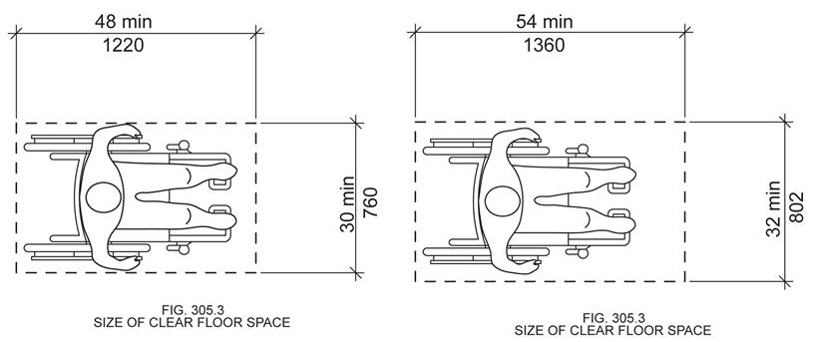

305.7.1 Parallel Approach. Where the clear floor space is positioned for a parallel approach, the alcove shall be 60 66 inches (1525 1676 mm) minimum in width where the depth exceeds 15 inches (380mm).

305.7.2 Forward Approach. Where the clear floor space is positioned for a forward approach, the alcove shall be 36 38 inches (915 965 mm) minimum in width where the depth exceeds 24 inches (610mm).

Reason: Many of the technical requirements of the ICC/ANSI A117.1 (2009) Accessible and Usable Buildings and Facilities (ICC/ANSI) designed to accommodate wheeled mobility users are based on research completed from 1974 to 1978 using a research sample that included about 60 individuals who used manual wheelchairs (Steinfeld et al., 1979).
The Center for Inclusive Design and Environmental Access (IDeA) at the University at Buffalo, SUNY recently completed an anthropometric study of 500 wheeled manual and powered mobility device users (Steinfeld, et al., 2010). Measurements of body and device size were captured in three dimensions. The functional anthropometric measurements required measuring reaching ability, grip strength and the minimum space needed for turning. It is the most extensive anthropometric study of wheeled mobility device users in the United States. Additional information about the study can be found at http://www.udeworld.com/ansi-standards-review. The proposed revisions are based on new anthropometric information that was generated from the database of anthropometric measurements developed as part of the study.

Analysis

Unlike turning spaces that are based on dynamic requirements, clear floor space represents the space required for a stationary wheeled mobility device. This area is typically depicted as a rectangular space the dimensions of which are based on measurements of occupied length and occupied breadth of wheeled mobility devices, which are defined as follows:
- Occupied length: measured as the horizontal distance between the forward-most point and the rear-most point on the wheelchair or occupant.
- Occupied width: measured as the horizontal distance between the side-most points of the wheelchair or participant on the right and left sides.
The results of our analysis suggest that the existing standard on clear floor space (48” length, 30” width) does not accommodate the occupied lengths and widths of the wheeled mobility user population and excludes powered wheeled mobility device users disproportionately as compared to manual device users. A length of 48” accommodates the occupied length of 75% of manual wheelchair users and only about 50% of powered chair and scooter users. A width of 30” accommodates the occupied width of 90% of manual wheeled mobility device users and only 75% of powered chair users.
We have taken the position that the clear floor space standards should accommodate the occupied lengths and widths of at least 90% of manual and powered wheeled mobility device users. A length of 54” accommodates the occupied lengths of 95% of manual chair users, and 90% of the powered chair users. A width of 32” accommodates the occupied widths of over 95% of manual wheeled mobility device users and 90% of the powered wheelchair users. Proposed changes to subsection 305.7.1 Parallel Approach reflect the 6-inch adjustment in basic clear floor space in order to be consistent with the current standard. The proposed changes to subsection 305.7.2 reflect the 2-inch adjustment in basic clear floor space in order to be consistent with the current standard.
These calculations are based on the three-dimensional database of wheeled mobility device user dimensions developed by the IDEA Center for the Anthropometry of Wheeled Mobility Project. The analysis was summarized in the Final Project Report to the U.S. Access Board and in a memorandum entitled “Evaluation of Clear Floor Space Requirements,” that was submitted to the ICC/ANSI A117 Task Force on Anthropometry of Wheeled Mobility Subcommittee on Clear Floor Space Clearances.

References (See http://www.udeworld.com/ansi-standards-review)

Paquet, V. (2012). Evaluation of Clear Floor Space Requirements. A memorandum submitted to the ICC/ANSI A117 Task Force on Anthropometry of Wheeled Mobility Subcommittee on Clear Floor Space Clearances.

Steinfeld, E., Paquet, V., D’Souza, C., Joseph, C, and Maisel, J. (2010). Final Report: Anthropometry of Wheeled Mobility Project. Washington, DC: U.S. Access Board.

Steinfeld, E. Schroeder, S. and Bishop, M. (1979). Accessible buildings for people with walking and reaching limitations. Washington, DC: U.S. Department of Housing and Urban Development.
input.doc

Committee Action

Disapproved

Committee Reason: The Committee disapproved this proposal in favor of approving Proposal 3-13-12. Clear floor space is a key building block for the rest of the Standard, after considerable debate and reconsideration, this proposal was disapproved in favor 3-13-12.

Staff Note: The history of the vote on this item and 3-13-12 will be reflected in the minutes of the Committee’s meetings.

3-15 – 12
305.7.2, Figure 305.7(a)

Proposed Change as Submitted

Proponent: Hank Falstad, Access Technologies Services, Inc., representing self

Revise as follows:

305.7.2 Forward Approach. Where the clear floor space is positioned for a forward approach, the full alcove shall be 36 inches (915 mm) minimum in width. Where the depth exceeds 24 inches; on only one side there is a partial alcove, the distance from that wall to the centerline of any element or fixture shall be 18 inches minimum.

Revise figure to change width from 36 to 30 inches.

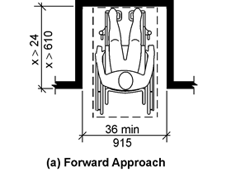
33 min
Full Alcove (a-1) Forward Approach
FIGURE 305.7(a) Partial Alcove

Reason: This allows the hand of the wheelchair user that extra 3 inches that is required in a full alcove.
input.doc

Committee Action

Disapproved

Committee Reason: The concept of a partial alcove was not clear to the Committee. Further the text and the figures of the proposal did not appear to be in agreement with each other. The proposal would not improve the Standard.

3-16 – 12
306.2.1, Figure 306.2, 306.2.2, 306.2.4, 306.2.5, Figure 306.3, 306.3.1, 306.3.2, 306.3.3, 306.3.4, 306.3.5

Proposed Change as Submitted

Proponent: Edward Steinfeld, IDEA Center, School of Architecture and Planning, University at Buffalo, State University of New York

Revise as follows:

306.2.1 General. Space beneath an element between the floor and 9 11 inches (230 280 mm) above the floor shall be considered toe clearance and shall comply with Section 306.2.

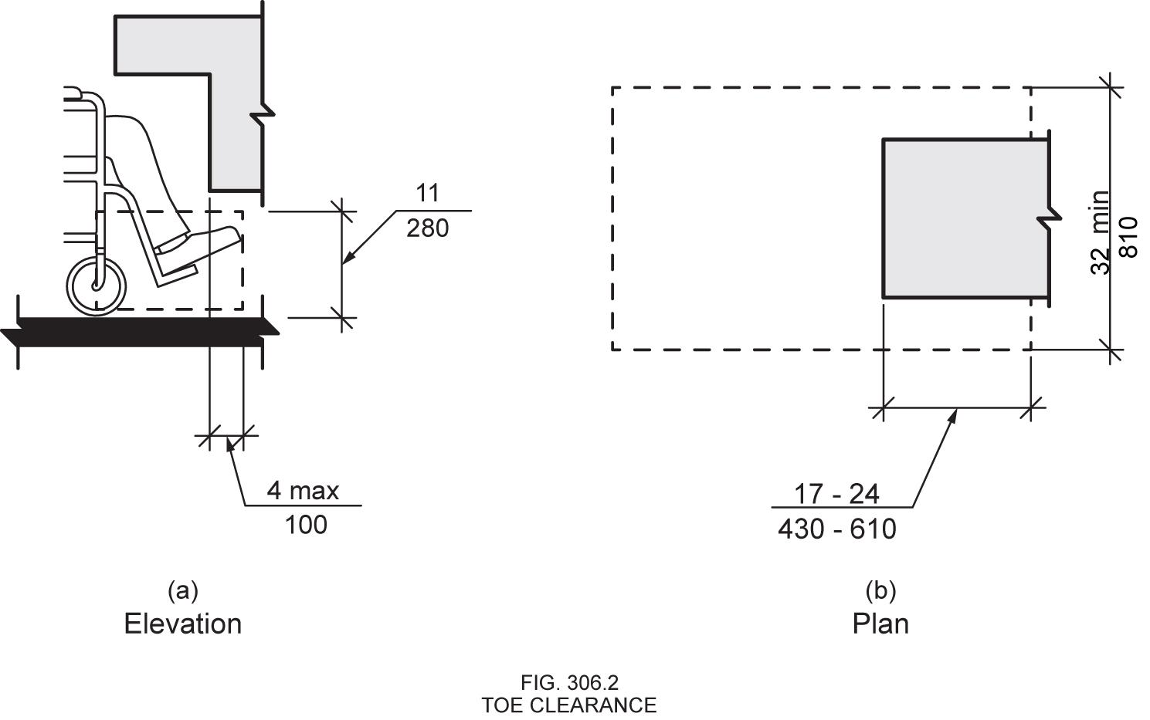
306.2.2 Maximum Depth. Toe clearance shall be permitted to extend 25 24 inches (635 610 mm) maximum under an element.
306.2.4 Additional Clearance. Space extending greater than 6 4 inches (150 100 mm) beyond the available knee clearance at 9 11 inches (230 280 mm) above the floor is allowable but shall not be considered as part of the toe clearance.
306.2.5 Width. Toe clearance shall be 30 32 inches (760 810 mm) minimum in width.
306.3.1 General. Space beneath an element between 9 11 inches (230 280 mm) and 27 29 inches (685 735 mm) above the floor shall be considered knee clearance and shall comply with Section 306.3.

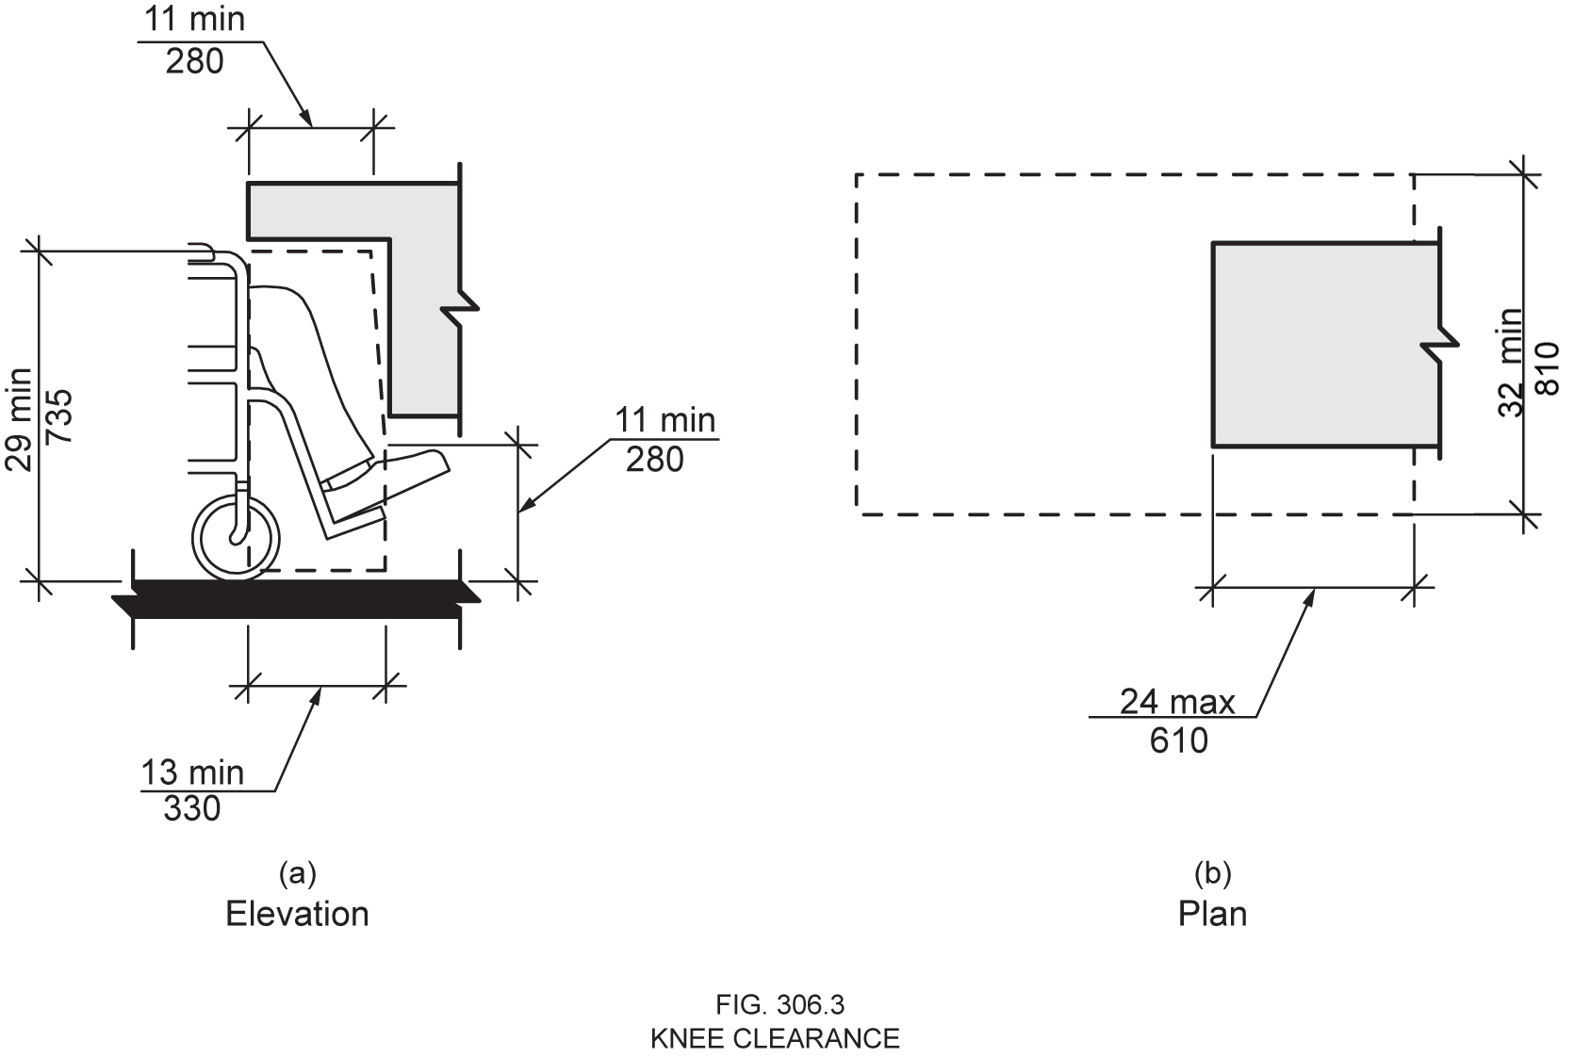
306.3.2 Maximum Depth. Knee clearance shall be permitted to extend 25 24 inches (635 610 mm) maximum under an element at 9 11 inches (230 280 mm) above the floor.
306.3.3 Minimum Depth. Where knee clearance is required beneath an element as part of a clear floor space complying with Section 305, the knee clearance shall be 11 13 inches (280 330 mm) minimum in depth at 9 11 inches (230 280 mm) above the floor, and 8 11 inches (205 280 mm) minimum in depth at 27 29 inches (685 735 mm) above the floor.
306.3.4 Clearance Reduction. Between 9 11 inches (230 280 mm) and 27 29 inches (685 735 mm) above the floor, the knee clearance shall be permitted to be reduced at a rate of 1 inch (25 mm) in depth for each 6 9 inches (150 230 mm) in height.
306.3.5 Width. Knee clearance shall be 30 32 inches (760 810 mm) minimum in width.
Reason: Many of the technical requirements of the ICC/ANSI A117.1 (2009) Accessible and Usable Buildings and Facilities (ICC/ANSI) designed to accommodate wheeled mobility users are based on research completed from 1974 to 1978 using a research sample that included about 60 individuals who used manual wheelchairs (Steinfeld et al., 1979).
The Center for Inclusive Design and Environmental Access (IDeA) at the University at Buffalo, SUNY recently completed an anthropometric study of 500 wheeled manual and powered mobility device users (Steinfeld, et al., 2010). Measurements of body and device size were captured in three dimensions. The functional anthropometric measurements required measuring reaching ability, grip strength and the minimum space needed for turning. It is the most extensive anthropometric study of wheeled mobility device users in the United States. Additional information about the study can be found at http://www.udeworld.com/ansi-standards-review. The proposed revisions are based on new anthropometric information that was generated from the database of anthropometric measurements developed as part of the study.

Analysis

An analysis based on the original findings of the study in Steinfeld, et al., 2010 was completed for a memorandum entitled “Evaluation of Clear Floor Space Requirements,” submitted to the ICC/ANSI A117 Task Force on Anthropometry of Wheeled Mobility Subcommittee on Clear Floor Space Clearances (posted online at website above). This analysis revealed the following:
1. The current ANSI knee and toe clearance dimensions exclude 22.7% of manual wheelchair users and 48.1% of power wheelchair users from fitting within a 54-inch clear floor length, given a minimum counter depth. They exclude 31.4% manual and 58.7% power wheelchair users at the maximum counter depth. (Paquet, 2012, pg. 12)
2. The current ANSI standards place the shoulders of 50% of manual wheelchair users 12.46 inches away from the counter edge (17.2 inches for power wheelchair users) when the counter is at maximum depth, greatly reducing the likelihood of being able to complete tasks over the target (writing on the surface, or reaching faucet controls). At minimum depth, the shoulder offset is 19.3 inches manual, and 22.2 inches for power wheelchair users. This indicates that many would encounter a barrier at either the knees or toes, preventing them from moving closer to the target. (Paquet, 2012, pg. 12).

3. Raising the toe clearance height in 306.2.1 to 11 inches (280 mm) would decrease the percentages of manual and power wheelchair users excluded from fitting within a 54-inch clear floor length to 17% and 43.4% respectively (with a minimum counter depth) and 26% and 56.1% (maximum counter depth) (Paquet, 2012, pg. 21, simulations 13 and 2, respectively). This would reduce the shoulder offsets for manual and power to 11.5 inches and 16 inches (maximum counter depth) and 18.1 inches and 21.2 inches (minimum counter depth), respectively. (Paquet, 2012, pg. 21).
4. Raising the toe clearance height in 306.2.1 to 11 inches (280 mm) while simultaneously raising the knee clearance height in 306.3.1 to 29 inches (735 mm) would further decrease the percentages of manual and power wheelchair users excluded from fitting within a 54-inch clear floor length to 16.2% and 29.6% respectively (with a minimum counter depth) and 18.4% and 34.4% (maximum counter depth). This would reduce the shoulder offsets for manual and power to 10.5 inches and 11.4 inches (maximum counter depth) and 17.8 inches and 18.2 inches (minimum counter depth), respectively. (Paquet, 2012, pgs. 12-13).
5. The change proposed above will exclude only 11.9% of manual wheelchair users and 25.9% of power wheelchair users from fitting within a 54-inch clear floor length (with a minimum counter depth). Only 13.7% manual and 31.2% power wheelchair users are excluded from fitting within a 54-inch clear floor length given the proposed maximum counter depth. This would mean the shoulder offsets for manual and power would be 11.1 inches and 11.7 inches (maximum counter depth) and 17 inches and 17.9 inches (minimum counter depth), respectively. (Paquet, 2012, pgs. 12-13).
Thus, the analysis completed in Paquet, 2012 revealed that the proposed change will allow a greater number of wheeled mobility device users to be accommodated where a clear floor space overlaps knee and toe clearance space. While raising the toe clearance only does show some improvement, still this proposal in its entirety benefits a much larger population. Furthermore, the proposed change allows a greater proportion of wheeled mobility device users to get closer to their target before being stopped by a barrier at the knees or toes.
The width of the clear floor space is proposed to increase to 32 inches (810 mm) (see separate change proposal). Therefore, to maintain consistency in the standard, we have also proposed to increase the clear floor space width for the knee and toe clearances. A clear floor space of 32 inches will accommodate the occupied width of at least 95% of manual wheelchair users and at least 90% of power chair users, as opposed to the current standard which only accommodates 90% of manual wheelchair users and 75% of power wheelchair users (Paquet, 2012, pg. 2).
NOTE: This change necessitates a change to Fig. 306.2 and Fig. 306.3 to ensure consistency. Thus, the proposed revised figures have been attached, along with the existing figures for comparison purposes.

References (See http://www.udeworld.com/ansi-standards-review for full text)

Paquet, V. (2012). Evaluation of Clear Floor Space Requirements. Memorandum to the ICC/ANSI A117 Task Force on Anthropometry of Wheeled Mobility Subcommittee on Clear Floor Space Clearances. Buffalo, NY: University at Buffalo Center for Inclusive Design and Environmental Access.

Steinfeld, E., Paquet, V., D’Souza, C., Joseph, C, and Maisel, J. (2010). Final Report: Anthropometry of Wheeled Mobility Project. Washington, DC: U.S. Access Board.

Steinfeld, E. Schroeder, S. and Bishop, M. (1979). Accessible buildings for people with walking and reaching limitations. Washington, DC: U.S. Department of Housing and Urban Development.
input.doc

Committee Action

Disapproved

Committee Reason: Changing the dimensions of these clearance has significant impacts on many features. While the heights of counters, sinks or fountains are not addressed specifically, the proposal would make fountain designs, work surfaces, sinks and similar features difficult to provide if heights are not raised. There were many concerns that this increase in clearances would force increase height for these features; many of the Committee objected to the potential for these other elements to be affected.

3-17 – 12
306.2.2, 306.3.3

Proposed Change as Submitted

Proponent: Kim Paarlberg, International Code Council

Revise as follows:

306.2.2 Maximum Depth. Where included as part of clear floor space in accordance with Section 306.1, toe clearance shall be permitted to extend 25 inches (635 mm) maximum under an element.

306.3.2 Maximum Depth. Where included as part of clear floor space in accordance with Section 306.1, knee clearance shall be permitted to extend 25 inches (635 mm) maximum under an element at 9 inches (230 mm) above the floor.

Reason: The quantity of change proposals submitted by International Code Council is reflective of three elements of our work: 1. ICC is the Secretariat for the Standard and some changes reflect inconsistencies or improvements suggested by staff; 2. ICC develops and publishes a Commentary on the standard and writing the commentary illuminates issues of the text and figures; and 3. ICC provides an interpretation service for the standard which results in the observation of provisions the users find most confusing.
This proposal clarifies the application of the “maximum” depth for knee and toe clearance. The problem is not that knee and toe clearance is not permitted beyond 25 inches, but that it does not qualify for use with the clear floor space.
This is covered by the text in Section 306.1 but it seems to get overlooked. We proposed the version you see above. Below are two other options of how to word the language.
While this revision is not a necessity since the standard is technically correct if users go back and follow Section 306.1; it will help connect the requirements and assist users by clarifying (reinforcing) the connection.

Option 1

306.2.2 Maximum Depth. Where located in accordance with Section 306.1, toe clearance shall be permitted to extend 25 inches (635 mm) maximum under an element.

306.3.2 Maximum Depth. Where located in accordance with Section 306.1, knee clearance shall be permitted to extend 25 inches (635 mm) maximum under an element at 9 inches (230 mm) above the floor.

Option 2

306.2.2 Maximum Depth. Toe clearance shall be permitted to extend 25 inches (635 mm) maximum under an element where included as part of clear floor space in accordance with Section 306.1.

306.3.2 Maximum Depth. Knee clearance shall be permitted to extend 25 inches (635 mm) maximum under an element at 9 inches (230 mm) above the floor where included as part of clear floor space in accordance with Section 306.1.
input.doc

Committee Action

Disapproved

Committee Reason: The Committee felt that the revision would result in misapplication of the Standard. More problems are created than solved by the change.

3-18 – 12
307.2

Proposed Change as Submitted

Proponent: Robert Feibleman, HAND Construction, representing self

Revise as follows:

307.2 Protrusion Limits. Objects with leading edges more than 27 inches (685 mm) and not more than 80 inches (2030 mm) above the floor shall protrude 4 inches (100 mm) maximum horizontally into the circulation path,(walks, halls, corridors, passageways or aisles).

EXCEPTION: Handrails shall be permitted to protrude 4 ½ inches (115 mm) maximum.

Reason: As written, the term circulation path includes all areas whereas the intent is to exclude rooms and areas where furniture is typically placed. Further defining the intent would help.
input.doc

Committee Action

Disapproved

Committee Reason: The change would not be consistent with the defined term. It also ignores that circulation paths would occur throughout a room. Lists of this sort do not provide clarity in the Standard.

3-19 – 12
308.1, Table 308.1 (New)

Proposed Change as Submitted

Proponent: Hope Reed, New Mexico Governor’s Commission on Disability (NMGCD)

Revise as follows:

308.1 General. Reach ranges shall comply with Section 308.

EXCEPTION: Where children are the primary user, reach ranges shall be as permitted in Table 308.1 for the chosen age group.

Table 308.1 – Children’s Reach Ranges
Forward or Side Reach | Ages 3 and 4 | Ages 5 through 8 | Ages 9 through 12
High (maximum) | 36 in (915 mm) | 40 in (1015 mm) | 44 in (1120 mm)
Low ( minimum) | 20 in (510) | 18 in (455 mm) | 16 in (405 mm)

Reason: This new exception and Table provide guidance for providing hooks, cubby holes, and operable parts that will be usable by each age group. This will provide usable reach ranges for children as shown in 2010 ADA Advisory 308.1.
See companion change for 102 Anthropometric Provisions.
input.doc

Committee Action

Disapproved

Committee Reason: The Committee concluded that provisions are best left outside the Standard. The ADA has left these as advisory. Adopting them as required and installing such in a building, freezes a building to a specific age group. It makes multiple use difficult, for example these could not be installed in a community center although use by children might dominate. As the ranges are already within the ranges allowed by the Standard, these should remain advisory.

3-20 – 12
308.2.1, Figure 308.2.1

Proposed Change as Submitted

Proponent: Edward Steinfeld, IDEA Center, School of Architecture and Planning, University at Buffalo, State University of New York

Revise as follows:

308.2.1 Unobstructed. Where a forward reach is unobstructed, the high forward reach shall be 48 inches (1220 mm) maximum and the low forward reach shall be 15 23 inches (380 585 mm) minimum above the floor.

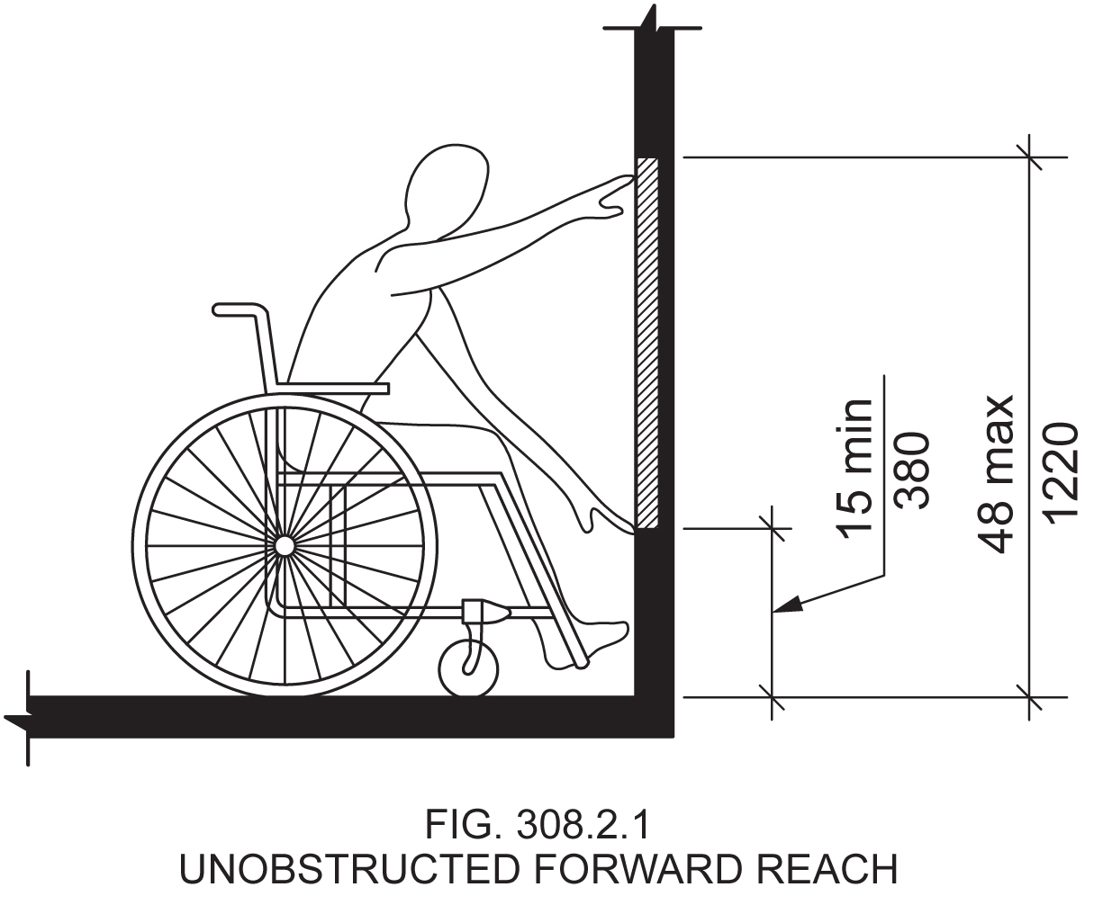

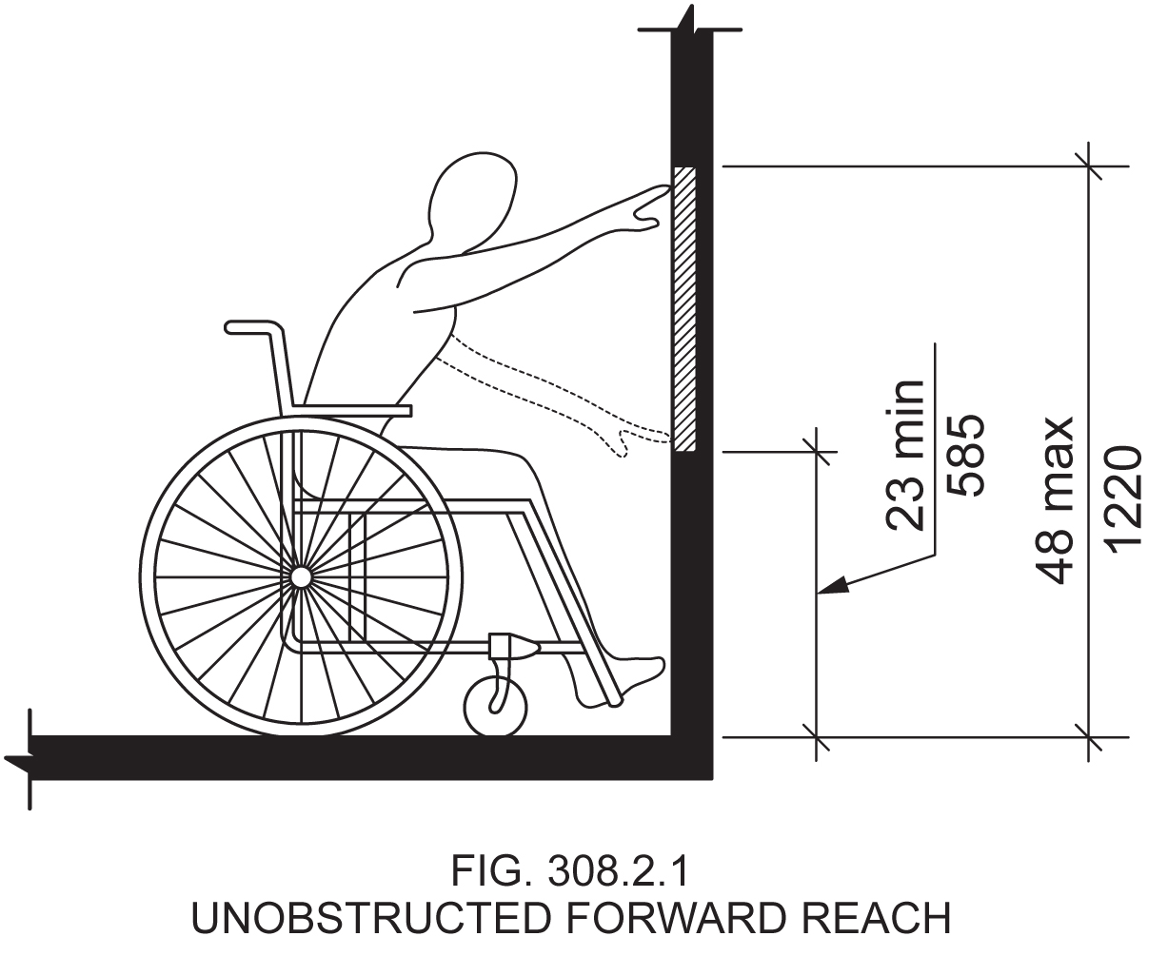

Reason: Many of the technical requirements of the ICC/ANSI A117.1 (2009) Accessible and Usable Buildings and Facilities (ICC/ANSI) designed to accommodate wheeled mobility users are based on research completed from 1974 to 1978 using a research sample that included about 60 individuals who used manual wheelchairs (Steinfeld et al., 1979).
The Center for Inclusive Design and Environmental Access (IDeA) at the University at Buffalo, SUNY recently completed an anthropometric study of 500 wheeled manual and powered mobility device users (Steinfeld, et al., 2010). Measurements of body and device size were captured in three dimensions. The functional anthropometric measurements required measuring reaching ability, grip strength and the minimum space needed for turning. It is the most extensive anthropometric study of wheeled mobility device users in the United States. Additional information about the study can be found at http://www.udeworld.com/ansi-standards-review. The proposed revisions are based on new anthropometric information that was generated from the database of anthropometric measurements developed as part of the study.

Analysis

In order to compare our measurements of maximum forward reach to the reach ranges in the ICC/ANSI A117.1 Standard, we analyzed our data on maximum forward reach using the forward-most point on the occupied wheeled mobility device as the reference point. This provides us an estimate of the percentage of wheeled mobility users that would be able to reach to or beyond the forward-most point, simulating an unobstructed forward reach. The analysis found that:
1) A substantial number of wheeled mobility users (about 15% of manual chair users and 42% of power chair users) did not possess any functional reach capability (defined as reaching and placing an empty canister above shoulder height), and
2) Of the remaining wheeled mobility users in our study that could perform the reach tests a large percentage could not reach beyond the most forward point of their device or foot. These percentages vary at different heights from the floor, and are also different for manual and power chair users. Figure 3-15 (pg. 68) in the Anthropometry of Wheeled Mobility (AWM) report (Steinfeld et al., 2010) summarizes these findings.
One finding of major concern is that in a functional reach task that involved object (canister) placement, none of the wheeled mobility users in our study that had reach capability could safely reach to the lower reach limit of 15” prescribed in the ICC/ANSI A117.1 Standard. To get a better understanding of reach capability at low reaches, we re-analyzed this data at 1-inch increments from the floor (in contrast to the 4 inch increments used in the AWM report). A sub-set of the data at lower reach heights is provided in Table 1 and forms the basis of our recommendation for identifying an alternate lower reach limit. The upper reach limit accommodated most wheeled mobility users that have reach capability, and thus did not require any change.

Table 1: Percentage of manual and power chair users capable of reaching to the forward-most point on the occupied device between the heights of 11”-28” from the floor

Height from the floor | % capable of forward unobstructed reach
Height from the floor | Manual (n=236) | Power (n=110)
27" - 28" | 74 | 52
26" - 27" | 68 | 47
25" - 26" | 68 | 46
24" - 25" | 67 | 45
23" - 24" | 51 | 36
22" - 23" | 28 | 15
21" - 22" | 28 | 14
20" - 21" | 26 | 13
19" - 20" | 15 | 3
18"- 19" | 1 | 0
17" - 18" | 1 | 0
16" - 17" | 0 | 0
15" - 16" | 0 | 0
14" - 15" | 0 | 0
13" - 14" | 0 | 0
12" - 13" | 0 | 0
11" - 12" | 0 | 0

The proportion of manual chair users able to reach to the forward-most point increases dramatically at heights above 23 inches (highlighted in yellow). Power chair users show a smaller but noticeable increase at this height. Hence, we recommend raising the lower limit for the forward reach range from 15 inches to 23 inches. Reaching to heights lower than the recommended are less accommodating and potentially unsafe to wheeled mobility users many of whom have poor postural and trunk control.
The proposed change would help accommodate a substantial number of manual chair users (51%) and a sub-set of power chair users (36%) that possess reach capability to accomplish a forward unobstructed reach at lower heights. Raising the lower reach limit would undoubtedly also benefit standing individuals and more so individuals that have trouble bending or kneeling (e.g. the elderly). Further, there are no constraints or requirements in building construction that require operable parts (e.g. electrical outlets) to be placed as low as 15 inches but not at 23 inches.
NOTE 1: This proposed change is also consistent with our recommendation for raising the lower reach limit for unobstructed side reach included in a separate proposal.
NOTE 2: This change necessitates a revision to Fig. 308.2.1 to ensure consistency. A revised figure is attached.

References (See http://www.udeworld.com/ansi-standards-review)

Steinfeld, E., Paquet, V., D’Souza, C., Joseph, C, and Maisel, J. (2010). Final Report: Anthropometry of Wheeled Mobility Project. Washington, DC: U.S. Access Board.

Steinfeld, E. Schroeder, S. and Bishop, M. (1979). Accessible buildings for people with walking and reaching limitations.Washington, DC: U.S. Department of Housing and Urban Development.
input.doc

Committee Action

Approved

Committee Reason: In contrast to the side reach proposal which the Committee did not accept, change to forward reach was accepted at the Committee meeting. The case made by the proponent and others is that the forward reach is very restricted, especially when considering the range of mobility devices used. Some members remained concerned that this change would significantly reduce access to electrical outlets, shelving, other equipment and would force redesign of rooms and spaces to accommodate a parallel approach.

3-21 – 12
308.2.1, 308.2.2

Proposed Change as Submitted

Proponent: Kim Paarlberg, International Code Council

Revise as follows:

308.2.1 Unobstructed. Where a forward reach is unobstructed, the high forward reach shall be 48 inches (1220 mm) maximum and the low forward reach shall be 15 inches (380 mm) minimum above the floor. For the purpose of this section an unobstructed high reach is permitted over an obstruction where all of the following conditions are met:

- The clear floor space complying with Section 305 shall extend beneath the element for a distance not less than the required reach depth over the obstruction, and
- The reach depth over the obstruction is 20 inches (510mm) maximum.

Where the reach depth exceeds 20 inches (510 mm), the high forward reach shall be considered as obstructed and shall comply with Section 308.2.2.

308.2.2 Obstructed High Reach. Where a high forward reach is over an obstruction, the clear floor space complying with Section 305 shall extend beneath the element for a distance not less than the required reach depth over the obstruction. The high forward reach shall be 48 inches (1220 mm) maximum above the floor where the reach depth is 20 inches (510mm) maximum. Where the reach depth over the obstruction exceeds 20 inches (510 mm), the high forward reach shall be 44 inches (1120 mm) maximum above the floor, and the reach depth shall be 25 inches (635 mm) maximum.

Reason: The quantity of change proposals submitted by International Code Council is reflective of three elements of our work: 1. ICC is the Secretariat for the Standard and some changes reflect inconsistencies or improvements suggested by staff; 2. ICC develops and publishes a Commentary on the standard and writing the commentary illuminates issues of the text and figures; and 3. ICC provides an interpretation service for the standard which results in the observation of provisions the users find most confusing.
The resultant text from this proposal will be as follows:
308.2 Forward Reach.
308.2.1 Unobstructed. Where a forward reach is unobstructed, the high forward reach shall be 48 inches (1220 mm) maximum and the low forward reach shall be 15 inches (380 mm) minimum above the floor. For the purpose of this section an unobstructed high reach is permitted over an obstruction where all of the following conditions are met:
- The clear floor space complying with Section 305 shall extend beneath the element for a distance not less than the required reach depth over the obstruction, and
- The reach depth over the obstruction is 20 inches (510mm) maximum.
Where the reach depth exceeds 20 inches (510 mm), the high forward reach shall be considered as obstructed and shall comply with Section 308.2.2.
308.2.2 Obstructed High Reach. Where a high forward reach is over an obstruction, the clear floor space complying with Section 305 shall extend beneath the element for a distance not less than the required reach depth over the obstruction. Where the reach depth over the obstruction exceeds 20 inches (510 mm), the high forward reach shall be 44 inches (1120 mm) maximum above the floor, and the reach depth shall be 25 inches (635 mm) maximum.

The intent of this proposal is to provide a clear distinction for when the forward reach is allowed a 48 inch reach height and when the reach height must be lowered to 44 inches. Format wise this also correlates with the side reach provisions of Section 308.3 by addressing an unobstructed reach over a limited depth obstruction and an obstructed reach when the depth of the obstruction exceeds that depth.
One portion of the proposal that the committee or an editorial task group may want to look at is the wording in the second sentence of the proposed Section 308.2.1. That sentence is currently proposed as being “For the purpose of this section an unobstructed high reach is permitted over an obstruction where all of the following conditions are met:”. It may be that the word “obstruction” should be revised to “element” so the sentence would read as “For the purpose of this section an unobstructed high reach is permitted over an element where all of the following conditions are met:”.
If the committee is uncertain of this revised format, another option would be to revise the text to create three separate sections that would address Unobstructed (the normal 15 to 48 inch height) Limited Obstruction (the 20 inch reach depth and its requirements) and then the Obstructed High Reach (with the 44 inch height and the 20 to 25 inch depth for the obstruction). I would be happy to provide that alternate if the committee indicates they are interested in reviewing that option during this development cycle.
input.doc
Committee Action

Disapproved

Committee Reason: The Committee was not convinced that the revised text provided clarity over the existing provisions. It was unclear regarding obstructions below a counter.

3-22 – 12
308.3.1, Figure 308.3.1

Proposed Change as Submitted

Proponent: Edward Steinfeld, IDEA Center, School of Architecture and Planning, University at Buffalo, State University of New York

Revise as follows:

308.3.1 Unobstructed. Where a clear floor space complying with Section 305 allows a parallel approach to an element and the edge of the clear floor space is 10 inches (255 mm) maximum from the element, the high side reach shall be 48 inches (1220 mm) maximum and the low side reach shall be 15 23 inches (380 585 mm) minimum above the floor.

EXCEPTION: Existing elements that are not altered shall be permitted at 54 inches (1370 mm) maximum above the floor.

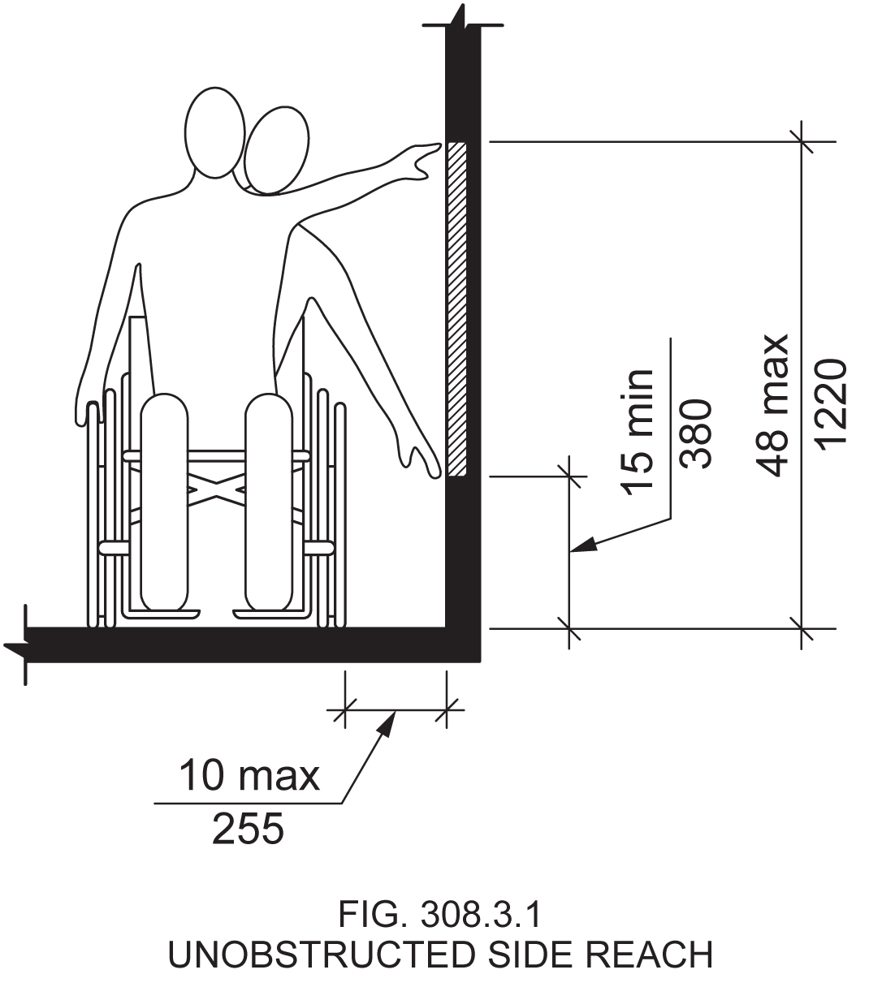

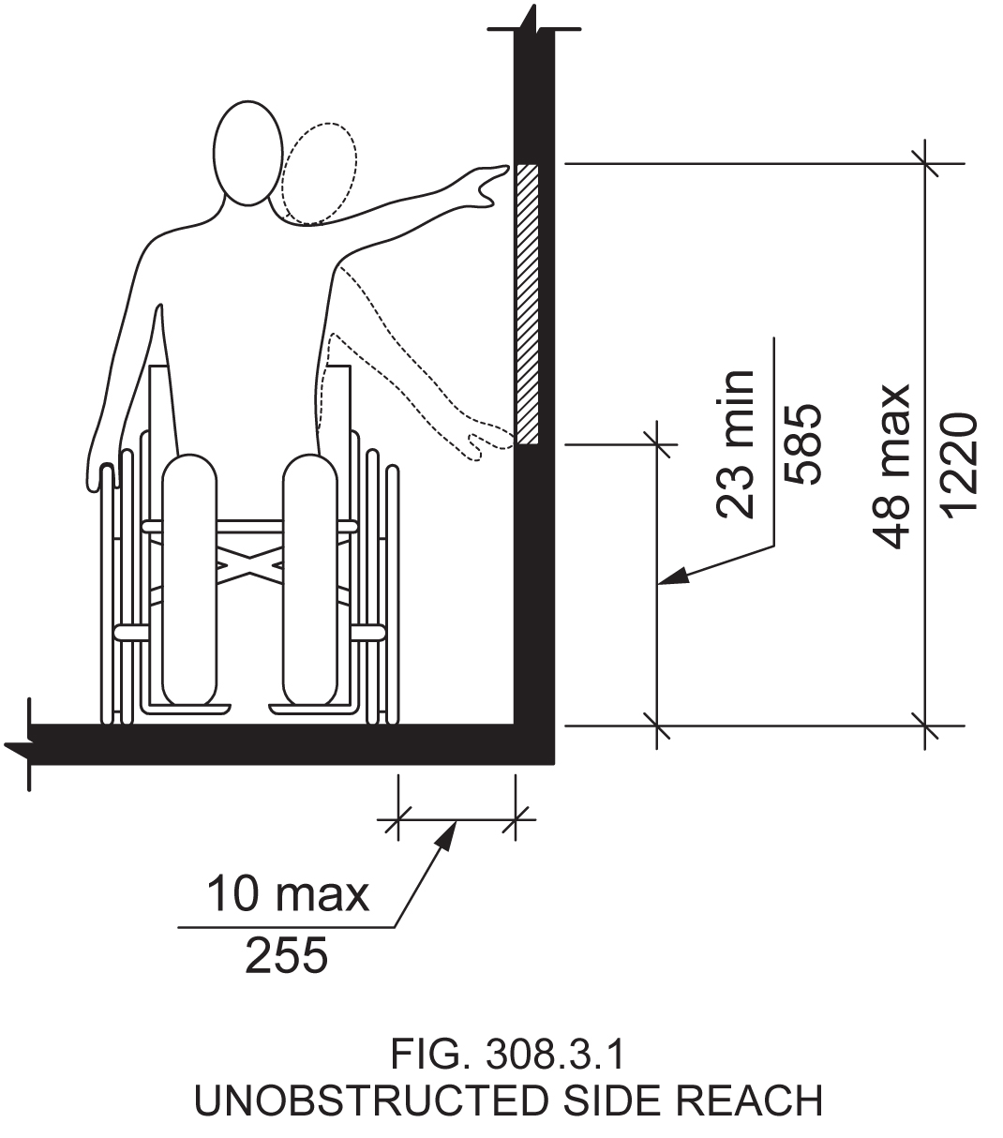

Reason: Many of the technical requirements of the ICC/ANSI A117.1 (2009) Accessible and Usable Buildings and Facilities (ICC/ANSI) designed to accommodate wheeled mobility users are based on research completed from 1974 to 1978 using a research sample that included about 60 individuals who used manual wheelchairs (Steinfeld et al., 1979).

The Center for Inclusive Design and Environmental Access (IDeA) at the University at Buffalo, SUNY recently completed an anthropometric study of 500 wheeled manual and powered mobility device users (Steinfeld, et al., 2010). Measurements of body and device size were captured in three dimensions. The functional anthropometric measurements required measuring reaching ability, grip strength and the minimum space needed for turning. It is the most extensive anthropometric study of wheeled mobility device users in the United States. Additional information about the study can be found at http://www.udeworld.com/ansi-standards-review. The proposed revisions are based on new anthropometric information that was generated from the database of anthropometric measurements developed as part of the study.

Analysis

In order to compare our measurements of maximum side reach to the reach ranges in the ICC/ANSI A117.1 Standard, we analyzed our data on maximum side reach using the lateral-most point on the occupied wheeled mobility device as the reference point. This provides us an estimate of the percentage of wheeled mobility users that would be able to reach to or beyond the lateral-most aspect of the occupied device, simulating an unobstructed side reach. The analysis found that:
1) A substantial number of wheeled mobility users (about 15% of manual chair users and 42% of power chair users) did not possess any functional reach capability (defined as reaching and placing an empty canister above shoulder height), and
2) Side reach access is far more preferable to forward reach access, which is quite restricted among the wheelchair user population. This was also evidenced by the percentages of wheeled mobility users reaching to different heights in a side reach being greater than that for a forward reach. These percentages vary at different heights from the floor, and are also different for manual and power chair users. Figure 3-16 (pg. 69) in the Anthropometry of Wheeled Mobility (AWM) report (Steinfeld, et al., 2010) summarizes these findings.
One finding of concern is that in a functional reach task that involved object (canister) placement none of the wheeled mobility users in our study that had reach capability could safely reach to the lower reach limit of 15” prescribed in the ICC/ANSI A117.1 Standard. To get a better understanding of reach capability at low reaches, we re-analyzed the data on side reach at 1 inch increments from the floor (in contrast to the 4 inch increments used in the AWM report). A sub-set of the results for lower reach heights is provided in Table 1 and forms the basis of our recommendation for identifying an alternate lower reach limit. The upper reach limit accommodated most wheeled mobility users that have reach capability, and thus did not require any change.

Table 1: Percentage of manual and power chair users capable of reaching to or beyond the lateral-most point on the occupied device between the heights of 11”-28” from the floor

Height from the floor | % capable of side unobstructed reach
Height from the floor | Manual (n=236) | Power (n=110)
27" - 28" | 96 | 86
26" - 27" | 86 | 71
25" - 26" | 85 | 71
24" - 25" | 85 | 70
23" - 24" | 68 | 56
22" - 23" | 34 | 21
21" - 22" | 34 | 19
20" - 21" | 34 | 18
19" - 20" | 20 | 8
18"- 19" | 1 | 0
17" - 18" | 1 | 0
16" - 17" | 1 | 0
15" - 16" | 0 | 0
14" - 15" | 0 | 0
13" - 14" | 0 | 0
12" - 13" | 0 | 0
11" - 12" | 0 | 0

The proportion of manual and power chair users able to reach to or beyond the lateral-most point increases dramatically at heights above 23 inches (highlighted in yellow). Hence, we recommend raising the lower limit for the forward reach range from 15 inches to 23 inches. Reaching to heights lower than the recommended are less accommodating and potentially unsafe to wheeled mobility users many of whom have poor postural and trunk control.
The proposed change would help accommodate a substantial number of manual chair users (68%) and power chair users (56%) that possess reach capability to accomplish a forward unobstructed reach at lower heights. Raising the lower reach limit would undoubtedly also benefit standing individuals and more so individuals that have trouble bending or kneeling (e.g. the elderly). Further, there are no constraints or requirements in building construction that require operable parts (e.g. electrical outlets) to be placed as low as 15 inches but not at 23 inches.
NOTE 1 - This proposed change is also consistent with our recommendation for raising the lower reach limit for unobstructed forward reach included in a separate proposal.
NOTE 2: This change necessitates a revision to Fig. 308.3.1 to ensure consistency. A revised figure is attached.

References (See http://www.udeworld.com/ansi-standards-review)

Steinfeld, E., Paquet, V., D’Souza, C., Joseph, C, and Maisel, J. (2010). Final Report: Anthropometry of Wheeled Mobility Project. Washington, DC: U.S. Access Board.

Steinfeld, E. Schroeder, S. and Bishop, M. (1979). Accessible buildings for people with walking and reaching limitations. Washington, DC: U.S. Department of Housing and Urban Development.
input.doc

Committee Action

Disapproved

Committee Reason: Impact of raising the lower side reach would be significant. The information provided was not clear why the existing reach range have been adequate. Why transfer heights in this range have been working.

3-23 – 12
308.3.1

Proposed Change as Submitted

Proponent: Kim Paarlberg, International Code Council

Revise as follows:

308.3.1 Unobstructed. Where a clear floor space complying with Section 305 allows a parallel approach to an element and the edge of the clear floor space is 10 inches (255 mm) maximum from the element, the high side reach shall be 48 inches (1220 mm) maximum and the low side reach shall be 15 inches (380 mm) minimum above the floor.

EXCEPTIONS:

1. Existing elements that are not altered shall be permitted at 54 inches (1370 mm) maximum above the floor.
2. Operable parts on fuel dispensers installed on an existing curbs shall be permitted at 54 inches (1370 mm) maximum above the floor.

Reason: The quantity of change proposals submitted by International Code Council is reflective of three elements of our work: 1. ICC is the Secretariat for the Standard and some changes reflect inconsistencies or improvements suggested by staff; 2. ICC develops and publishes a Commentary on the standard and writing the commentary illuminates issues of the text and figures; and 3. ICC provides an interpretation service for the standard which results in the observation of provisions the users find most confusing.
The proposal is consistent with allowances for gas pumps on existing curbs found in ADA. The amount of work to take out the curb and connections is extensive.
input.doc

Committee Action

Approved

Committee Reason: Provides consistency with the ADA 2010.

3-24 – 12
308.3.1

Proposed Change as Submitted

Proponent: Kim Paarlberg, International Code Council

Revise as follows:

308.3.1 Unobstructed. Where a clear floor space complying with Section 305 allows a parallel approach to an element and the edge of the clear floor space is 10 inches (255 mm) maximum from the element, the high side reach shall be 48 inches (1220 mm) maximum and the low side reach shall be 15 inches (380 mm) minimum above the floor.

EXCEPTIONS:

1. Existing elements that are not altered shall be permitted at 54 inches (1370 mm) maximum above the floor.
2. Mailboxes serving Type B dwelling units shall be permitted at 54 inches (1370 mm) maximum above the floor.

Reason: The quantity of change proposals submitted by International Code Council is reflective of three elements of our work: 1. ICC is the Secretariat for the Standard and some changes reflect inconsistencies or improvements suggested by staff; 2. ICC develops and publishes a Commentary on the standard and writing the commentary illuminates issues of the text and figures; and 3. ICC provides an interpretation service for the standard which results in the observation of provisions the users find most confusing.
There is a code change to the IBC that is adding specific criteria for mailbox scoping. The current proposal is for 50% of the mailboxes required accessible, plus an addition 5% accessible. There has been concern from the post office about providing mailboxes below 29 inches so that the mailmen don’t have to bend over too far. Therefore, in facilities with a large number of mailboxes, the additional reach on the high side is needed.

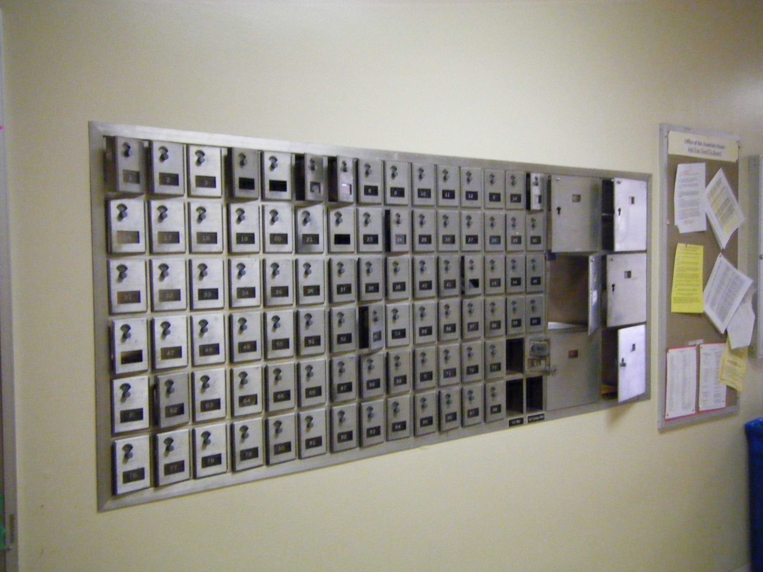

input.doc

Committee Action

Disapproved

Committee Reason: The Committee was concerned that if this exception is included, it could be abused. It could result in few if any Type B dwelling unit mailboxes being accessible to people who are challenged by reach over 48 inches. The Committee was not convinced that the ‘flexibility’ resulting from allowing certain mailboxes to be up to 54 is needed.

3-25 – 12
308.3.1

Proposed Change as Submitted

Proponent: Robert D. Feibleman, HAND Construction Company

Revise as follows:

308.3.1 Unobstructed. Where a clear floor space complying with Section 305 allows a parallel approach to an element and the edge of the clear floor space is 10 inches (255 mm) maximum from the element, the high side reach shall be 48 inches (1220 mm) maximum and the low side reach shall be 15 inches (380 mm) minimum above the floor.

EXCEPTIONS:

- Existing elements that are not altered shall be permitted at 54 inches (1370 mm) maximum above the floor.
- Where an unobstructed side reach is available, thermostats in Type B dwelling and sleeping units shall be permitted at 54 inches.

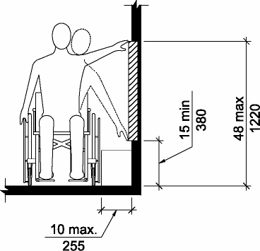

Fig. 308.3.1
Unobstructed Side Reach

Reason: Forty eight inches is too low for people not in wheel chairs. This would match UFAS 4.2.6.
input.doc

Committee Action

Disapproved

Committee Reason: The text does not say that it would be a maximum. The revision would conflict with the Fair Housing Act provisions. The Committee is reluctant to carve out exceptions to the 48 inch reach range maximum.

3-26 – 12
308.3.2, 611.3

Proposed Change as Submitted

Proponent: Kim Paarlberg, International Code Council

Revise as follows:

308.3.2 Obstructed High Reach. Where a clear floor space complying with Section 305 allows a parallel approach to an element and the high side reach is over an obstruction, the height of the obstruction shall be 34 inches (865 mm) maximum above the floor and the depth of the obstruction shall be 24 inches (610 mm) maximum. The high side reach shall be 48 inches (1220 mm) maximum above the floor for a reach depth of 10 inches (255 mm) maximum. Where the reach depth exceeds 10 inches (255 mm), the high side reach shall be 46 inches (1170 mm) maximum above the floor for a reach depth of 24 inches (610 mm) maximum.

EXCEPTION: At washing machines and clothes dryers, the height of the obstruction shall be permitted to be 36 inches (915 mm) maximum above the floor.

611.3 Operable Parts. Operable parts, including doors, lint screens, detergent and bleach compartments, shall comply with Section 309.

EXCEPTION: The height of the obstruction can be 36 inches (915 mm) maximum above the floor.
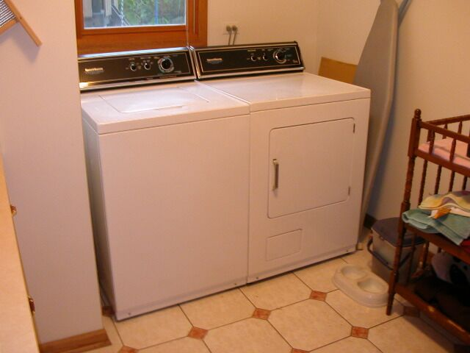

Reason: The quantity of change proposals submitted by International Code Council is reflective of three elements of our work: 1. ICC is the Secretariat for the Standard and some changes reflect inconsistencies or improvements suggested by staff; 2. ICC develops and publishes a Commentary on the standard and writing the commentary illuminates issues of the text and figures; and 3. ICC provides an interpretation service for the standard which results in the observation of provisions the users find most confusing.
Why send the user to Section 309, than 308.3.2 to tell them that the height of the washer and dryer can be 36 inches? Just put it in the provisions for washers and dryers.
input.doc

Committee Action

Disapproved

Committee Reason: Because obstruction is ‘defined’ in Section 308 and not in Section 611.3, moving this text would result in a disconnect between the exception and its charging provision.

3-27 – 12
309.1, 309.4, 309.5 (New), 309.5.1 (New), 309.5.2 (New), 309.5.3 (New),
309.5.4 (New)

Proposed Change as Submitted

Proponent: Kim Paarlberg, International Code Council

Revise as follows:

309.1 General. Operable parts required to be accessible shall comply with Section 309.

EXCEPTIONS:

- Receptacle outlets serving a dedicated use.
- In kitchens, kitchenettes, toilet and bathing facilities, receptacle outlets and switches shall comply with Section 309.5.
- Floor receptacle outlets.
- HVAC diffusers.
- Controls mounted on ceiling fans.
- Where redundant controls other than light switches are provided for a single element, one control in each space shall not be required to be accessible.
- Reset buttons and shut-offs serving appliances, piping and plumbing fixtures.
- Gas pump nozzles shall not be required to provide operable parts that have an activating force of 5.0 pounds (22.2 N) maximum in accordance with Section 309.4.
- Equipment for emergency responders.

309.4 Operation. Operable parts shall be operable with one hand and shall not require tight grasping, pinching, or twisting of the wrist. The force required to activate operable parts shall be 5.0 pounds (22.2 N) maximum.

EXCEPTION: Gas pump nozzles shall not be required to provide operable parts that have an activating force of 5.0 pounds (22.2 N) maximum.

309.5 Receptacle outlets and switches in kitchens, kitchenettes and toilet and bathing facilities. Receptacle outlets and switches in toilet and bathing facilities complying with Section 603 and kitchens shall be provided as specified in Sections 309.5.1 through 309.5.4. Outlets and switches in toilet and bathing facilities no complying with Section 603 and kitchenettes shall be provided as specified in Sections 309.5.3 and 309.5.4.

309.5.1 Receptacle outlets required in kitchens. In kitchens, receptacle outlets must be provided at the following locations:

1. A receptacle outlet must be provided over the accessible work surface and comply with Section 308.2.2 (forward obstructed reach range).
2. A receptacle outlet must be provided on one side of the accessible sink less than 12 inches horizontally from the inside face of the sink bowl and 44 inches maximum above the floor level. Receptacle outlets are permitted to be located over adjacent counters or cabinets that are 36 inches (915 mm) maximum.

309.5.2 Receptacle outlets required in toilet and bathing facilities. In toilet and bathing facilities complying with Section 603, an outlet shall be provided on one side of the accessible lavatory less than 12 inches horizontally from the inside face of the lavatory bowl.

309.5.3 Other receptacle outlets. In kitchens, kitchenettes and toilet and bathing facilities, receptacle outlets shall be provided in accordance with the electrical code. Where outlets are provided over counter tops 18 inches or greater in length, at least one outlet per counter length shall be located a minimum of 12 inches horizontally from a cabinet return, perpendicular wall or refrigerator. Receptacle outlets are permitted to be located over cabinets with counter tops 36 inches (915 mm) maximum in height and 25 ¹/₂ inches (650 mm) maximum in depth.

Exception: Receptacle outlets within 36 inches horizontally from an inside corner at intersecting counter top runs are not required to comply with this section.

309.5.4 Switches. In kitchens, kitchenettes, and bathing and toilet facilities switches shall comply with the following as applicable:

- Light switches are permitted to be located over cabinets or counter tops 36 inches (915 mm) maximum in height where the reach depth is 10 inches or less.
- Switches for lights and for control of garbage disposals are permitted to be located in the same area as the receptacle outlets in Section 309.5.1 Item 2.
- Redundant controls for range hoods shall be provided over the accessible work surface adjacent to the range, or adjacent to cooktops provide with front approach at a location where access to controls does not require reaching across burners.

Reason: The quantity of change proposals submitted by International Code Council is reflective of three elements of our work: 1. ICC is the Secretariat for the Standard and some changes reflect inconsistencies or improvements suggested by staff; 2. ICC develops and publishes a Commentary on the standard and writing the commentary illuminates issues of the text and figures; and 3. ICC provides an interpretation service for the standard which results in the observation of provisions the users find most confusing.
The intent of this proposal is to pick up on the same idea for outlets and switches in public kitchens and bathrooms as what is found in the dwelling unit. Literally these areas are sent back to the general operable parts provisions in Section 309.
There is also the idea of providing the same logical exceptions for general spaces as found in dwelling units. The circuit breaker box is not included since this is currently located in areas accessed only be service personnel (which is exempted). There is an added exception for emergency equipment such as call and Knox boxes, fire hoses, hood extinguishers, etc.
Regarding the outlets and switches:
Kitchens, 804.5.2 and 1003.12.4.1 deals with appliance controls, but not the outlets or wall switches. The decision was rather than to go through an extensive exception list, the better approach would be where do we want outlets so they can be reached. There are four plans attached with examples.
The intent is to work with the electrical code, and at the same time place outlets where they would be the most accessible.
In Accessible and Type A kitchens, an outlet would be required at the work surface and immediately adjacent to the sink. The immediately adjacent is so that the electrical cord would not fall into the water and cause a safety hazard. Switches for lights over the sink and the garbage disposal are permitted in the same area.
In Accessible and Type A bathrooms, an outlet would be required adjacent to the accessible lavatory.
For all kitchens, kitchenettes and bathrooms (Accessible, Type A and Type B), an outlet would be located so that they would fall in the best reach area. In order to allow this, you do not ask for compliance with outlets over less than 18” lengths of counter or in dead corners. See the attached graphics for application.
For Accessible and Type A units, switches are permitted
1) on the side wall over a standard counter if the reach was less than 10 inches
2) next to the sink
3) over the accessible work surface
In Type B units, the switch can be over a standard counter. Since switches tend to be next to doors or the sink where it might be confined, it was decided not to ask for distance from obstructions.
Is there an interest in allowing for outlets or switches to be provided under the upper cabinets? This would typically be 54 inches high and 15-18 inches deep.
input.doc

Committee Action

Disapproved

Committee Reason: Consistent with the action to disapproved proposal 10-7-12

3-28 – 12
309.2

Proposed Change as Submitted

Proponent: Edward Steinfeld, IDEA Center, School of Architecture and Planning, University at Buffalo, State University of New York

Revise as follows:

309.2 Clear Floor Space. A clear floor space complying with Section 305, positioned for a parallel approach, shall be provided at a minimum, unless otherwise specified.

Reason: Many of the technical requirements of the ICC/ANSI A117.1 (2009) Accessible and Usable Buildings and Facilities (ICC/ANSI) designed to accommodate wheeled mobility users are based on research completed from 1974 to 1978 using a research sample that included about 60 individuals who used manual wheelchairs (Steinfeld et al., 1979).
The Center for Inclusive Design and Environmental Access (IDeA) at the University at Buffalo, SUNY recently completed an anthropometric study of 500 wheeled manual and powered mobility device users (Steinfeld, et al., 2010). Measurements of body and device size were captured in three dimensions. The functional anthropometric measurements required measuring reaching ability, grip strength and the minimum space needed for turning. It is the most extensive anthropometric study of wheeled mobility device users in the United States. Additional information about the study can be found at http://www.udeworld.com/ansi-standards-review. The proposed revisions are based on new anthropometric information that was generated from the database of anthropometric measurements developed as part of the study.

Analysis

Unlike turning spaces that are based on dynamic requirements, clear floor space represents the space required for a stationary wheeled mobility device. This area is typically depicted as a rectangular space the dimensions of which are based on measurements of occupied length and occupied breadth of wheeled mobility devices, which are defined as follows:
- Occupied length: measured as the horizontal distance between the forward-most point and the rear-most point on the wheelchair or occupant.
- Occupied width: measured as the horizontal distance between the side-most points of the wheelchair or participant on the right and left sides.
Furthermore, clear floor space dimensions for reaching are different from seating because they require a specific orientation to the target. This type of clear floor space should be used for tasks that involve reaching or grasping to adjacent design elements such as sink faucets, door handles, wall outlets, and other wall-mounted elements. Further, they can be applied to the operation of automated teller machines, information kiosks, where there is a need for allowing flexibility in use by people that are right or left hand dominant, as well as taking into account how an individual will be oriented when reaching and seek to optimize the range of reach i.e., forward vs. sideways reach. Our data suggest that only 50% of wheeled mobility device users can reach beyond the forward most boundary of their wheeled mobility device or foot, and therefore providing accommodations for lateral reach is critical for tasks involving operable parts.
The ICC/ANSI A117.1 (2009) Accessible and Usable Buildings and Facilities (ICC/ANSI) prescribes minimum dimensions for a ‘generic’ clear floor area space to accommodate wheeled mobility users, but does not take into account task demands (e.g., reaching, grasping) or any variation in how users may accomplish the task. The minimum required clear floor area prescribed is 30 inches wide by 48 inches long.
We have taken the position that the clear floor space standards should accommodate the occupied lengths and widths of at least 90% of manual and powered wheeled mobility device users. A length of 54” accommodates the occupied lengths of 95% of manual chair users, and 90th%tile values of length and width for the power chair and scooter users. A width of 32” accommodates the occupied widths of over 95% of manual wheeled mobility device users and 90% of the powered wheeled mobility device users. We propose that tasks involving operable parts require a minimum clear floor space that is 54” wide by 32” deep. We propose clearances that allow for a side (parallel) approach to all operable parts at a minimum, and recommend additionally providing a forward approach for use by those who are capable of operating parts with such an approach. Such a recommendation would therefore result in a “T” shape clearance having the recommended dimensions that we propose for section 305 of the standard. We added, “unless otherwise specified,” to account for the few circumstances, such as water fountains and lavatories, where a forward approach is more accommodating.
These calculations provided are based on the three-dimensional database of wheeled mobility device user dimensions developed by the IDEA Center for the Anthropometry of Wheeled Mobility Project. The analysis was summarized in the Final Project Report to the U.S. Access Board and in a memorandum entitled “Evaluation of Clear Floor Space Requirements,” that was submitted to the ICC/ANSI A117 Task Force on Anthropometry of Wheeled Mobility Subcommittee on Clear Floor Space Clearances.

References (See http://www.udeworld.com/ansi-standards-review)

Paquet, V. (2012). Evaluation of Clear Floor Space Requirements. A memorandum submitted to the ICC/ANSI A117 Task Force on Anthropometry of Wheeled Mobility Subcommittee on Clear Floor Space Clearances.

Steinfeld, E., Paquet, V., D’Souza, C., Joseph, C, and Maisel, J. (2010). Final Report: Anthropometry of Wheeled Mobility Project. Washington, DC: U.S. Access Board.

Steinfeld, E. Schroeder, S. and Bishop, M. (1979). Accessible buildings for people with walking and reaching limitations. Washington, DC: U.S. Department of Housing and Urban Development.
input.doc

Committee Action

Disapproved

Committee Reason: The proposal would set up a preference in the Standard for a parallel approach to any operable part. The Committee found that this would be a bad format for the Standard, requiring a review of operable parts throughout the Standard and require revision or restatement. Two examples raised is doors and elevators. The text may directly conflict with Section 305.

3-29 – 12
309.3, 309.4 (New)

Proposed Change as Submitted

Proponent: Hale Zukas, representing World Institute on Disability

Revise as follows:

309.3 Height. Operable parts shall be placed within one or more of the reach ranges specified in Section 308
309.4 Horizontal Placement. Operable parts shall be placed 24 inches (610 mm) minimum from adjacent inside corners.

EXCEPTIONS:

- Elevator control panels shall not be required to comply with Section 309.4.
- In alcoves whose width is less than 48 inches, operable parts shall be located on the centerline of the alcove width.

309.4 309.5 Operation. (No change in text.)

Reason: 1. One recommendation in the IDeA study is that “Standards developers should consider requiring either side reach access to all targets within the scope of standards or limiting front reach to locations where knee clearance is provided beyond the plane on which the target is located.” The purpose of this proposal is o implement this recommendation by a) requiring a side approach to almost all operable parts, and b) requiring that operable parts be located on the centerline of the associated clear floor space in order to accommodate the varying reaching abilities of as many wmd users as possible
2. The words “or more” in existing Section 309.3 are superfluous.
input.doc

Committee Action

Disapproved

Committee Reason: The Committee found the proposal unclear. Was it intended to just apply to alcoves at doorways, or any alcove? The term ‘inside corner’ is unclear. The impact on toilet rooms and water closet compartments could be significant.

3-30 – 12
309.4

Proposed Change as Submitted

Proponent: Gene Boecker, Code Consultants, Inc

Revise as follows:
309.4 Operation. Operable parts shall be operable with one hand and shall not require tight grasping,
pinching, or twisting of the wrist. The force required to activate operable parts shall be 5.0 pounds (22.2 N) maximum.

EXCEPTIONS:

- Gas pump nozzles shall not be required to provide operable parts that have an
activating force of 5.0 pounds (22.2 N) maximum.
2. Fire rated opening protectives shall have the minimum opening force allowed by the appropriate administrative authority. These forces do not apply to the force required to retract bolts or disengage other devices that hold the door or chute in a closed position.

Reason: Laundry chutes, trash chutes, and other rated openings may require a force greater than 5.0 pounds (22.2 N) maximum to remain in a closed position, especially in high rise buildings. The exception uses the same language of door opening force for fire doors in Section 404.2.8. However, because these access openings are not passage doors, they do not fall into the overview of Section 404 and require attention in another section of the standard. This Section is the appropriate location.
The last sentence is open for discussion. While access to these elements is important, it remains to be seen if the hardware is capable of the desired operation and also meet the required safety features. For example, it may be not possible to design the hardware on the trash chute to operate at 5 pounds force maximum due to the need for a tight fit when the chute is closed. If the provision is included here that requires the bolt retraction/disengagement to be subject to this force can it be achieved by the time the standard would be adopted and enforced?
input.doc

Committee Action

Disapproved

Committee Reason: The Committee found that text too broad in its application. The reason statement implies a much more limited proposal.

3-31 – 12
309.4.1 (New)

Proposed Change as Submitted

Proponent: Hope Reed, New Mexico Governor’s Commission on Disability (NMGCD)

Add new text as follows:

309.4.1 Card Key Operation. Card keys shall slide horizontally.

Reason: Add new section to make hotel card keys easier to use. Accessible card keys need to slide horizontally to allow gravity to work with them and allow the card key to fall into your open hand or on your lap. The vertical card keys are far more difficult to pinch and at the same time pull up, then rotate to place it in your other hand or on your lap before you lose your grip.
input.doc

Committee Action

Disapproved

Committee Reason: The proposal controls the action of the card key versus stating that the card key reader shall accommodate a horizontal slide of the card keys. The Committee also expressed concern that many readers are becoming proximity readers and requiring a specific motion may be outdated. No evidence was provided justifying that the horizontal motion is appropriate for the range of disabilities.

