COMMITTEE ACTION REPORT
UNRESOLVED ISSUES (Report of January 3, 2014)

This report contains the preliminary actions of the ASC/ICC A117.1 Committee regarding Unresolved Issues raised by proponents of changes.

AUGUST 21, 2014

ASC/ICC A117.1 STANDARD
DEVELOPMENT - 2015 EDITION*

The preliminary actions contained in this report will be subject to written ballot of the Committee members. Based on the ballots received, the actions will be finalized.

Considered by the A117.1 Committee
January 21 – 24, 2014 and July 14 -16, 2014
U.S. Access Board Conference Room
Washington, DC.

Unresolved Issue - 3-5 – 12

Ed Roether, Chair of Harmonization Task Group, proponent, asks for further consideration of Proposal 3-5-12.

Reason: Many valid points and concerns were raised during the ballot stage, but based upon the committee’s action, comment 3-5 is unresolved. Potentially, some items in the proposal may be unresolvable. But, in an effort to reach a consensus please consider the following comments:
The proposed change to 304.2 is consistent with the ADA Advisory to 304.2 and therefore harmonizes with the 2010 ADA Standards. It is recognized that the ANSI Standards can exceed ADA, but please understand that many floor surfaces are incapable of providing a pure planar surface. If ANSI’s intent is for a pure planar surface then the Standard would prohibit some floor surfaces even though many members of the committee would consider many of those “non-compliant” floor surfaces acceptable. The ANSI Standard does not include the clarifying language regarding its intent that is found in the ADA Standards where it states: “changes in level refers to surfaces with slopes and to surfaces with abrupt rise exceeding that permitted in Section 303.3”.

The proposed change to 305.2, 404.2.3.1, 405.7.1, 502.5, 503.4 & 802.2 is intended for harmonization with the 2010 ADA Standards based upon the ADA Advisory to 304.2 statement that the phrase “changes in level refers to surfaces with slopes and to surfaces with abrupt rise exceeding that permitted in Section 303.3. Such changes in level are prohibited in required clear floor and ground spaces, turning spaces, and in similar spaces where people using wheelchairs and other mobility devices must park their mobility aids such as in wheelchair spaces, or maneuver to use elements such as at doors, fixtures, and telephones.”

If the committee cannot accept the limits of 303.3 then the question to be answered is what limits would be acceptable for 304.2, 305.2, 404.2.3.1, 405.7.1, 502.5, 503.4 & 802? This proposed change was to harmonize with the 2010 ADA Standards. A pure planar surface for each of these conditions is unrealistic considering construction materials currently available. Developing limits that are attainable would better assure that each of these conditions could be constructed in compliance with the committee’s intent. This comment will be unresolved until the committee’s intent is clarified.

The remaining proposed changes account for where the term “changes in level” occurred within the standards. However, 504.4 address conditions where people using wheelchairs and other similar mobility devices would not park or maneuver. Even though other mobility aids would use the tread surface, this may not truly be a harmonization issue. It should receive similar consideration regarding the committee’s intent, but for this comment the proposed change to 504.4 in 3-5 is withdrawn. Similarly, the committee’s action to 405.4 is accepted and harmonizes with the 2010 ADA Standards, so a proposed change to 405.4 in 3-5 is not included with this comment.

304 Turning Space

304.2 Floor Surface. Floor surfaces of a turning space shall have a slope not steeper than 1:48 and shall comply with Section 302. Changes in level exceeding that permitted by Section 303.3 are not permitted within the turning space.

EXCEPTION: Slopes not steeper than 1:48 shall be permitted.

305 Clear Floor or Ground Space

305.2 Floor Surfaces. Floor surfaces of a clear floor space shall have a slope not steeper than 1:48 and shall comply with Section 302. Changes in level exceeding that permitted by Section 303.3 are not permitted within the clear floor space.

EXCEPTION: Slopes not steeper than 1:48 shall be permitted.

404.2 Manual doors

404.2.3.1 Floor Surface. Floor surface within the maneuvering clearances shall have a slope not steeper than 1:48 and shall comply with Section 302. Changes in level exceeding that permitted by Section 303.3 are not permitted within the maneuvering clearances.

405 Ramps

405.7.1 Slope. Landings shall have a slope not steeper than 1:48 and shall comply with Section 302. Changes in level exceeding that permitted by Section 303.3 are not permitted within the landings.

502 Parking spaces

502.5 Floor Surfaces. Parking spaces and access aisles shall comply with Section 302 and have surface slopes not steeper than 1:48. Access aisles shall be at the same level as the parking spaces they serve. Changes in level exceeding that permitted by Section 303.3 are not permitted within the parking spaces and access aisles.

503 Passenger loading zones

503.4 Floor Surfaces. Vehicle pull–up spaces and access aisles serving them shall comply with Section 302 and shall have slopes not steeper than 1:48. Access aisles shall be at the same level as the vehicle pull–up space they serve. Changes in level exceeding that permitted by Section 303.3 are not permitted within the vehicle pull-up spaces and access aisles.

802 Wheelchair spaces

802.2 Floor Surfaces. The floor surface of wheelchair space locations shall have a slope not steeper than 1:48 and shall comply with Section 302. Changes in level exceeding that permitted by Section 303.3 are not permitted within the floor surface of wheelchair space locations.

Committee action on 3-5-12 Unresolved Issue

Approve Item 3-5-12 as requested above.

Reason: The seven changes reflect the essential pieces of the original 3-5-12 proposal which are essential for coordination with the 2010 ADA.

Unresolved Issue - 4-33– 12

Joseph Hetzel, proponent, asks for further consideration of Proposal 4-33-12.

We request that Proposal 4-33-12, which was originally disapproved, be approved as modified using Public Comment 4-33.2 and as further modified by the following editorial changes:

404.3 Automatic Doors. Automatic doors and automatic gates shall comply with Section 404.3. Full powered automatic doors shall comply with ANSI/BHMA A156.10 listed in Section 105.2.4. Power-assist and low-energy doors shall comply with ANSI/BHMA A156.19 listed in Section 105.2.3.

EXCEPTION: Doors, doorways, and gates designed to be operated only by security personnel shall not be required to comply with Sections 404.3.2, 404.3.4 and 404.3.5.

Where more than two doors are located at an accessible route entrance to a building or facility, other than dwelling units and sleeping units, at least one door shall be an automatic door. Where an accessible route entrance has a vestibule with more than two exterior entrance doors and more than two interior entrance doors, at least one exterior automatic door and one interior automatic door shall be provided.

Reason: The Committee supports the principle that automatic doors enhance accessibility. To fulfill that principle, the standard needs clear threshold based requirements for specifying automatic doors in locations involving higher public traffic areas.

We believe the Committee should be working toward approving a proposal that satisfies the “automatic doors enhance accessibility” principle. Therefore, we believe Committee disapproval of our comment 4-33.2 is insufficient toward that goal. Our response to the Committee reasoning is as follows:

Committee point #1: The proposed text was found to be vague. It is unclear what is intended by ‘accessible doors’?
AAADM response: The proposal intends to address building/facility entrance situations involving more than two doors in an "accessible route", a term used throughout A117.1 including the Chapter 4 title. Therefore, we have made editorial changes accordingly. Our editorial changes result in the proposed text being clear and not vague.

Committee point #2: Is it clear that across a vestibule that these automatic doors should line up?
AAADM response: A Committee member actually pointed out that doors do not always line up in a vestibule. Exterior doors may be side entrances at a 90 degree angle to interior entrances. Therefore, this Committee point should not be a reason to disapprove the proposal.

Committee point #3: The proposal seemed to make what had been an exception in the original proposal, a requirement.
AAADM response: The originally submitted proposal is a requirement along with two Exceptions to that requirement.

Therefore, we request that the Committee reconsider their action on comment 4-33.2, and approve new language in Section 404.3 supporting accessibility enhancement through automatic doors.

Committee action on 4-33-12 Unresolved Issue

Approve Proposal 4-33-12 with modifications: The modification is a substitute proposal for the original submittal:

Modification – Add new section as follows:

404.3.1 Public Entrances. Where an automatic door is required at a building or facility public entrance, it shall be a full powered automatic door or a low-energy door. Where the entrance includes a vestibule that has exterior and interior entrance doors, at least one exterior door and one interior door in the vestibule shall be either a full powered automatic door or a low-energy door.

Reason: The Committee via this proposal has been exploring how to make automatic doors essential to building entrances in an accessible route. This approved proposal is intended to be of a technical origin. If an automatic door is specified for an application, full powered automatic doors and low-energy doors hold a distinct advantage over power-assist doors from an accessibility standpoint, because they require no intended effort on the part of the door user to access the building or facility. This results in access for a much wider range of people with disabilities.
Clarification is needed regarding automatic doors used in vestibules. The proposed vestibule language is from GSA Facilities Standard P100. Both doors need to be either full powered or low-energy to support the concept of getting people completely inside a building or facility.

Unresolved Issue 5-11– 12
David W. Cooper, proponents asks for further consideration of Proposal 5-11-12.

Reason: The committee needs to reconsider the intent of this proposal modified and approved at the July meeting. It has been misunderstood and is a needed proposal. Figure one provides a graphic explanation to clarify the limits and provides a comparison to what is allowed in other codes mentioned in prior comments.

504.5 Nosings. Nosings shall be curved or beveled. The radius of curvature at the leading edge of the tread shall be not exceed the limit described by a ½ inch (13 mm) radius maximum. A bevel shall not exceed the limit described by a plane that is tangent to a ½ inch (13 mm) radius of curvature at the leading edge of the upper surface of treads. Nosings that project beyond risers shall have the underside of the leading edge curved or beveled. Risers shall be permitted to slope under the tread at an angle of 30 degrees maximum from vertical. The permitted projection of the nosing shall be 1 ½ inches (38 mm) maximum over the tread or floor below.

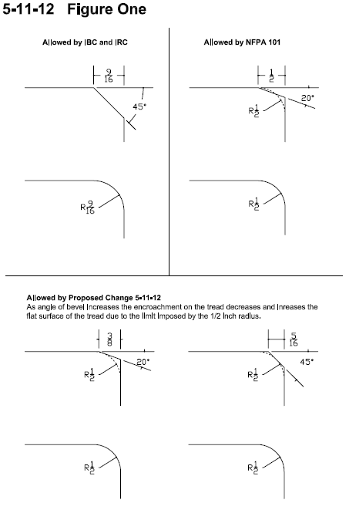

The following figure 2 shows a section through the tread at the nosing and upper surface of the tread. The “limiting plane” is described as a red line. In each example the “limiting plane” is shown tangent to different points on the ½ inch (13mm) radius of curvature.

FIGURE 2 for Issue 5-11-12
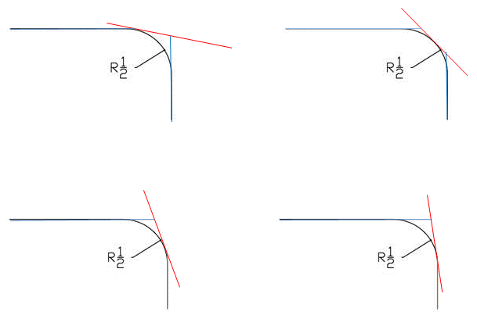
Committee action on 5-11-12 Unresolved Issue

Approve with modifications – Proposal 5-11-12

Modification:

504.5 Nosings. Rounding or beveling at the leading edge of the tread shall not exceed the limit of a ½ inch (13 mm) radius. Nosings that project beyond risers shall have the underside of the leading edge curved or beveled. Risers shall be permitted to slope under the tread at an angle of 30 degrees maximum from vertical. The permitted projection of the nosing shall be 1 ½ inches (38 mm) maximum over the tread or floor below.

504.5 Nosings. Nosings shall comply with 504.5.1 through 504.6.3.

504.5.1 Nosings within a stairway shall be uniform.

504.5.2 If rounded, the radius of curvature at the leading edge shall be 1/2 inch (13 mm) maximum.

504.5.3 If beveled, the bevel shall slope at 45 degrees to the plane of the top surface of the tread and landing and extend for a horizontal distance of 1/2 inch (13 mm) maximum.

504.5.4 Nosings that project beyond the risers shall have the underside of the leading edge curved or beveled.

504.5.5 Risers shall be permitted to slope under the tread at an angle of 30 degrees maximum from vertical. The permitted projection of the nosing shall be 1 1/2 inches (38 mm) maximum over the tread or floor below.

Reason: The Committee approved 5-11-12 to have Section 504.5 read as indicated by the paragraph, above, which is struck through. Upon reconsideration, the Committee revised the section to provide clear requirements in a clear format. Stairway nosings are a critical element of stairway design and must work. There has been considerable Committee debate on the issue. The above revision was believed to be the best reflection of the needed standards and should be included in the Second Public Review Draft and available for public comment.

Staff note: The Section 504.6.3 referred to in the charging provision refers to sections contained in 5-13-12 Approved as modified.

Unresolved Issue 6-1– 12

Kim Paarlberg, proponent, asks for further consideration of Proposal 6-1-12.

There are two concerns, so I would like to split the question.

Question 1:

602.1 General. Wheelchair accessible drinking fountains shall comply with Sections 602.2 and 307.

Drinking fountains for standing persons shall comply with Section 602.3 and 307.

602.2 Wheelchair accessible drinking fountains. Wheelchair accessible drinking fountains shall comply with Section 602.2.1 through 602.2.5.

602.2 602.2.1 Clear Floor Space. A clear floor space complying with Section 305, positioned for a forward approach to the drinking fountain, shall be provided. Knee and toe space complying with Section 306 shall be provided. The clear floor space shall be centered on the drinking fountain.
EXCEPTIONS:
1. Drinking fountains for standing persons.
2. Drinking fountains primarily for children’s use shall be permitted where the spout outlet is 30 inches (760 mm) maximum above the floor, a parallel approach complying with Section 305 is provided and the clear floor space is centered on the drinking fountain.

602.2.2 602.3 Operable Parts. Operable parts shall comply with Section 309.

602.2.3 602.4 Spout Outlet Height. Spout outlets of wheelchair accessible drinking fountains shall be 36 inches (915 mm) maximum above the floor. Spout outlets of drinking fountains for standing persons shall be 38 inches (965 mm) minimum and 43 inches (1090 mm) maximum above the floor.

EXCEPTION: At drinking fountains primarily for children’s use, the spout outlet shall be 30 inches (760 mm) maximum above the floor.

606.2.4 602.5 Spout Location. The spout shall be located 15 inches (380 mm) minimum from the vertical support and 5 inches (125 mm) maximum from the front edge of the drinking fountain, including bumpers.

EXCEPTION: Where only a parallel approach is provided At drinking fountains primarily for children’s use, the spout shall be located 3¹/2 inches (89 mm) maximum from the front edge of the drinking fountain, including bumpers.

606.2.5 602.6 Water Flow. The spout shall provide a flow of water 4 inches (102 mm) minimum in height. The angle of the water stream from spouts within 3 inches (76 mm) of the front of the drinking fountain shall be 30 degrees maximum, and from spouts between 3 inches (76 mm) and 5 inches (125 mm) from the front of the drinking fountain shall be 15 degrees maximum, measured horizontally relative to the front face of the drinking fountain.

602.3 Drinking fountains for standing persons. Drinking fountains for standing persons shall comply with Section 602.3.1 through 602.3.4.

602.3.1 Operable Parts. Operable parts shall comply with Section 309.3 and 309.4.

602.3.2 Spout Outlet Height. Spout outlets of drinking fountains for standing persons shall be 38 inches (965 mm) minimum and 43 inches (1090 mm) maximum above the floor.

602.3.3 Spout location. The spout shall be located 5 inches (125 mm) maximum from the front edge of the drinking fountain, including bumpers.

602.3.4 Water Flow. The spout shall provide a flow of water 4 inches (102 mm) minimum in height. The angle of the water stream from spouts within 3 inches (76 mm) of the front of the drinking fountain shall be 30 degrees maximum, and from spouts between 3 inches (76 mm) and 5 inches (125 mm) from the front of the drinking fountain shall be 15 degrees maximum, measured horizontally relative to the front face of the drinking fountain.

Reason: The purpose is to reorganize the drinking fountain section to clearly differentiate between the requirements for wheelchair and standing drinking fountains. Since these are separate drinking fountains, they requirements for each need to be clear.
Since side approach is now only allowed for children (and is no longer permitted as an option for existing), that can also be clarified and made consistent. The current height for the spout outlet for children is listed as an exception under clear floor space. The revised text would deal with children’s drinking fountains in the same manner under clear floor space, spout outlet, and spout location.

Question 2:

602.1 General. Accessible drinking fountains shall comply with Sections 602 and 307.

602.2 Clear Floor Space. A clear floor space complying with Section 305, positioned for a forward approach to the drinking fountain, shall be provided. Knee and toe space complying with Section 306 shall be provided. The clear floor space shall be centered on the drinking fountain.

EXCEPTIONS:
- Drinking fountains for standing persons.
- Wheelchair accessible drinking fountains primarily for children’s use shall be permitted where the spout outlet is 30 inches (760 mm) maximum above the floor, a parallel approach complying with Section 305 is provided and the clear floor space is centered on the drinking fountain.

602.3 Operable Parts. Operable parts shall comply with Section 309.

602.4 Spout Outlet Height. Spout outlets of wheelchair accessible drinking fountains shall be 36 inches (915 mm) maximum above the floor. Spout outlets of drinking fountains for standing persons shall be 38 inches (965 mm) minimum and 43 inches (1090 mm) maximum above the floor.

EXCEPTION: Drinking fountains for standing persons and primarily for children’s use shall be permitted where the spout outlet is 30 inches (760 mm) minimum and 43 inches (1090 mm) maximum above the floor.

602.5 Spout Location. The spout shall be located 15 inches (380 mm) minimum from the vertical support and 5 inches (125mm) maximum from the front edge of the drinking fountain, including bumpers. Where only a parallel approach is provided, the spout shall be located 3¹/₂ inches (90 mm) maximum from the front edge of the drinking fountain, including bumpers.

602.6 Water Flow. The spout shall provide a flow of water 4 inches (100 mm) minimum in height. The angle of the water stream from spouts within 3 inches (75 mm) of the front of the drinking fountain shall be 30 degrees maximum, and from spouts between 3 inches (75 mm) and 5 inches (125 mm) from the front of the drinking fountain shall be 15 degrees maximum, measured horizontally relative to the front face of the drinking fountain.

Reason: The current text only allows for designing for children at the wheelchair drinking fountains. In facilities such as day care and primary schools, all the drinking fountains within certain areas are designed for the children. The drinking fountains (and bathrooms) for all teachers are in a different location. The exception would allow for both drinking fountains serving children to be designed for kids. If the drinking fountains serve adults, they cannot use this option for either the standing or wheelchair fountains. If this is not allowed, the children are too short to use the standing drinking fountain, so current text are discriminatory towards their height limits.

Committee action on 6-1-12 Unresolved Issue

Approve Proposal 6-1-12 as reflected in Questions 1 and 2, above.

Reason: The proposal clarifies the standard by organizing the drinking fountain section so that there are distinct sections for wheelchair accessible drinking fountains and standing fountains. Also clarified is the interaction with children’s facilities.

Unresolved Issue 6-39– 12

Kim Paarlberg, proponent, asks for further consideration of Proposal 6-39-12.

Reason: The current Figure 607.2 is not literally consistent with the text. If the diagram can be revised by the editorial committee to be consistent with the current text, I would consider my comment resolved.
The length of the tub is not the tub and the seat as indicated in Figure 607.2(b). The overall dimension is correct.

Committee action on 6-39-12 Unresolved Issue
The proposal was referred to the editorial task group, no motion was made.

Unresolved Issue 6-61– 12

Hope Reed, proponent, asks for further consideration of Proposal 6-61-12.

Using the Approved as Modified proposal 6-60 as the basis, see below further modifications from NMGCD in support of proposal 6-61.5 (Ambulatory Roll-in Showers) and companion proposal for Grab Bars:

608.4 Controls and Hand Showers. Controls and hand showers shall comply with Section 608.4 and 309.4.

608.4.1 Transfer-Type Showers. In transfer-type showers, the controls and hand shower shall be located:
1. On the control wall opposite the seat,
2. At a height of 38 inches (965 mm) minimum and 48 inches (1220 mm) maximum above the shower floor, and
3. 15 inches (380 mm) maximum, from the centerline of the control wall toward the shower opening.

608.4.2 Standard Roll-in Showers. In standard roll-in showers, the controls and hand shower shall not be located above the seat. Controls and hand showers shall be located:
1. On the back wall,
2. At a height of 38 inches minimum and 48 inches (1220 mm) maximum above the shower floor, and
3. 16 inches (405 mm) minimum and 27 inches (685 mm) maximum from the wall behind the seat.

608.4.2.1 Ambulatory Roll-In Showers. Where a side wall is provided opposite the seat within 72 inches (1830 mm) of the seat wall, an additional shower control and hand shower may be located on this side wall:
- At a height of 38 inches (965 mm) minimum to 48 inches (1220 mm) maximum above the shower floor, and
- 17 inches (430 mm) to 19 inches (485 mm) from the back wall.

608.4.3 Alternate Roll-in Showers. In alternate roll-in showers, the controls and hand shower shall be located:
- At a height of 38 inches (965 mm) minimum and 48 inches (1220 mm) maximum above the shower floor, and
- Where the controls and hand shower are located on the end wall adjacent to the seat, the controls and hand shower shall be 16 inches (405 mm) minimum and 27 _{inches} (685 mm) maximum from the wall behind the seat wall, or
- Where the controls and hand shower are located on the back wall opposite the seat, the controls and hand shower shall be located within 15 inches (380 mm) maximum from, the centerline of the seat toward the transfer space.

Companion proposal for Grab Bars:

608.3 Grab Bars.

608.3.2 Standard Roll-in Type Showers. Grab bar for standard roll-in showers shall comply with Section 608.3.2. In standard roll-in type showers, grab bars shall be provided

608.3.2.1 Horizontal Grab Bars. Horizontal grab bars shall be provided on the back wall beginning at the edge of the seat. The grab bars shall not be located above the seat. The back wall grab bar shall extend the length of the wall but shall not be required to exceed 48 inches (1220 mm) in length. Where a side wall is provided opposite the sea within 72 inches (1830 mm) of the seat wall, a grab bar shall be provided on the side wall opposite the seat. The side wall grab bar shall extend the length of the wall but shall not be required to exceed 30 inches (760 mm) in length. Grab bars shall be 6 inches (150 mm) maximum from the adjacent wall.

608.3.2.1.1 Vertical Grab Bar. Where an ambulatory roll-in shower control and hand spray are provided, a vertical grab bar shall be provided. A vertical grab bar 18 inches (45 mm) minimum in length shall be provided on the ambulatory control side wall 3 inches (75 mm) minimum and 6 inches (150 mm) maximum above the horizontal grab bar, and 4 inches (100 mm) maximum inward from the front edge of the shower.

Reason: Many people with walking disabilities prefer to walk into the shower and stand while they shower. People with walking disabilities frequently have knee or hip problems that severely restrict their ability to easily sit and rise from a wet shower seat. The roll-in shower controls and spray located on the back wall are not easily usable by a person who prefers to stand and use the grab bars while showering because the water sprays out into the room and their elbows hit the back wall. Provide option for additional Ambulatory Roll-in Shower Controls and Hand Shower. See sketches at end.

Four benefits of this proposal include:
- Serve a greater number of people with disabilities in the Standard Roll-in Shower (those using wheelchairs and those who are walking impaired)
- Add language for consistency in preventing installation of controls and hand showers above the seat in 608.4.2
- Reformat a Standard Roll-in Shower and add new section for optional Ambulatory Roll-in Showers controls and hand showers in 608.4.2.1
- Re-format Roll-in Showers horizontal grab bar, and add optional vertical grab bar for consistency in 608.3.2

Committee action on 6-61-12 Unresolved Issue

Approve proposal 6-61-12 as outlined above.

Reason: The proposal allows more flexibility in the use of roll-in showers for persons who are ambulatory and not just those who use a wheelchair or other mobility device.
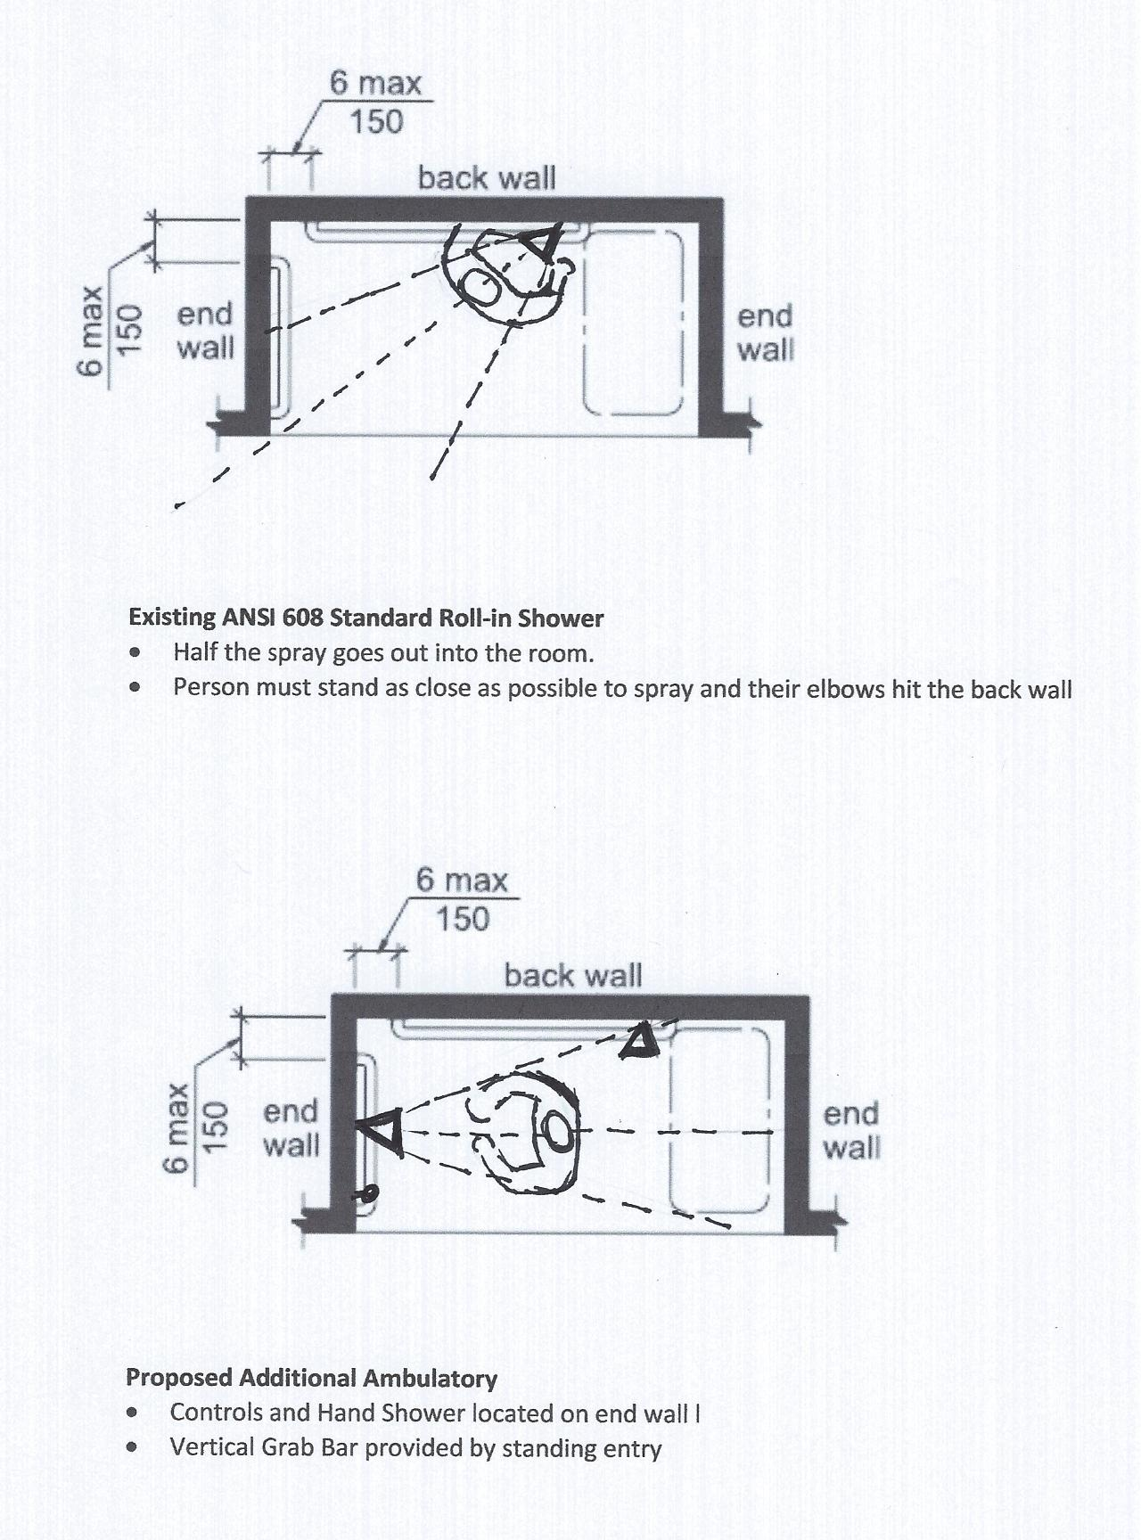

Unresolved Issue 10-19– 12

Kim Paarlberg, proponent, asks for further consideration of Proposal 10-19-12.

Split the question to address public showers and each type of unit separately.

Question 1:

607.7 Bathtub Enclosures. Enclosures for bathtubs shall not obstruct controls, faucets, shower and spray units or obstruct transfer from wheelchairs onto bathtub seats or into bathtubs. Enclosures on bathtubs shall not have tracks installed on the rim of the bathtub. Fixed panels, sliding panels and swinging panel assemblies for tub enclosure shall not be permitted on the access side of the bath tub.

608.7 Shower Enclosures. Fixed panels, sliding panels and swinging panel assemblies for shower enclosure shall not be permitted on the access side of the shower.

Exception: Panels for Shower compartment enclosures for shall be permitted where all of the following are met:
- Panels shower compartments shall not obstruct controls or obstruct transfer from wheelchairs onto shower seats.
- At least one sliding or swinging panel shall provide a minimum clear width of 32”

Question 2:

1003.11.2.5.1 Bathtub. Bathtubs shall comply with Section 607.
EXCEPTIONS:
- The removable in-tub seat required by Section 607.3 is not required.
- Counter tops and cabinetry shall be permitted at one end of the clearance, provided the following criteria are met:
- The countertop and cabinetry can be removed;
- The floor finish extends under the countertop and cabinetry; and
- The walls behind and surrounding the countertop and cabinetry are finished.
3. A panel assembly for tub enclosure shall be permitted at the bathtub entry where the panel assembly can be removed without removal or replacement of the surrounding walls and tub edge to which it is affixed.

1003.11.2.5.2 Shower. Showers shall comply with Section 608.

EXCEPTIONS:

- At standard roll-in shower compartments complying with Section 608.2.2, lavatories, counter tops and cabinetry shall be permitted at one end of the clearance, provided the following criteria are met:
- The countertop and cabinetry can be removed;
- The floor finish extends under the countertop and cabinetry; and
- The walls behind and surrounding the countertop and cabinetry are finished.
2. A panel assembly for shower enclosure shall be permitted at the shower entry where the panel assembly can be removed without removal or replacement of the surrounding walls and floor to which it is affixed.

Question 3:

1004.11.3.1.3 Bathing Fixtures. Where provided, a bathtub shall comply with Section 1004.11.3.1.3.1 or 1004.11.3.1.3.2 and a shower compartment shall comply with Section 1004.11.3.1.3.3. . A panel assembly for tub enclosure shall be permitted at the bathtub entry.
1004.11.3.1.3.3 Shower Compartment. If a shower compartment is the only bathing facility, the shower compartment shall have dimensions of 36 inches (915 mm) minimum in width and 36 inches (915 mm) minimum in depth. A clearance of 48 inches (1220 mm) minimum in length, measured perpendicular from the shower head wall, and 30 inches (760 mm) minimum in depth, measured from the face of the shower compartment, shall be provided. Reinforcing for a shower seat is not required in shower compartments larger than 36 inches (915 mm) in width and 36 inches (915 mm) in depth. A panel assembly for shower enclosure shall be permitted at the shower entry.

Reason: While enclosures are addressed for bathtubs and showers in the current text, the enclosures are not the same as the door to the shower. The enclosure can be all four walls. A shower stall enclosure on the approach side is not the same as a door addressed in Section 404 – therefore, this section should not be referenced for requirements. The desired requirements for access to a shower and tub needs to be clearly expressed in the standard.
I do not see how a sliding or swinging door on the front of a minimum size shower or a standard tub could meet the current limitations for not obstructing access to the controls or to transfer.

The two types of doors are swinging and sliding. The following is the best information I was able to find on a computer search. Better answers may come from the plumbing industry representatives.
Sliding move in two directions, so it can be shifted to either side to allow access to the controls or access to the seat . Can I assume that meets the current enclosure requirements? With a sliding door, the maximum overall width is 60” wide. Door width on a 36” stall is 16” maximum. Door width on a 60” stall size is 28” maximum.
Swinging shower doors still need space for hinges. In a 36” stall, the door width is 30” with the standard frame. The doors can come 22” to 36” wide with side panels for a 60” shower.

For public showers and Accessible units – With roll-in showers required to have a seat, the controls have moved to the back. With a minimum size stall, can a swinging door of 32” clear at the seat end provide adequate clearance? Would any sliding door work? I don’t see how the minimum size shower would ever meet the enclosure requirements, so we might as well start out saying they are prohibited. If someone wants to provide a larger shower with a door, then they can use the exception, which includes the current text requiring access to controls and the seat.

For Type A dwelling units – a common complaint is the water from the shower going onto the floor of the bathroom. The ½” threshold is not adequate to hold the water in the pan. That is being addressed with the new style trench drains, but should we prohibit Type A units from having tub or shower enclosures? Since a Type A units is expected to have some features ‘adaptable’ the exception would allow for someone that did not need the full entry opening to have a shower door as long as it was removable. This would be consistent with the allowance for removable cabinetry in Type A units.

For Type B dwelling units – FHA allows for shower doors on their showers with no limitations. This should be permitted for consistency. Also, for showers, many renters and owners prefer a door to a shower curtain.

Committee action on 10-19-12 Unresolved Issue

Approve as modified 10-19-12

Modification:

The modification is a complete substitution. It replaces all parts of the original proposal as follows:

1004.11.3.1.3.3 Shower Compartment. If a shower compartment is the only bathing facility, the shower compartment shall have dimensions of 36 inches (915 mm) minimum in width and 36 inches (915 mm) minimum in depth. A clearance of 48 inches (1220 mm) minimum in length, measured perpendicular from the shower head wall, and 30 inches (760 mm) minimum in depth, measured from the face of the shower compartment, shall be provided. Reinforcing for a shower seat is not required in shower compartments larger than 36 inches (915 mm) in width and 36 inches (915 mm) in depth

Exception: A shower door assembly shall be permitted where the assembly can be removed without removal or replacement of the surrounding walls and floor to which it is affixed.

Reason: The Committee felt the issue of the installation of shower door assemblies needs to be addressed. Consensus has been difficult to achieve. The Committee approved this exception for Type B units, but not for Type A.

