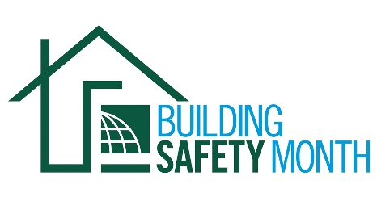
Sample Letter to the Editor
Dear Member: To help promote Building Safety Month and the important role you play in your community, the International Code Council is providing this draft letter to the editor to promote your department through local newspapers. Fill in the appropriate information and send it in early April to your newspaper’s editorial page editor. Be sure to list any special events you will be holding in conjunction with Building Safety Month.
Dear Editor:
May 2020 marks the 40th year that communities around the world will celebrate Building Safety Month. With the increased frequency and severity of devastating storms, each year the importance of building safety has become a personal topic – especially for those still recovering from recent disasters. While the destruction has uprooted many, building codes continue to protect and save lives. Building codes incorporate the latest technology and provide the safest, most resilient structures for our families and communities. The International Codes, development by the International Code Council and adopted by our community, are the most widely used and adopted set of building safety codes in the U.S. and around the world.
Building Safety Month was first observed in 1980. The campaign raises awareness about critical building safety issues from structural to fire prevention, plumbing and mechanical systems, and energy efficiency. This year’s Building Safety Month campaign theme is “Safer Buildings, Safer Communities, Safer World.” Each week of the month highlights an essential area of building safety, including Disaster Preparedness, May 1-10; Water Safety, May 11-17; Resiliency. Sustainability. Innovation., May 18-24; and Training the Next Generation, May 25-31.

The (name of jurisdiction and department), a member of the Code Council, is a longtime Building Safety Month supporter and participant. (Insert a reference to recently adopted codes, Building Safety Month plans, or other examples that illustrate the value of building safety in your community.)

Code officials, plan reviewers, fire inspectors, architects, builders, engineers, design professionals, contractors and staffers in the (name of jurisdiction and department) are among the 64,000 members of the International Code Council that created Building Safety Month. All of us work together to provide the first line of defense against building disasters and to ensure the safety of the buildings where we all live, work and play.
(Insert brief summaries of your building department accomplishments. Remind the community how it obtains permits and for what projects they are required.)
Local activities during Building Safety Month include (insert any activities you have planned including date, time and location). Educational materials are available for schools and the community at large, including brochures about flood cleanup, mold prevention, green building and preparing for natural disasters. Everyone is encouraged to participate and learn about the essential safety work of the (name of jurisdiction and department).
Your Name
Your Title
Your Office Phone Number

