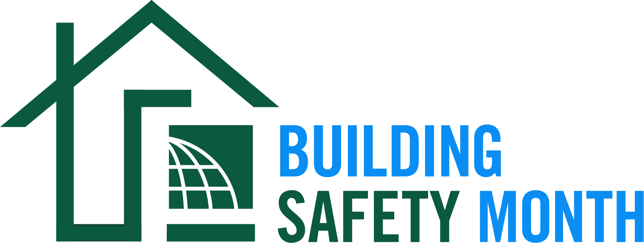

How to Submit a Proclamation for Countries Worldwide
- Please fill out the document on page 2 or use the language to create your own proclamation.
- Send your document to communications@iccsafe.org.
- Our communications team will review and post your proclamation on our Building Safety Month 2022 Proclamations page:
- https://www.iccsafe.org/advocacy/building-safety-month/2022-proclamations/

Proclamation
Building Safety Month — May 2022

Whereas, our [City, Town, Country, Organization] is committed to recognizing that our growth and strength depends on the safety and essential role our homes, buildings and infrastructure play, both in everyday life and when disasters strike, and;

Whereas, our confidence in the structural integrity of these buildings that make up our community is achieved through the devotion of vigilant guardians––building safety and fire prevention officials, architects, engineers, builders, tradespeople, design professionals, laborers, plumbers and others in the construction industry––who work year-round to ensure the safe construction of buildings, and;

Whereas, these modern building codes include safeguards to protect the public from hazards such as hurricanes, snowstorms, tornadoes, wildland fires, floods and earthquakes, and;

Whereas, Building Safety Month, a campaign launched by the International Code Council and jointly sponsored by [local building safety regulatory authority], is intended to remind the public about the critical role of our communities’ largely unknown protectors of public safety––our local code officials––who assure us of safe, sustainable and affordable buildings that are essential to our prosperity, and;

Whereas, “Safety for All: Building Codes in Action,” the theme for Building Safety Month 2022, encourages us all to raise awareness about planning for safe and sustainable construction; career opportunities in building safety; understanding disaster mitigation, energy conservation; and creating a safe and abundant water supply to all of our benefit, and;

Whereas, each year, in observance of Building Safety Month, people all over the world are asked to consider the commitment to improve building safety, resilience and economic investment at home and in the community, and to acknowledge the essential service provided to all of us by our building regulatory departments, fire prevention bureaus and national and international agencies in protecting lives and property.

NOW, THEREFORE, I, _______________________________, (Lawmaker, Elected Official, Department Head) of the (City, Town, Country, Organization) of ____________________________, do hereby proclaim the month of May 2022 as Building Safety Month. Accordingly, I encourage our citizens to join us as we participate in Building Safety Month activities.

_________________________________________________________________________
Signature

