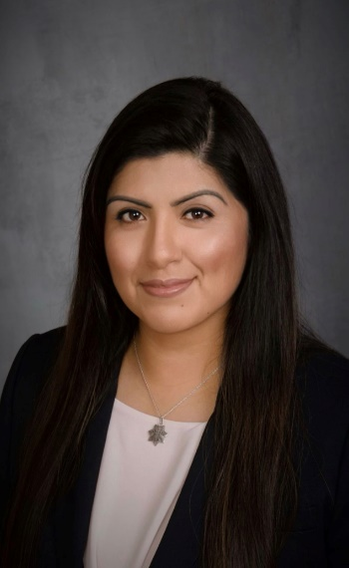
Cecilia Muela, SAS
Cecilia Muela is currently a Director of Code Enforcement Services and Building Official with 4LEAF, Inc. Previously, Ceci served as the Chief Building Official for the City of Santa Rosa.

Ceci's dedication to education and training in the code enforcement field has had a significant impact on professionals across the country. Her experience as a Building Official and Director of Code Enforcement Services with 4LEAF, Inc gives her a unique perspective that she is able to share with others through her presentations and training programs. Additionally, her involvement in various committees and organizations within the International Code Council to include Code Action Committee hearings, serving as Chair of the Ad Hoc Committee on Diversity Equity and Inclusion, currently serving as a governing member of the Emerging Leaders Membership Council, and previously holding a Board seat with California Association of Code Enforcement Officers, demonstrates her commitment to advancing the field of code enforcement.

Through her work as Founder of the Women Leaders in Code Group, Ceci is actively working to support and empower women in the building and safety industry, creating opportunities for mentorship and professional growth. Her passion for education and advocating for diversity and inclusion in the industry has set her apart as a leader and role model in the field of code enforcement.
Overall, Ceci's diverse background and 26 plus years of experience make her a highly respected professional in the code enforcement field, and her commitment to education and mentorship has had a lasting impact on the industry as a whole.

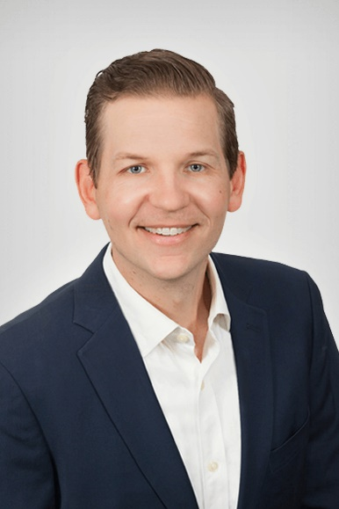
Stephen Wagner
Stephen Wagner is the Vice President at KWSM: a digital marketing agency. KWSM creates and executes integrated digital marketing strategies that generate leads and sales.
Stephen has a finance background and an entrepreneurial heart.
With a degree in Finance from Oregon State University, Stephen has worked in Finance & Operations Management at two Fortune 100 companies. In addition, he spent 5 years as a small business consultant, working with clients in the real estate, food & beverage, retail, and finance industries. Stephen founded KWSM with his wife Katie in 2010. As an entrepreneur himself, Stephen identifies with the challenges of trying to ‘get it all done’ with limited resources.

He loves showing clients how they can level the playing field with an engaging digital marketing presence. Stephen is well-trained in Websites and Search Engine Optimization and works with clients to make sure they are getting the most benefit from the work we do. He brings business savvy to the world of digital marketing and enjoys creating digital marketing strategies that help companies meet their goals.
Away from the office, Stephen plays music and is a certified sommelier.


Gabe Maser
Gabe Maser is Senior Vice President of Government Relations at the International Code Council. Maser leads the development and implementation the Code Council's strategic priorities at the federal, state, and local levels. Previously, he served as Vice President of Government Relations and National Strategy and Vice President of Federal Programs. He received the degree of Doctor of Law from Georgetown University Law Center in 2013 and received a Bachelor of Science degree from McGill University in 2004.

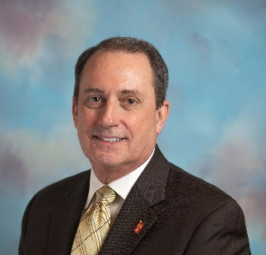
Hon. James (Tim) T. Ryan, C.B.O.
Tim Ryan served the City of Overland Park for 40 years; all in the Building Safety Division. He served that community as a field inspector, plans examiner, field supervisor and as Code Administrator from 1998 until 2017. He currently serves as an International Code Consultant. Tim graduated from Pittsburg State University with a Bachelor of Science Degree in Construction Management and Technology. He is certified in 15 separate categories of building code administration and management. He is well recognized as a public speaker and is highly regarded as an instructor on several topics of building and fire codes, legal aspects, emergency response, leadership and management. He served on the Board of Directors for the Building Officials and Code Administrators (BOCA), Intl. from 1993 through 2002, including as President of the board. He served on the initial Board of Directors for the International Code Council (ICC) from 2001 until 2009. He served on the Board of Directors for the National Institute of Building Sciences (NIBS) from 2006 until 2021. Nine of those years as one of six board members appointed by the President of the United States. He was awarded ICC’s Bob Fowler award for his outstanding leadership in furthering a safer built environment in 2012. Additionally, he was awarded the Mortimer M. Marshal Award from the National Institute of Building Sciences in January 2018 for outstanding lifetime achievement. He currently serves as a moderator in ICC’s code development process and as a member of ICC’s Code Correlation Committee.

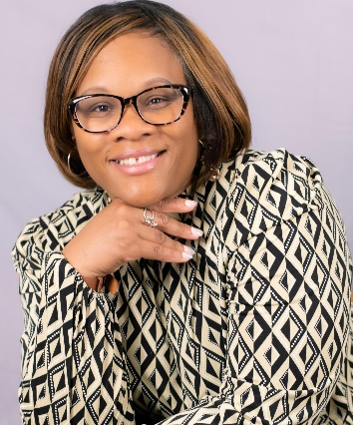
Christina Jackson, PMO, CZA
Ms. Jackson began her code career in Ohio back in 2001 so her code experience spans over 20 years. Ms. Jackson currently works for the City of Newport News and is a Certified Building Maintenance Official in Virginia. She is a member of the Virginia Building Code Official Association (VBCOA) and serves as VBCOA Education Chair which provides training for all 8 regions within Virginia and its stakeholders. As the VBCOA Education Chair, Ms. Jackson is always making connections with industry and professional colleagues to offer training locally and on a state level. As of September 2015, she is a founding board member of the Women in Code Enforcement and Development Virginia Chapter and has been instrumental in getting the word out about women getting recognized for their contributions to building codes and inspections. Currently Ms. Jackson is the WICED National Secretary. Ms. Jackson is also a member of the Virginia Association of Zoning Officials where she is a Certified Zoning Administrator. In August 2018, Ms. Jackson was appointed by Gov‍ernor Ralph Northam to the State Technical Review Board, becoming the1st African American female to serve in this capacity. Ms. Jackson also sits on the Permit Tech Nation Board of Directors. Ms. Jackson is also a member of National Association of Women in Construction and American Association of Code Enforcement. Since 2017, she has been an instructor at Tidewater Community College, teaching the International Residential Code BLD115. Ms. Jackson is a naval spouse, served as Navy Ombudsman and a mother of three.
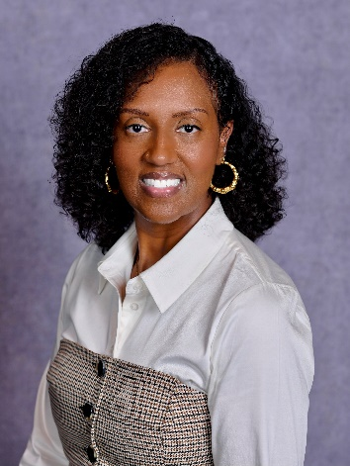
Maryia Lackansingh
Maryia Lackansingh works as a Code Specialist III in the Commercial Building Division for Fairfax County, Virginia. Maryia has been with Fairfax County since 2018; and she holds a bachelor’s degree in architectural engineering and an associate degree in interior design from the State University of New York at Alfred. She has over 16 years of code enforcement experience. Maryia started her professional career as an Assistant Architect with Paralyzed Veterans of America, where she traveled across the country conducting accessibility reviews and inspections for a variety of federal government facilities and projects. Prior to her time in Fairfax County, she worked as a commercial building plans examiner for Prince William County and a Small Business and Residential Project Facilitator for Alexandria City. Maryia is also the newly re-elected President of Women in Code Enforcement and Development of Virginia (WICED of VA). WICED of VA is an organization that promotes the value, recognition, and professional development of women in code enforcement and development within the Commonwealth of

Virginia. Additionally, Maryia is an instructor for the Virginia Department of Health and Community Development’s Virginia Building Code Academy. Outside of life in the code enforcement world, she enjoys spending time with family and friends, shopping, biking, and roller skating.

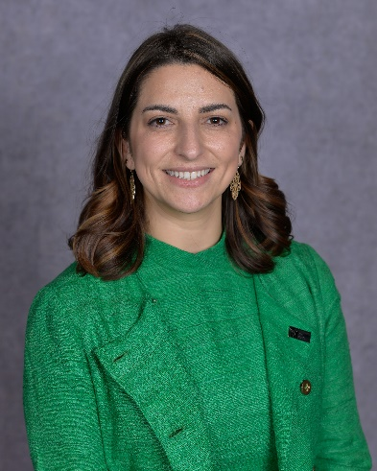
Stella Carr
Stella Carr is currently spearheading critical initiatives as the Energy and Resilience Project Manager at the International Code Council. Her role is pivotal in bridging the gap between the complexities of federal funding and the imperative adoption of energy and resilience building codes. Stella's expertise lies in her ability to facilitate access to grants for Code Council members and customers, ensuring that they are well-equipped to navigate the challenges of implementing progressive building standards.
Stella has honed her skills in coordinating multi-faceted initiatives, fostering strategic partnerships, a skill set that is crucial for entities looking to tap into federal funding for decarbonization projects. Throughout her career Stella has demonstrated commitment to community resilience and sustainability in the realm of local government and decarbonization efforts.

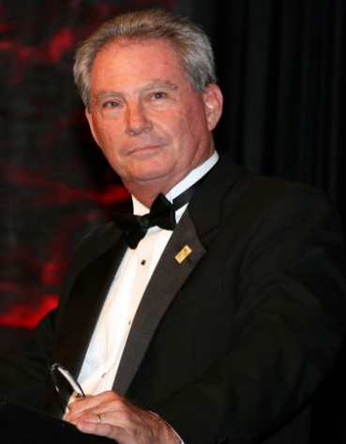
James Brothers
James L. Brothers, retired, served as Director of the Decatur, Alabama, Building Department and is a Past President of the Code Council Board of Directors. He was awarded Alabama’s Code Official of the Year in 1997. During his professional tenure he served on the Legislative and Codes Advisory Council for the American Society of Interior Design and is a Past President of the North Alabama Code Officials Association and the Code Officials Association of Alabama. In 2024, Brothers received the Bobby J. Fowler Award, recognizing his longstanding legacy of leadership at the Code Council.

