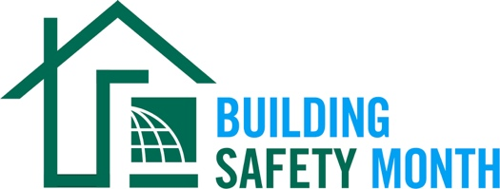

Sample Press Release
This news release template will help promote your community’s involvement with Building Safety Month. Fill in the appropriate information. Be sure to include any special events being held in conjunction with Building Safety Month and, if available to you, seek assistance from your municipality’s or company’s Public Information Officer. Distribute the release in April or early May to your local media. You can also post it on your website and social media channels.

For Immediate Release | Contact: Name Here
Month Day, 2024 | Contact Phone Number
Website URL | Contact Email

(Municipality/Company name) joins International Code Council for the celebration of Building Safety Month 2024
(Insert subtitle about your local event/activities – ex. City XYZ is hosting an in-person event for kids on May XX to promote building safety)

CITY, STATE – Throughout the month of May, (Name of municipality/department/company) will participate in the 44th annual Building Safety Month, a worldwide campaign presented by the International Code Council, its members and partners to promote building safety. This year’s campaign, “Mission Possible,” encourages people to get involved in all aspects of building safety. The campaign also makes the connection between building codes and our personal safety, as well as the important work done by building safety professionals in our communities.

This year’s campaign addresses how building safety impacts everyone on a personal, local, and global level.

- Week One: Understanding the Mission, May 1-4, includes an introduction of building safety, what Building Safety Month is, and how building safety affects us all.
- Week Two: Preparing a Building Safety Plan, May 5-11, highlights available educational resources (water/fire, sustainability and resiliency/disaster preparedness), including downloadable brochures, for building safety tips and best practices at home and in your community.
- Week Three: Learning from the Pros, May 12-18, shines a spotlight on building safety professionals, including what they do, how to work with them and how to become one yourself.
- Week Four: Engaging Your Community, May 19-25, includes information on how to advocate for building safety in your community, including actionable tips on how to be a proponent of building safety and ways to get kids involved.
- Week Five: Celebrating Success in Building Safety, May 26-31, highlights individuals and communities who are making a difference in building safety (editorial spotlights), including sharing the current year's Building Safety Month celebrations and events.
Local events to celebrate Building Safety Month include (list any activities you have planned, including date, time and location).

(Insert a quote from your local, city or state leader about the significance of Building Safety Month, your municipality’s participation in Building Safety Month, or the importance of building codes.)

Learn more about Building Safety Month at www.buildingsafetymonth.org or join the conversation on social media using #BuildingSafety365.

###

About (Insert Municipality Name)
(Insert boilerplate language about your municipality)

