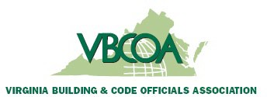

September 12, 2025

Stuart Tom & Members of the ICC Nominating Committee
International Code Council
900 Montclair Road
Birmingham, AL 35213

Subject: Chapter Support for ICC Board of Directors Candidate – Jack Applegate
Dear Chairman Tom & ICC Nominating Committee
On behalf of the Virginia Building and Code Officials Association, we are pleased to offer our support for Jack Applegate as a candidate for the ICC Board of Directors.
Jack has demonstrated a clear commitment to the mission and values of the International Code Council. He is actively engaged in the code profession within his local jurisdiction and have contributed significantly to advancing safe, sustainable, and resilient communities.
Our chapter believes that Jack meets the requirements of serving as a Board member based on his professional credentials, leadership experience, and long-standing involvement in the code professional arena. He brings valuable knowledge, perspective, and dedication that will strengthen the ICC Board of Directors and support its continued success as the global leader in building safety.
We respectfully request your consideration of Jack.
Respectfully,
Michelle Coward
Michelle Coward, CBMO
Immediate Past President,
Virginia Building and Code Officials Association

