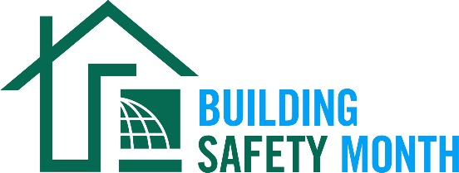
Sample Letter to the Editor

To help promote Building Safety Month and the important role you play in your community, the International Code Council (ICC) is providing this draft letter to the editor to feature your company/organization in local newspapers. Fill in the appropriate information and send it in early April to your newspaper’s editorial page editor. Be sure to list any special events you will be holding in conjunction with Building Safety Month.
Dear Editor:
The 46th annual Building Safety Month will be celebrated internationally during the month of May to raise awareness about building safety. This celebration highlights how modern building codes, safety professionals and resilient construction practices protect homes and communities around the world. Everyone is encouraged to participate in the celebration and learn about the essential work of the (name of jurisdiction/department/company).

The 2026 Building Safety Month theme is “Built to Last” and the weekly themes are as follows:

- Week One (May 1–10): “Safe Homes, Strong Communities” focuses on simple actions homeowners can take to improve safety at home
- Week Two (May 11—17): “Voices of the Built Environment” spotlights building safety professionals and the roles they play in keeping communities safe
- Week Three (May 18—24): “Prepared to Protect” encourages community preparedness and highlights how disaster-resilient building codes protect people and property
- Week Four (May 25—31): “Communities Without Limits” showcases accessibility in building construction and design

The (name of jurisdiction/department/company) is a proud Building Safety Month supporter and participant. (Insert a reference to recently adopted International Codes®, Building Safety Month plans or other examples that illustrate the value of building safety in your community.)

(Insert a quote from a jurisdiction official about what Building Safety Month means to you, your participation in Building Safety Month or the importance of building codes.)

Local activities during Building Safety Month include (insert any activities you have planned including date, time and location). Educational materials are available for schools and the community at large, including brochures and lesson plans on the Building Safety Month website.

This May, code officials, plan reviewers, fire inspectors, architects, builders, engineers, design professionals, contractors and others in the construction industry, including employees of the (name of jurisdiction/department/company), work to educate the public about the importance of safe buildings where we live, work and play. These professionals provide the first line of defense against building disasters; working vigilantly to ensure the safety of our communities.

(Insert brief summaries of your department/company accomplishments. If you work for a building department, remind the community how it obtains permits and for what projects they are required.)

Your Name
Your Title
Your Office Phone Number

