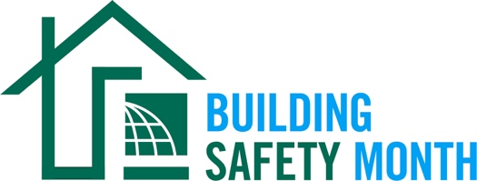

Sample Press Release
This press release template will help promote your community’s involvement with Building Safety Month. Fill in the appropriate information. Be sure to include any special events being held in conjunction with Building Safety Month and, if available to you, seek assistance from your municipality’s or company’s Public Information Officer. Distribute the release in April or early May to your local media. You can also post it on your website and social media channels.

For Immediate Release | Contact: Name Here
Month Day, 2026 | Contact Phone Number
Website URL | Contact Email

(Municipality/Company name) Joins International Code Council for the Celebration of Building Safety Month 2026
(Insert subtitle about your local event/activities – ex. City XYZ is hosting an in-person event for kids on May XX to promote building safety)

CITY, STATE – Throughout the month of May, (Name of municipality/department/company) will participate in the 46th annual Building Safety Month, a worldwide campaign presented by the International Code Council (ICC), its members and partners to promote building safety. This year’s campaign, “Built to Last,” highlights how modern building codes, safety professionals and resilient construction practices protect homes and communities around the world.

This year’s campaign encourages people of all ages to participate in learning about building safety.

- Week One (May 1–10): “Safe Homes, Strong Communities” focuses on simple actions homeowners can take to improve safety at home
- Week Two (May 11—17): “Voices of the Built Environment” spotlights building safety professionals and the roles they play in keeping communities safe
- Week Three (May 18—24): “Prepared to Protect” encourages community preparedness and highlights how disaster-resilient building codes protect people and property
- Week Four (May 25—31): “Communities Without Limits” showcases the importance of accessibility in building construction and design

Local events to celebrate Building Safety Month include (list any activities you have planned, including date, time and location).

(Insert a quote from your local, city or state leader about the significance of Building Safety Month, your municipality’s participation in Building Safety Month, or the importance of building codes.)

Learn more about Building Safety Month at www.buildingsafetymonth.org or join the conversation on social media using #BuildingSafety365.

###

About (Insert Municipality Name)
(Insert boilerplate language about your municipality)

