August 21, 2026

Mr. David Spencer, Chair
Nominations Committee
International Code Council
900 Montclair Road
Birmingham, Alabama 35213

RE: Letter of Support for Mr. Benjamin Breadmore – Secretary/Treasurer of the ICC Board of Directors

Dear Chairman Spencer:

Mr. Benjamin Breadmore of Holden, Maine seeks the endorsement of the International Code Council (ICC) Nominations Committee as a candidate for Secretary/Treasurer of the Board of Directors. The purpose of this letter is to voice California Building Officials’ (CALBO’s) endorsement of Mr. Breadmore and his candidacy for Secretary/Treasurer of the Board of Directors. It is our hope that this endorsement of Mr. Breadmore will be of assistance to you and the Nominations Committee as his candidacy is evaluated.

As the largest chapter of ICC, CALBO has a vested interest in promoting only the most qualified of candidates for the Board of Directors. We look for geographic diversity, background, and commitment to the code official profession, demonstrated achievement, and a strong understanding of contemporary issues affecting California. CALBO has held a solid relationship with Mr. Breadmore for years, working with him in a variety of capacities. He has invested time and resources within our state and connected himself with our members. We feel that Mr. Breadmore has shown leadership in each of these aforementioned areas and is astutely prepared for this elevated leadership role.

Should you have any questions about CALBO’s endorsement of Mr. Benjamin Breadmore, please feel free to reach out to me directly. I look forward to personally supporting Mr. Breadmore in Nashville.

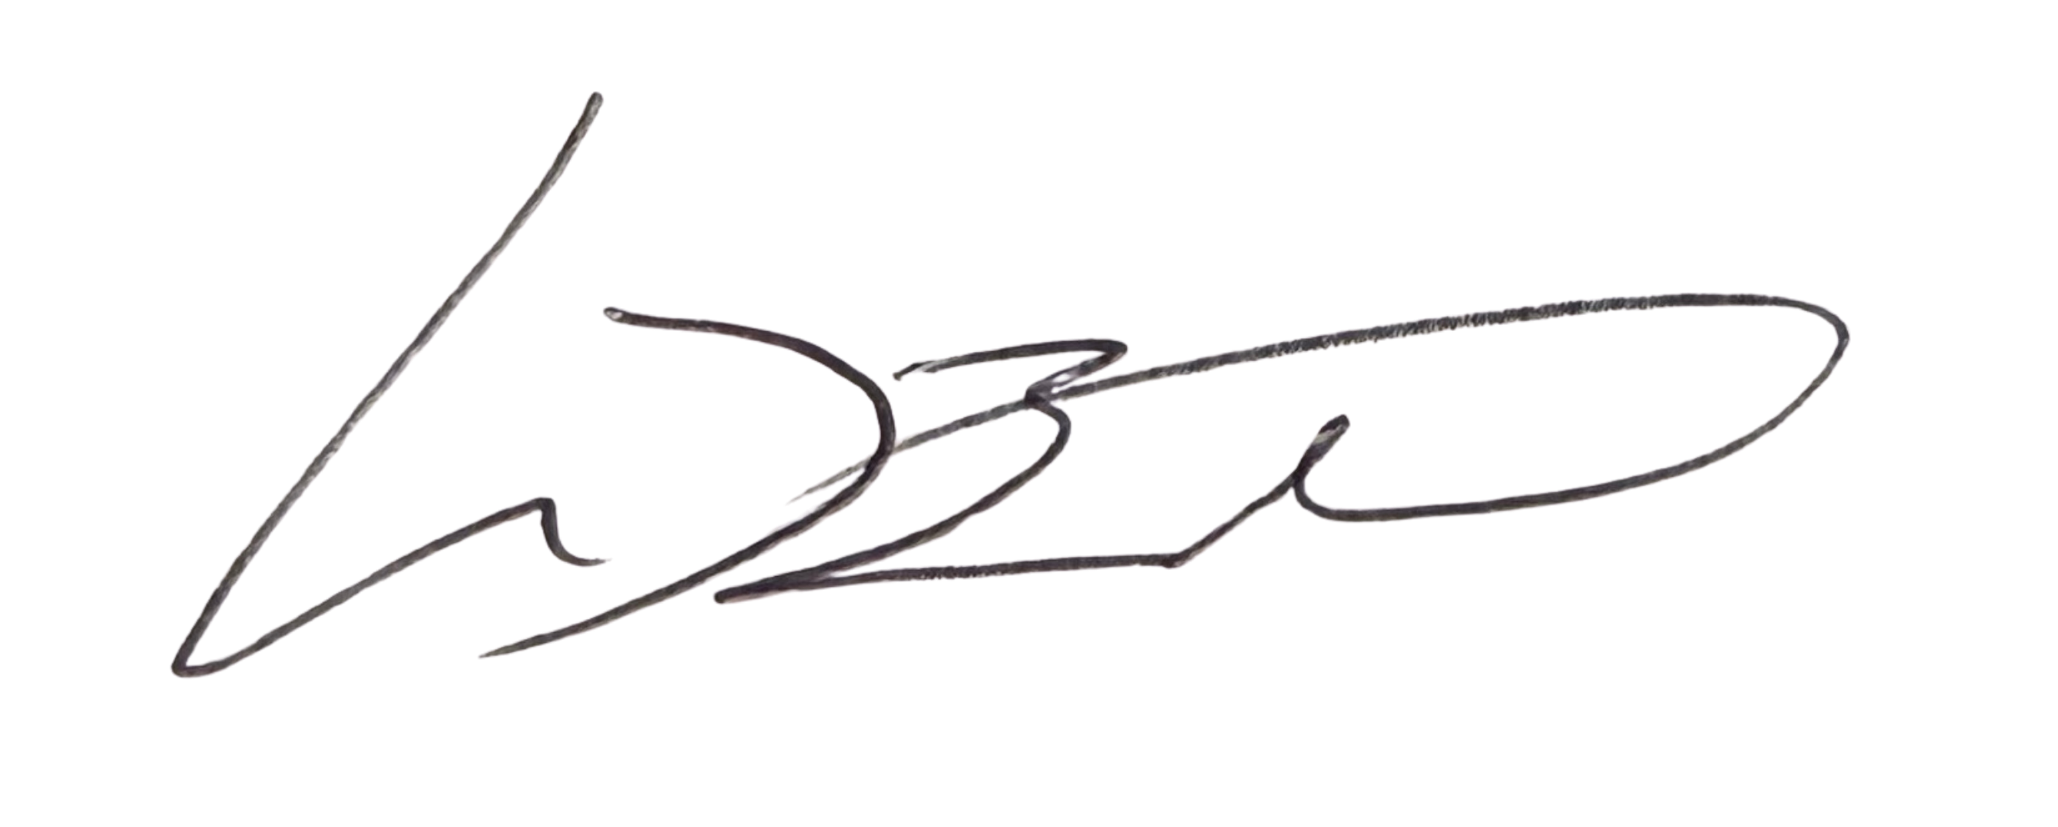
Sincerely,

Mike Brinkman, CASp, C.B.O.
President

