August 21, 2026

Mr. David Spencer, Chair
Nominations Committee
International Code Council
900 Montclair Road
Birmingham, Alabama 35213

RE: Letter of Support for Mr. Steve McDaniel – President of the ICC Board of Directors

Dear Chairman Spencer:

Mr. Steve McDaniel of Corning, New York seeks the endorsement of the International Code Council (ICC) Nominations Committee as a candidate for President of the Board of Directors. The purpose of this letter is to voice California Building Officials’ (CALBO’s) endorsement of Mr. McDaniel and his candidacy for President of the Board of Directors. It is our hope that this endorsement of Mr. McDaniel will be of assistance to you and the Nominations Committee as his candidacy is evaluated.

As the largest chapter of ICC, CALBO has a vested interest in promoting only the most qualified of candidates for the Board of Directors. We look for geographic diversity, background, and commitment to the code official profession, demonstrated achievement, and a strong understanding of contemporary issues affecting California. CALBO has held a solid relationship with Mr. McDaniel for years, working with him in a variety of capacities. He has invested time and resources within our state and connected himself with our members. Steve is no stranger to California. We feel that Mr. McDaniel has shown leadership in each of these aforementioned areas and is astutely prepared for this elevated leadership role.

Further, as an organization, CALBO feels strongly that previous commitments made by the membership must be honored. Once the membership instills their faith in a candidate through promotion to the Executive Committee, in essence and without egregious action, the membership is pledging their sustained candidate support for the Executive Committee duration of four-years. As Mr. McDaniel was promoted in 2024 to the role of Secretary/Treasurer and then to Vice President in 2025, CALBO honors the membership in their decisive action through sustained support. CALBO is hopeful that your Nominations Committee will exercise similar judgement.

Should you have any questions about CALBO’s endorsement of Mr. Steve McDaniel, please feel free to reach out to me directly. I look forward to personally supporting Mr. McDaniel in Nashville.

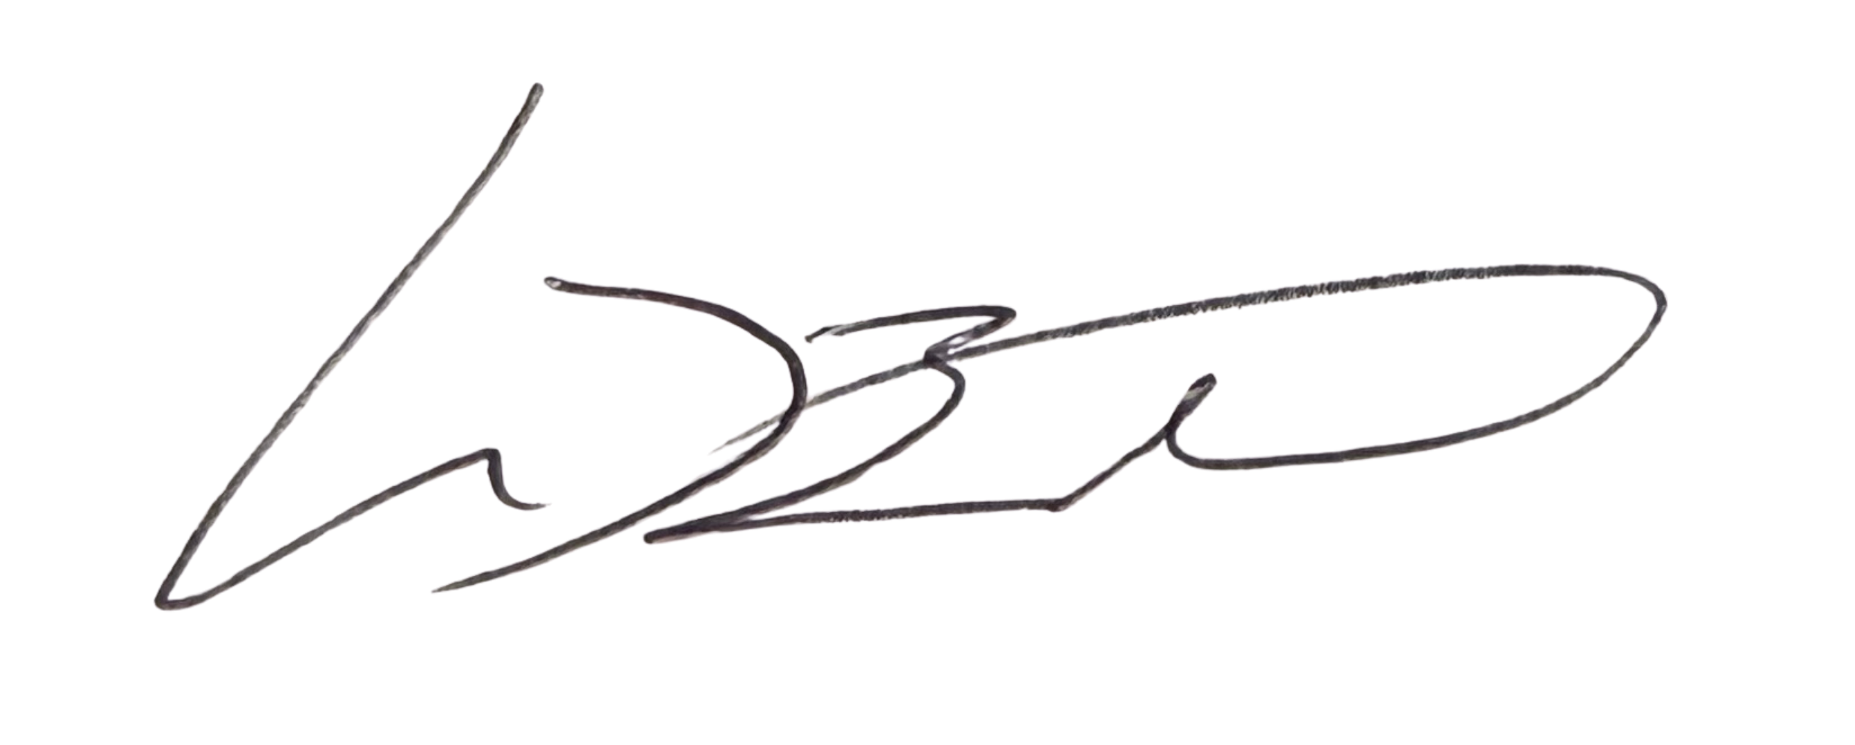
Sincerely,

Mike Brinkman, CASp, C.B.O.
President

