August 21, 2026

Mr. David Spencer, Chair
Nominations Committee
International Code Council
900 Montclair Road
Birmingham, Alabama 35213

RE: Letter of Support for Mr. Marty Moseley – Member of the ICC Board of Directors

Dear Chairman Spencer:

As you know, Mr. Marty Moseley of Ithaca, New York seeks the endorsement of the International Code Council (ICC) Nominations Committee as a candidate for the Board of Directors. The purpose of this letter is to voice California Building Officials’ (CALBO’s) endorsement of Mr. Moseley and his candidacy for an At-Large – or Section E - seat on the Board of Directors. It is our hope that this endorsement of Mr. Moseley will be of assistance to you and the Nominations Committee as his candidacy is evaluated.

As the largest chapter of ICC, CALBO has a vested interest in promoting only the most qualified of candidates for the Board of Directors. We look for geographic diversity, background, and commitment to the code official profession, demonstrated achievement and a strong understanding of contemporary issues affecting California and the west coast. CALBO feels that Mr. Moseley has shown leadership in each of these aforementioned areas and is therefore worthy of service on the ICC Board of Directors.

Should you have any questions about CALBO’s endorsement of Mr. Moseley, please feel free to reach out to me directly. I look forward to personally supporting Mr. Moseley in Nashville.

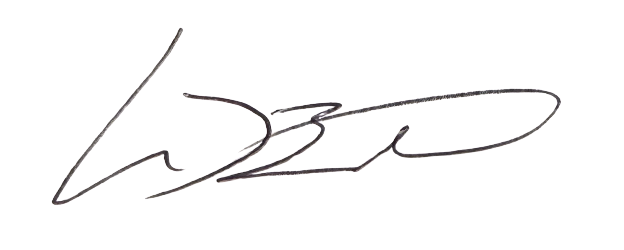
Sincerely,

Mike Brinkman, CASp, C.B.O.
President

