August 21, 2026

Mr. David Spencer, Chair
Nominations Committee
International Code Council
900 Montclair Road
Birmingham, Alabama 35213

RE: Letter of Support for Chief Sean Toomey – Member of the ICC Board of Directors

Dear Chairman Spencer:

As you know, Chief Sean Toomey of New Hampshire seeks the endorsement of the International Code Council (ICC) Nominations Committee as a candidate for re-election to the Board of Directors. The purpose of this letter is to voice California Building Officials’ (CALBO’s) endorsement of Chief Toomey and his candidacy for an At-Large seat on the Board of Directors. It is our hope that this endorsement of Chief Toomey will be of assistance to you and the Nominations Committee as his re-election candidacy is evaluated.

As the largest chapter of ICC, CALBO has a vested interest in promoting only the most qualified of candidates for the Board of Directors. We look for geographic diversity, background, and commitment to the code official profession, demonstrated achievement and a strong understanding of contemporary issues affecting California and the west coast. CALBO feels that Chief Toomey has shown leadership in each of these aforementioned areas and is therefore worthy of continued service on the ICC Board of Directors. We have valued the time that Chief Toomey has spent with our California members and know that he will continue to represent us well.

Should you have any questions about CALBO’s endorsement of Chief Sean Toomey, please feel free to reach out to me directly. I look forward to personally supporting Chief Toomey in Nashville.

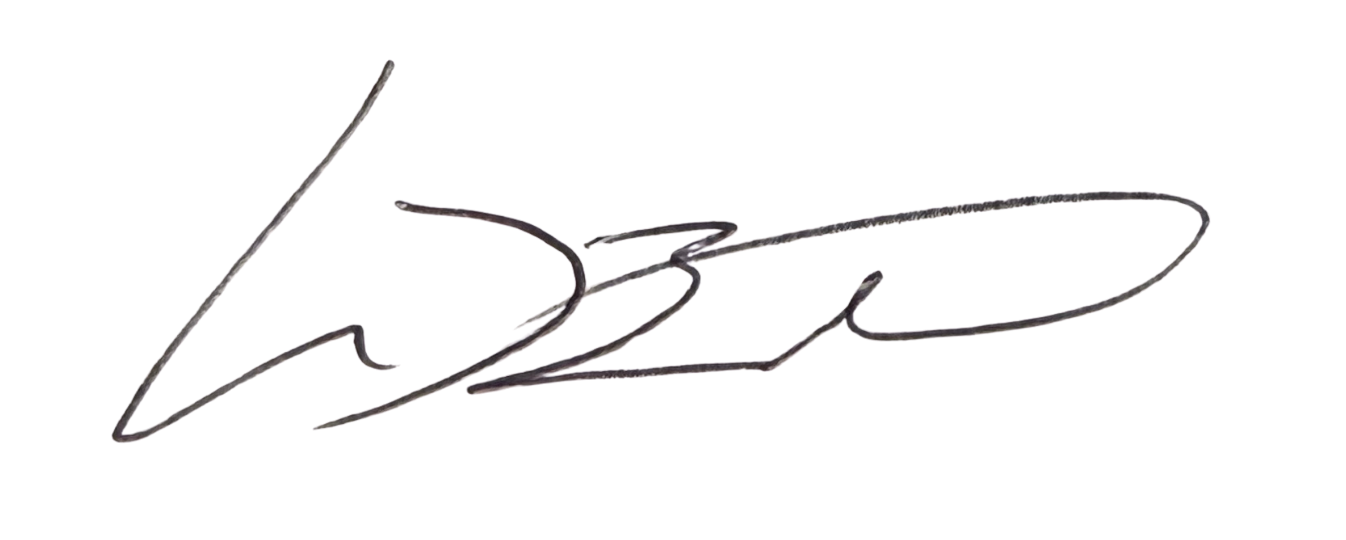
Sincerely,

Mike Brinkman, CASp, C.B.O.
President

