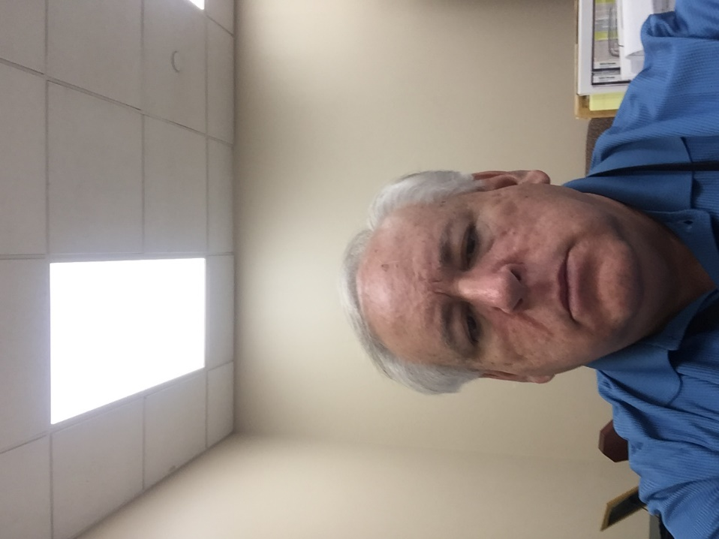**Gary Lewis**

Gary Lewis has been the chief building official for the City of Summit, NJ, for the past 28 years. Over his nearly 40 years of working in building and fire code enforcement, Lewis has served or chaired a number of code development committees, including the original ICC Performance Code project.