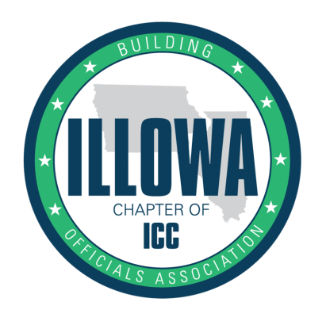
  
  Jamie Just | Sean Meyer | Greg Schaapveld Justin Blaser
  President | Vice –President | Secretary Treasurer

Stuart Tom, Chairperson
ICC Nominating Committee
c/o John Belcik, CEO
International Code Council
900 Montclair Rd
Bermingham Al 35213

RE: ICC Illowa Chapter ‘s Candidate Support Letter for Ben Pothoff for the ICC Board of Directors

Dear Stuart,

Th Illinois/Iowa Quad Cities area ICC Chapter is excited to announce to you that we have had a UNANIMOUS vote from membership to offer our full support and backing for Ben Pothoff for the ICC Board of Directors as Section B representative!

Ben is a highly respected person of influence in our industry within the area of representation, and we look forward to working with him in this capacity.

If you require any additional information or if we can assist you any further, please feel free to contact us.

Sincerely,

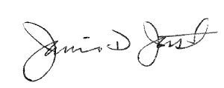

Jamie Just
President, Illinois & Iowa Building Officials Association
ILLOWA ICC Chapter

