September 26, 2025

Mr. Stuart Tom
Chair, ICC Nominating Committee
c/o John Belcik, Chief Executive Officer
900 Montclair Rd.
Birmingham, AL 35213
stom@iccsafe.org
communications@iccsafe.org

Re: ICC Board President Nomination
Michael Boso

Dear Chairman Tom and Members of the Nominating Committee:

The Building Officials Conference of Northeast Ohio (BOCONEO) is requesting your consideration to appoint Mr. Michael Boso to Position of President of the ICC Board of directors. Mr. Boso’s experience in the building industry along with his knowledge of codes, standards, and building practices, would lead to insightful value-added contributions to the ICC Board President’s position.

Mr. Boso has contributed to many associations dedicated to the adoption, education, and enforcement of Building and Fire Codes. He is a Past President of the Central Ohio Code Officials Association and a Past President of the Ohio Building Officials Association. Along with his OBOA colleagues, he has been instrumental in the growth of OBOA and the OBOA Foundation.

On behalf of BOCONEO, I respectfully request your consideration in the appointment of Mr. Michael Boso to ICC Board President.

Respectfully:

Mr. Dale Steppenbacker
President BOCONEO

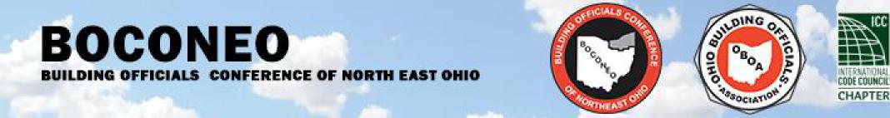
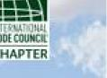
B.O.C.O.N.E.O. Officers
President
Dale Steppenbacker
Twinsburg
First Vice President
Jim Urankar
Brunswick
Second Vice President
Mark Patterson
Safebuilt
Secretary/Webmaster
Monica Ferrante
Mayfield Heights
Treasurer
Jason Pastorius
Twinsburg
Education Chairmen
Dan Perno
Mentor
Cooperating Member
Joe Eisenhuth
Solon Fire Dept.
Past President
Russ Rodic
Safebuilt
BOCONEO P.O. Box 18, Aurora, OH 44202
Copyright © 2024 by B.O.C.O.N.E.O. · All Rights reserved
E-Mail: boconeo@gmail.com

