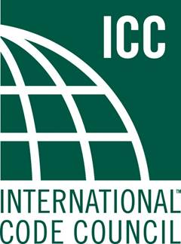
APPLY FOR THE PROFESSIONAL DEVELOPMENT COUNCIL
ICC is issuing a call for new members of the Professional Development Council (PDC). If you are interested in having a say in the governance of the ICC National Certification exams and/or the ICC Education program, now’s the time to apply, the application closing date is May 22nd, 2020.
The PDC is comprised of two committees: the Certification Committee [CC] and the Education Committee [EC]. The CC and EC are each made up of six members, with ICC Board of Directors liaisons and PDC Chair. The CC and EC will meet separately and/or jointly as meeting items warrant. The CC and EC members are appointed by the ICC Board of Directors for three-year terms. Currently, there will be 4 positions open on PDC (2 for the CC and 2 for the EC).
Individuals appointed to the Certification Committee shall be responsible for advising ICC staff and the ICC Board of Directors on all matters related to the Certification Program, as well as direction and oversight of Examination Development Committees. The CC has sole authority over the rules and procedures of the ICC Certification Program, including such topics as the appeals process, examination security policies, disciplinary action, and others.

Individuals appointed to the Education committee shall be responsible for advising ICC staff and the ICC Board of Directors on strategic matters related to ICC Education Program activities. Serving on the EC will help strengthen the credibility and quality of the ICC Education program.

Committee members will be required to meet via web/telephone conference and/or in person up to several times per year as needed. In-person meetings are held at least once a year for a one- to two-day period, with travel expenses reimbursed by ICC. Committee members must be able and willing to travel for scheduled meetings. Orientation and initial training will be provided by ICC staff Liaisons and ongoing assistance will be provided as needed.

If you have additional questions about the duties and responsibilities of a PDC member, please feel free to contact us at 888-422-7233, ext. 3389 or at cthomas@iccsafe.org

