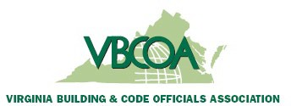

September 12, 2025

Stuart Tom & Members of the ICC Nominating Committee
International Code Council
900 Montclair Road
Birmingham, AL 35213

Subject: Chapter Support for ICC Board of Directors Candidate – Rachel Parrish
Dear Chairman Tom & ICC Nominating Committee
On behalf of the Virginia Building and Code Officials Association, we are pleased to offer our support for Rachel Parrish as a candidate for the ICC Board of Directors.
Rachel has demonstrated a clear commitment to the mission and values of the International Code Council. She is actively engaged in the code profession within her local jurisdiction and have contributed significantly to advancing safe, sustainable, and resilient communities.
Our chapter believes that Rachel meets the requirements of serving as a Board member based on her professional credentials, leadership experience, and long-standing involvement in the code professional arena. She brings valuable knowledge, perspective, and dedication that will strengthen the ICC Board of Directors and support its continued success as the global leader in building safety.
We respectfully request your consideration of Rachel.
Respectfully,
Michelle Coward
Michelle Coward, CBMO
Immediate Past President,
Virginia Building and Code Officials Association

