August 27, 2025

Stuart Tom & Members of the
ICC Nominating Committee
International Code Council
900 Montclair Road
Birmingham, AL 35213

Re: Board of Directors Letter of Support

Dear Chairman Tom and ICC Nominating Committee:

On behalf of the Board of Directors of the Washington State Association of Fire Marshals, we are writing to you today to express our support for Jack Applegate for election to ICC Board of Directors Director at Large Position at the 2025 Annual Business Meeting in Cleveland, Ohio.

Mr. Applegate has supported our Association and helps to represent our best interests. He is well known in the industry and our region as a code official and as an ICC Board Member. Mr. Applegate has distinguished himself in the industry and in his role on the ICC board of directors and committees, through his continuing focus to do what is best for the membership and ICC as an organization. Mr. Applegate also has shown a longstanding passion for the building and fire codes and the code development process. Mr. Applegate has worked diligently to educate himself on all the issues in order to make decisions that best serve the ICC membership along with the organization. He continues to advocate for the membership to raise their profiles and increase professionalism within our industry.

Jack has been involved at the local, regional, state and national code levels for many years and we feel he will continue to be a great asset to the ICC Board of Directors. Please accept this letter as our support for Jack Applegate to continue as an at Large position on the ICC board of Directors.

We appreciate your time and your help in this.

Respectfully,
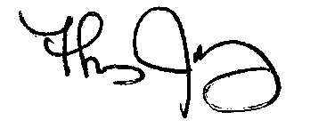

Thomas J. Maloney, MBA/PA, CFO, EFO, FM
President
Washington State Association of Fire Marshals

CC: WSAFM Board of Directors

