

ICC A117.1 STANDARD

UNRESOLVED ISSUE REPORT

Stemming from
SECOND PUBLIC REVIEW DRAFT

October 1, 2015

ICC/ANSI A117.1 STANDARD
DEVELOPMENT - 2015 EDITION

A117.1 Standard Committee

2012 Cycle Changes to review for

2015 Edition of the A117.1 Standard
Copyright ©2015 International Code Council, Inc.

Unresolved Issue Request
#24B (6-37-12 PC1) Lavatory Basin Setback

To: A117.1 Committee Members
From: Kermit Robinson – staff secretariat
Date: June 15, 2015 – Updated October 1, 2015

As a result of the distribution of Matt Sigler’s unresolved Issue Request, comments were received. Those are found starting on Page 19.

Matt Sigler of PMI asked that issue #24B (6-37-12 PC1) be considered an unresolved issue based on the committee’s action to disapprove public comments to revised 6-37-12. The request for consideration was sent (5/26/15) to the committee as a follow up to the recirculation of the ballot. Because Mr. Sigler was hoping for consideration of the revised proposal presented at the February meeting – and included below, more specific instructions were sent to the committee on the 28th. They were as follows:

My apologies for not giving you better guidance on this ‘Unresolved” issue. This is a part of our process that doesn’t trigger often – and I should have given you better information. The information is here – please read it carefully. Don’t be afraid to ask me questions on this. And if this information results in you wanting to change you ballot/vote, you may do so. Deadline for commenting on this item remains June 9th.

First: All committee members can submit a ‘comment’ on this item, even if you did not submit the 15.02 Ballot.

Your options:
- If you submitted the 15.02 ballot –
  - You can opt not to comment on this Unresolved issue. If I do not hear from you I will assume your ballot vote for this item (#24B) will carry forth.
  - You can opt to tell me you wish to confirm your vote on the ballot 15.02 – I will carry it forward
  - You can return a ‘negative ballot’ on #24B – But it is important to tell me
    - If you are voting against the committee action; (Supports the original comment for a 6 inch setback of the lavatories), or
    - You are voting against the committee action and for PMI’s Proposed Change to Sec. 606.5 (attached – a 5 inch setback and 3.5 inches in specified locations)
- If you didn’t submit the 15.02 ballot –
  - If I don’t hear from you regarding this issue, I must assume you are not voting.
  - You can return a statement saying you approve of the committee’s action to disapprove this item
  - You can return a ‘negative ballot’ on this ‘Unresolved issue - #24B – But it is important to tell me
    - If you are voting against the committee action; (Supports the original comment for a 6 inch setback of the lavatories), or
    - You are voting against the committee action and for PMI’s Proposed Change to Sec. 606.5 (attached – a 5 inch setback and 3.5 inches in specified locations)

Results of Committee Response:

This issue will be returned to the Committee’s agenda in November for further consideration. While there were not sufficient comments supporting either c.i or c.ii. (above), there were sufficient comments to establish that the original disapproval of this public comment no longer represents 2/3 of the committee voting upon this issue.

Who were considered eligible voters on this issue:

As this was outside the ballot process, all committee members were eligible for voting including those who failed to return the first ballot and those who abstained. The members who returned the original ballots (44) were joined by two more members who voted on this issue: HUD and AOTA – therefore the number voting is 46.

Results:

Seventeen members supplied a negative ballot during the first balloting or supplied a comment supporting a different solution based on Mr. Sigler’s request. That means only 29 of 46 members voting on this item have voted to sustain the committee’s action. That is equal to 63%. The committee’s rules require actions to be sustained by 2/3 of those voting. Thus the committee’s disapproval is not sustained. However, there was also not a 2/3 voting majority for an alternative solution. Without an action sustained by 2/3 of the voting committee we don’t have a decision. This issue needs to be returned to the agenda.

Comments by those not supporting original committee action:

Alan Gettelman
Comment: I want to change my original ballot on Item 6-37-12. I now submit a Negative Ballot supporting PMI-Matt Sigler for reconsideration.

John Salmen
Comment: I am voting for item c.ii. – against the committee action and for PMI’s proposed change to Section 606.5 that calls for a 5 inch setback and 3.5 inches in specific locations.

AH&LA – Doug Anderson
Comment: The requirement for a maximum dimension from the countertop edge to the inside of the basin is a new provision and the dimension is arbitrary and not based on any type of research. The impact of this requirement on the instillation of different types of sinks (under-mount/self-rimming/integrated basins in countertops, wall mounted, etc.) is not known, the benefit of this requirement is not known, and the impact on provision of accessible knee space with different types of sinks is not know.
Based on the extent of the unknowns and potential expense and conflict with accessible knee space requirements, it seems unreasonable to adopt any basin setback requirements until more research is conducted.
AHLA is choosing option 1.c.ii for #24B. Against the committee action and for PMI’s Proposed Change to Section 606.5 (attached – a 5 inch setback and 3.5 inches in specified locations).

AIA – David Collins
Comment: I am voting against the committee action and for PMI’s Proposed Change to Sec. 606.5 (attached – a 5 inch setback and 3.5 inches in specified locations)
I believe that the information provided in the changes to Section 606.5 is as relevant today as it was when originally developed. I believe that the committee was wrong in its decision to not provide some means for flexible design solutions for a broader user base.

APSP – John Caden
Comment: I agree with the Kohler research.

AOTA – Shoshana Shamberg/BrianDudgeon
Comment: We would like to vote in and be in favor of the 5 inch setback with 3.5 inches in specified locations.

ASPE – Dan O’Gorman
Comment: ASPE is choosing option 1.c.ii for #24B. Against the committee action and for PMI’s Proposed Change to Section 606.5 (attached – a 5 inch setback and 3.5 inches in specified locations).

BOMA – Steve Orlowski
Comment: Based on the persuasive arguments from Mr. Anderson and Mr. Sigler, BOMA is voting against the committee action and in support of PMI’s proposed change to Section 606.5.
CSI – Dennis Hall
Comment: CSI is choosing option 1.c.ii for #24B. Against the committee action and for PMI’s Proposed Change to Section 606.5 (attached – a 5 inch setback and 3.5 inches in specified locations).

HLAA – Sharon Toji
Comment: I would like to see choices if possible.

ICC – Kimberly Paarlberg
Comment: I want this back on the agenda for discussion and consideration. I do not like the current proposed fix. At this point I support the proposal for 6 inches.

NAHB – Dan Buuck
Comment: When the committee approved the 3 1/2 inch dimension, it did so with the intent that the number was a starting point to encourage feedback from industry. The industry responded with more technical data than is usually required by the committee for proposed changes, and yet it stuck with the original dimension for which no data was given. Some member comments criticized the age of the research, but why would there be newer data if the issue had not come to the forefront recently? The industry’s research is much preferable to the complete lack of data presented by others on the committee.
NAHB is choosing option 1.c.ii for #24B. Against the committee action and for PMI’s Proposed Change to Section 606.5 (attached – a 5 inch setback and 3.5 inches in specified locations).

NATO – Gene Boecker
Comment: I support the position taken by PMI and their proposed modification. Although the original proponent made an effective argument that people use sinks in airports and offices for oral hygiene, such is not the case in shopping centers, bars and movie theaters. The scope needs to be limited in some fashion to allow other sinks basins to be used. I agree with PMI that without a limit the basin could be placed too far from the counter edge (and I have seen these awkward things). The 5 inch dimension seems adequate for that need. The 3-1/2 inches in limited conditions seems appropriate for constructability. The next step would be to modify the scoping for these enhanced reach range sinks in the proper installations.

PMI – Matt Sigler
Comment: Voting against the committee action and for PMI’s Proposed Change to Section 606.5 (attached – a 5 inch setback and 3.5 inches in specified locations.)
There are extensive comments from Matt Sigler throughout this document.

RESNA – Edward Steinfeld
Comment: This is a two-fold problem caused by lack of an evidence based approach to standards development and lack of current research on PMI’s side. On one hand, there is no research to support the 3.5 in. max and the plumbing industry is probably right about the impact. The rule we approved would probably throw us back to surgical sinks as the only code compliant option. On the other hand, the current knee space is not good either so the illustrations showing the impact should be looked at in light of that. Only 50% of the 500 people we measured in our anthropometry study fit under the current knee space clearance. But our recommendations for changing that were not accepted by the Committee. I reviewed our data. You can find it at http://udeworld.com/documents/designresources/pdfs/KneeToeClearance.pdf See Fig. 1. Given the actual sizes of WMD users, the 3.5 in. rule would probably be an improvement because, with the current distance, the individuals requiring the deeper knee space have to position themselves back further from the counter. The enhanced lavatory would allow them to be closer to the sink edge. So, I am voting against the committee’s action and for PMI’s proposal. As I understand it, this would require the 3.5 in max. in the enhanced lav only, perhaps spurring some innovation in the plumbing industry.

SMA – David Cooper
Comment: Based upon review of all the comments I am voting against the committee action and for PMI’s Proposed Change to Sec. 606.5 describing – a 5 inch setback and 3.5 inches in specified locations.

WABO – Rick Lupton.
Comment: Based on the public comments submitted.

PMI Rationale included with Unresolved Issue distribution – 5/26/15

PMI does not believe that the Committee’s actions provided an appropriate resolution to our comment for 6-37-12 PC1 (Agenda Item #24B) for the following reasons:
1. What is shown in the committee action report for Agenda Item #24B (6-37-12 PC1) is incorrect, and should be replaced with the attached that was discussed during the February Meeting.
2. PMI provided the Technical Committee with the attached field studies conducted by Kohler that demonstrated:
a. A 3-1/2 inch basin setback does not work for all disabilities.
b. Some wheel chair users prefer more surface area contact for forearms, this gives them greater control and stability. A setback of 5 inches provided the necessary surface area for such users.
3. Those in opposition to PMI’s comment indicated that Kohler’s field studies were dated, and not based on current practices. However, it was also acknowledged by those who opposed PMI’s comment that no technical data or evidence was ever provided to prove that a 3-1/2 inch maximum basin setback was a valid dimension. Even the Chair acknowledged such when casting his negative vote to break the tie during the February Meeting.
4. Those in opposition to PMI’s comment further indicated that they were opposed to PMI’s comment because they believed that a 3-1/2 inch lavatory basin setback was necessary for those with limited reach, and because the A117.1 does not mandate that a certain percentage of public lavatories meet the requirements of Section 606.6 (Lavatories with Enhanced Reach Range) that all ADA lavatories should have a 3-1/2 inch maximum basin setback. PMI agrees that those with limited reach should have a maximum basin setback of 3-1/2 inches and indicated such within the attached comment that was discussed during the February Meeting. However, PMI does not agree that all ADA lavatories should be required to have a maximum 3-1/2 inch basin setback just because a certain percentage of those with disabilities require it, but instead would encourage the committee to consider mandating that a certain percentage of ADA required lavatories meet the requirements of Section 606.6.
5. PMI is very concerned that an ICC Committee such as A117.1 would knowingly allow a technical requirement into one of their standards/codes that was based on absolutely no technical data.

PMI Proposal included with Unresolved Issue distribution – 5/26/15

606.5 Basin Location. The interior edge of the rim of the lavatory basin shall be located 5 3 ½ inches (127 90 mm) maximum from the front edge of the fixture or countertop. Where a lavatory is required to comply with Section 606.6, the interior edge of the lavatory basin shall be located 3 ¹/₂ (90 mm) maximum from the front edge of the fixture or countertop.
Substantiation:
- The proponents for the 3-1/2 inch maximum lavatory basin setback requirement have failed to provide sufficient evidence to show that setbacks greater than 3-1/2 inches have been an issue in all circumstances. The facts are that a 5 inch setback is necessary to allow the use of various styles of lavatories such as counter-mounted. Additionally, based on the underside contour and style of the lavatory, in conjunction with the countertop thickness, a 5 inch setback is necessary to achieve the required knee and toe clearances.
- As far as providing sufficient evidence for the proposed 5 inch maximum setback, Kohler conducted in-house research that demonstrated that as much as 5 inches was necessary based on some users comfortably stabilizing themselves upon the front edge of the fixture. Additionally, a 5 inch dimension is necessary depending on the style of sink being used as previously indicated. Furthermore, Kohler discovered that a 3-1/2 inch setback was more appropriate for persons with limited reach, and therefore the recommendation by PMI to add the second sentence to Section 606.5.
- The committee should be reminded that for years 5 inches or greater was necessary to accommodate lavatory overflow channels as they were not permitted to infringe into the required knee and toe clearances that were mandated by the standard. It was not until the standard was changed (1992 version of the standard) to allow the overflow channel to infringe into the knee and toe clearance space that manufacturers were able to move the basin forward to accommodate a 3-1/2 inch setback.
- A mandate for a 3-1/2 inch maximum lavatory basin setback for all circumstances would significantly limit choice in the marketplace. In fact, it would literally eliminate 50% or more of the accessible product that is currently available.
- In conclusion, a 3-1/2 inch maximum lavatory basin setback is not appropriate for all circumstances, and therefore PMI recommends a 5 inch maximum setback for all lavatories except those that are required to comply with Section 606.6 (Lavatories with Enhanced Reach Range).

ORIGINAL PROPOSAL

6-37– 12
606.5 (New)

Proposed Change as Submitted

Proponent: Judith K. Pipher, Independence First

Add new text as follows:

606.5 Basin Location. The interior edge of the rim of the lavatory basin shall be located 3 inches (75 mm) maximum from the front edge of the fixture or countertop.

Reason: Lavatory basins need to be accessible not only regarding reach ranges for faucets but for persons performing hygiene activities such as brushing their teeth or using mouthwash. Quite simply, basins need to be located to allow a person in a wheelchair to move his or her head and mouth over the basin to spit out toothpaste, mouthwash or other waste materials. Particularly where lavatories are dropped into countertops (but also where pedestal lavatories have especially deep horizontal ledges between their leading edges and the bowl) the location of the basin should be within a range that makes it usable to persons in a seated position.
A dimension of ±3 inches (75 mm) is typical of kitchen sink locations and should be sufficient to providing this level of access to wheelchair users and persons of short stature at bathroom and toilet room lavatories.
While this issue is greatest in dwelling units, many persons perform hygiene activities in commercial facilities such as office or airport toilet rooms. Because of this, the change in Section 606 is appropriate.
606.5 (New)-PIPHER.doc

FIRST COMMITTEE ACTION -
Committee Action

Approved

Committee Reason: The proposal provides a reasonable standard to address a growing issue of the placement of lavatory basins. Three inches provide a reasonable setback from the edge of the countertop for inset basins.

BALLOT COMMENTS

6-37.1
Commenter: Rick Lupton, Representing WABO
Ballot: Affirmative with comment:

Comment: To be consistent with our usual policy, the proponent really should provide data that shows the 3-inches is within neck reach range –though it does “seem” adequate.

Committee Review of Comments and Action – July 2013

Approved.

Committee Reason: The committee discussed concerns that a 3 inch set back could result in structural support issues for certain counter top materials. For example a stone counter top may not be able to be cut to a 3 inch minimum without breaking. The committee sees this as an important improvement to the standard and maintained its approval for the public review draft.

FIRST PUBLIC REVIEW DRAFT AND PUBLIC COMMENTS

6-37– 12
(This represents the language approved by the committee for the First Public Review Draft)

Add new text as follows:

606.5 Basin Location. The interior edge of the rim of the lavatory basin shall be located 3 inches (75 mm) maximum from the front edge of the fixture or countertop.

Brad Gaskins, representing self

Further revise as follows:

606.5 Basin Location. The interior edge of the rim of the lavatory basin shall be located 3 ½ inches (75 90 mm) maximum from the front edge of the fixture or countertop.

Reason: At the current 3” from the front edge most sinks would not be able to comply with the required knee clearance. It would be impossible to meet the 8” deep requirement.

The following figures were submitted as part of Mr. Gaskins comment.

6-37-12 PC1

Committee action on 6-37-12 PC1

Approve Public Comment 6-37-12 PC1.

Reason: Mr. Gaskins demonstrated that the 3 inch measurement would not allow other provisions to be in compliance. The 3.5 depth still addresses the need raised by this original proposal and allows overall compliance.

MR. GASKIN’S PUBLIC COMMENT WAS APPROVED AND WAS PART OF 2ND PUBLIC REVIEW DRAFT.

MR. SIGLER’S COMMENTS (below) WERE ON PUBLIC COMMENT 1 (PC1) TO 6-37-12 .

6-37-12 PC1
Agenda Item #24
Comment No:  6-37-12 PC1.1 | Submitted by:  Matt Sigler - PMI
Further revise as follows:

606.5 Basin Location. The interior edge of the rim of the lavatory basin shall be located 3 ½ 6 inches (90 150 mm) maximum from the front edge of the fixture or countertop.

Reason:
PMI is very much against the original proposal of 3 inches, and this public comment that revises the dimension to 3-1/2 inches for the following reasons:
1. There are many lavatories in the market that have been acceptable for years with setbacks of up to 5 or more inches to gain the required knee clearance as stated in Section 306.3.
2. According to studies conducted by Kohler, lavatories can be very uncomfortable even painful to use when the rims are moved so far forward on the counter as would be the case with the proposed language. People would be resting their forearms or wrists on the rims of the lavatories that can cause a pinching sensation of the wrists and soreness of the underside of the forearms.
3. The further forward a lavatory is set there is greater propensity for splashing because of the angle of discharge from the faucet.
4. There is no known study that supports the proposed setbacks. Therefore, a task group should be formed to review this proposal before being considered by the committee for inclusion into the standard.

As it is too late in the process to eliminate this new requirement, we are offering a dimension that should be appropriate for the fixtures that are available on the market and provides that the original issue is still addressed. We are still researching with our member manufacturers as to what would be the best distance. We will bring out findings to the February 2015 meeting and may suggest a distance different than 6 inches.

6-37-12 PC1 - AS PUBLISHED 2ND PUBLIC REVIEW DRAFT
Revise as follows:

606.5 Basin Location. The interior edge of the rim of the lavatory basin shall be located 3 ½ inches (75 90 mm) maximum from the front edge of the fixture or countertop.

COMMITTEE ACTION ON MR. SIGLER’S COMMENT – FOLLOWED BY INITIAL RESULTS OF BALLOT 15.02.

6-37-12 PC1
Agenda Item #24B
Committee Action on Agenda Item #24B – comment number 6-37-12 PC 1.1

Disapproved:

Reason:
The committee considered considerable information provided by the proponent, but found that it was based on older information which did not reflect even the current A117.1 (and ADA) standards nor typical wheeled mobility equipment in use today. There are sinks currently on the market that will allow the 3-1/2 setback installation. The Committee remained committed to adding this provision – at this setback distance into the Standard.

Ballot Results for #24B:
51 Number eligible to vote
44 Number of members casting a vote.
40 - Affirmative (Uphold the Committee Recommendation)
0 - Affirmative with Comment
4 - Negative (Disagree with the Committee Recommendation) AHLA, APSP, NAHB, PMI
1 - Abstain (from Voting) -ASID
6 - Not Returned – Andersen, AERBVI, AOTA, HUD, NFPA, PVA

AH&LA – Doug Anderson
Negative Ballot
Comment: The requirement for a maximum dimension from the countertop edge to the inside of the basin is a new provision and the dimension is arbitrary and not based on any type of research. The impact of this requirement on the instillation of different types of sinks (under-mount/self-rimming/integrated basins in countertops, wall mounted, etc.) is not known, the benefit of this requirement is not known, and the impact on provision of accessible knee space with different types of sinks is not know.
Based on the extent of the unknowns and potential expense and conflict with accessible knee space requirements, it seems unreasonable to adopt any basin setback requirements until more research is conducted.

APSP – John Caden
Negative Ballot
Comment: I agree with the Kohler research.

NAHB– Dan Buuck
Negative Ballot
Comment: When the committee approved the 3 1/2 inch dimension, it did so with the intent that the number was a starting point to encourage feedback from industry. The industry responded with more technical data than is usually required by the committee for proposed changes, and yet it stuck with the original dimension for which no data was given. Some member comments criticized the age of the research, but why would there be newer data if the issue had not come to the forefront recently? The industry’s research is much preferable to the complete lack of data presented by others on the committee.

PMI– Matt Sigler
Negative Ballot
Comment: PMI does not agree with the Committee’s actions for 6-37-12 PC1.1 (Agenda Item #24B) for the following reasons:

- What is shown in the committee action report, dated March 20, 2015, for Agenda Item #24B (6-37-12 PC1) is incorrect, and should be replaced with the following that was discussed during the February meeting:

606.5 Basin Location. The interior edge of the rim of the lavatory basin shall be located 5 3 ½ inches (127 90 mm) maximum from the front edge of the fixture or countertop. Where a lavatory is required to comply with Section 606.6, the interior edge of the lavatory basin shall be located 3 ¹/₂ (90 mm) maximum from the front edge of the fixture or countertop.

Substantiation:
- The proponents for the 3-1/2 inch maximum lavatory basin setback requirement have failed to provide sufficient evidence to show that setbacks greater than 3-1/2 inches have been an issue in all circumstances. The facts are that a 5 inch setback is necessary to allow the use of various styles of lavatories such as counter-mounted. Additionally, based on the underside contour and style of the lavatory, in conjunction with the countertop thickness, a 5 inch setback is necessary to achieve the required knee and toe clearances.
- As far as providing sufficient evidence for the proposed 5 inch maximum setback, Kohler conducted in-house research that demonstrated that as much as 5 inches was necessary based on some users comfortably stabilizing themselves upon the front edge of the fixture. Additionally, a 5 inch dimension is necessary depending on the style of sink being used as previously indicated. Furthermore, Kohler discovered that a 3-1/2 inch setback was more appropriate for persons with limited reach, and therefore the recommendation by PMI to add the second sentence to Section 606.5.
- The committee should be reminded that for years 5 inches or greater was necessary to accommodate lavatory overflow channels as they were not permitted to infringe into the required knee and toe clearances that were mandated by the standard. It was not until the standard was changed (1992 version of the standard) to allow the overflow channel to infringe into the knee and toe clearance space that manufacturers were able to move the basin forward to accommodate a 3-1/2 inch setback.
- A mandate for a 3-1/2 inch maximum lavatory basin setback for all circumstances would significantly limit choice in the marketplace. In fact, it would literally eliminate 50% or more of the accessible product that is currently available.
- In conclusion, a 3-1/2 inch maximum lavatory basin setback is not appropriate for all circumstances, and therefore PMI recommends a 5 inch maximum setback for all lavatories except those that are required to comply with Section 606.6 (Lavatories with Enhanced Reach Range).

- PMI provided the Technical Committee with field studies conducted by Kohler that demonstrated:
  - A 3-1/2 inch basin setback does not work for all disabilities.
  - Some wheel chair users prefer more surface area contact for forearms, this gives them greater control and stability. A setback of 5 inches provided the necessary surface area for such users.

- Those in opposition to PMI’s comment indicated that Kohler’s field studies were dated, and not based on current practices. However, it was also acknowledged by those who opposed PMI’s comment that no technical data or evidence was ever provided to prove that a 3-1/2 inch maximum basin setback was a valid dimension. Even the Chair acknowledged such when casting his negative vote to break the tie during the February Meeting.

- Those in opposition to PMI’s comment further indicated that they were opposed to PMI’s comment because they believed that a 3-1/2 inch lavatory basin setback was necessary for those with limited reach, and because the A117.1 does not mandate that a certain percentage of public lavatories meet the requirements of Section 606.6 (Lavatories with Enhanced Reach Range) that all ADA lavatories should have a 3-1/2 inch maximum basin setback. PMI agrees that those with limited reach should have a maximum basin setback of 3-1/2 inches and indicated such within the above comment that was discussed during the February Meeting. However, PMI does not agree that all ADA lavatories should be required to have a maximum 3-1/2 inch basin setback just because a certain percentage of those with disabilities require it, but instead would encourage the committee to consider mandating that a certain percentage of ADA required lavatories meet the requirements of Section 606.6.

- PMI is very concerned that an ICC Committee such as A117.1 would knowingly allow a technical requirement into one of their standards/codes that was based on absolutely no technical data.

PMI believes that the attached public comment should be accepted as submitted. However, if PMI’s comment does not receive the necessary votes for reconsideration by the Technical Committee, than at least the item in question should be tabled until next code cycle and a task group formed to properly vet this item.

Additional comments received after July 1, 2015

24B.2015-01
Comment Submitted by: Dan Bartz, Representing Kohler

#24B (6-37-12 PC1) Lavatory Basin Setback

The following proposed language should be considered:

606.6 Lavatories With Enhanced Reach Range At least one lavatory shall be provided with enhanced reach range and shall comply with section 606.6. The interior edge of the lavatory basin shall be located 3 ¹/₂ (90 mm) maximum from the front edge of the fixture or countertop. Where enhanced reach range is required at lavatories, f Faucets and soap dispenser controls shall have a reach depth of 11 inches (280 mm)maximum, or if automatic shall be activated within a reach depth of 11 inches (280 mm) maximum. Water and soap flow shall be provided with a reach depth of 11 inches (280 mm).

Reason:” Leave the current standards as is and simply add language to the Enhanced Reach Range section. By doing so would then require installations in public bathrooms that would ensure the presence of accessible bathroom sinks for the little people. The current standard as is states “where enhanced reach range is required …” this language leaves the issue wide open for in consistent application of the requirements and poor judgement as to whether or not these type of installation are needed. We have heard testimony that are few if any public bathrooms that presently have such installations that meet this need.

24B.2015.02
Comment Submitted by: Jean Tessmer, Representing herself

#24B (6-37-12 PC1) Lavatory Basin Setback

Further revise as follows:

606.5 Basin Location. The interior edge of the rim of the lavatory basin shall be located 3 1/2 2 inches ( 90 75 mm) maximum from the front edge of the fixture or countertop.

Background and documentation supporting the 2 inch setback for Basins.

The later proposal from PMI which I am commenting on all started with the original proposed change from Judith K. Pipher, Independence First – 6-37-12 606.5 (new). See below in red.
PMI without providing any disability usability studies submitted that the sink should move back away from the front edge of the counter by 5”. Then Kim Paarlberg said 6”. Since I did not see any disability ergonomics study that would satisfy the usability of the movement of the bowl further from the leading edge of a counter, the suggestion does not make sense based on the original ANSI A117.1 1961 and 1986.
The ANSI A117.1 is a disability design and construction criterion. The primary focus of this particular committee is to lean toward providing usable design and products. This is the stated goal of this body of members. It is not a plumbing or marketing business membership. The outcomes from this committee should not impede but allow better access to goods and services equal to the same access to goods and services for ambulatory individuals. The ANSI A117.1 is the American version of disability rights which is to augment independence not obstruct and create by dependence. We are not supposed to make the lame look lamer. We are supposed to make the way straight.
Here is I hope a simple analogy that we can all relate to. When we are all in a seated position at a dining table the placement of the large place is to be 1 to 2 inches from the edge of the table (see references below). The reason why is obvious, it is easier to eat off a plate if the plate is closer to the edge. Can you imagine what it would be like to make the required stated position of a plate 5 to 6 inches back from the edge of the table?
Now imagine that you’re sitting in a chair to use a lavatory that is 5 or 6 inches away from the edge of a counter or a drinking fountain with the spout 5 or 6 inches away from the leading edge of the rim of the fountain. You would be hard pressed to get some water to your face to rinse if off since you cannot get your face over the bowl. Should we put signs up that state you cannot shave, rinse your face, and brush your teeth or do any other activity that would allow you to place your face over the bowl of a sink.
Another example is drinking fountains now allowed per the newer code to have the spout 5 inches from the front rim of the bowl how do you get your lips to touch the water when you are seated, especially when you have to use your fist against your chest (adding 2 or 3 more inches to the 5 to 6 inch distance). We have already created problems with drinking fountains by moving the fountain spout so it can be 5 inches from the front rim. See Photos below.

The 1990 ADA and UFAS had drinking fountains with the spout at the front edge of the drinking fountain with the trajectory of water parallel to the front edge.

Now we have set precedence with allowing the spout to be 5 inches max., from the leading edge of the drinking fountain. There is no research that bears out this distance to be usable. The original drinking fountain spout location was based on the research and conversation with the University of Illinois. Pushing the essential access to water back far away from the face of the individual with a disability means we are telling them to go back to carrying around a cup for attaining access to water because the drinking fountain will only give them clear approach but no access to the water. Who is the ANSI A117.1 committee supposed to represent? Who is pressuring the committee to follow market trends? I am grateful for manufacturers who still provide usable drinking fountains and other components for individuals with disabilities. I only spec components and fixtures that are usable based on the research and studies produced over a 40 year period by the University of Illinois and I still converse with the original researchers who have said this requirement does not make sense. How will an individual rinse their face if on an outing if they get hot? How will they reach the handle sets which will only be pushed back further? Will PMI require the industry to drastically narrow down the faucet to be sold with the pushed back bowls to be a type that is a single lever with an extra-long handle? How does pushing back the leading edge of a bowl that needs to be access, facilitate the usability of that lavatory of someone with a disability? I say if the market wants to do something different let the burden of proof come from them and not from the individuals who make recommendations to help. That is the David and Goliath technique.
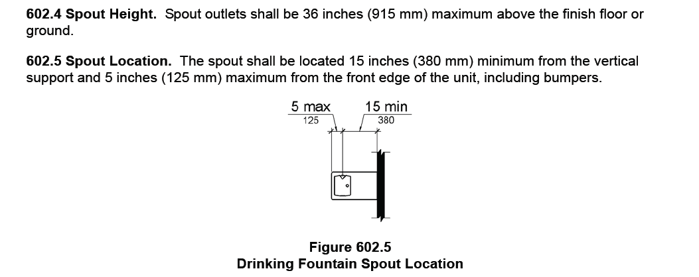
The distance should be set at 2 inches any component that needs to allow a person in a wheelchair to be able to get their face over the fixture such as lavatories, and drinking fountains. We need to look at the whole picture not just a part of it. That is the dynamic approach originally used to create the ANSI A117.1 Standard.
Before PMI this was the recommendation.

Original Proposal

6-37– 12
606.5 (New)
Proposed Change as Submitted

Proponent: Judith K. Pipher, Independence First

Add new text as follows:
606.5 Basin Location. The interior edge of the rim of the lavatory basin shall be located 3 inches (75 mm) maximum from the front edge of the fixture or countertop.

Reason: Lavatory basins need to be accessible not only regarding reach ranges for faucets but for persons performing hygiene activities such as brushing their teeth or using mouthwash. Quite simply, basins need to be located to allow a person in a wheelchair to move his or her head and mouth over the basin to spit out toothpaste, mouthwash or other waste materials. Particularly where lavatories are dropped into countertops (but also where pedestal lavatories have especially deep horizontal ledges between their leading edges and the bowl) the location of the basin should be within a range that makes it usable to persons in a seated position.
A dimension of ±3 inches (75 mm) is typical of kitchen sink locations and should be sufficient to providing this level of access to wheelchair users and persons of short stature at bathroom and toilet room lavatories.
While this issue is greatest in dwelling units, many persons perform hygiene activities in commercial facilities such as office or airport toilet rooms. Because of this, the change in Section 606 is appropriate.

Ms. Pipher was seeking better access (ergonomically) for individuals with disabilities to have usable sinks.
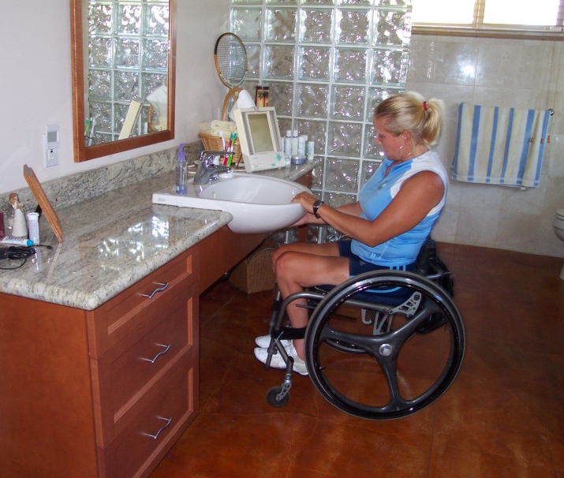
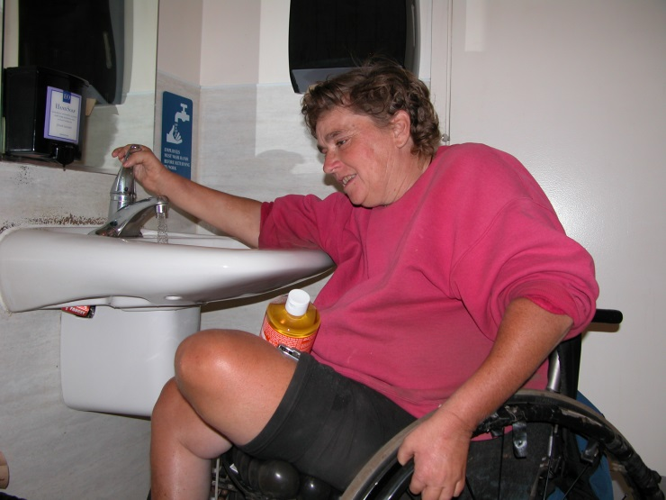

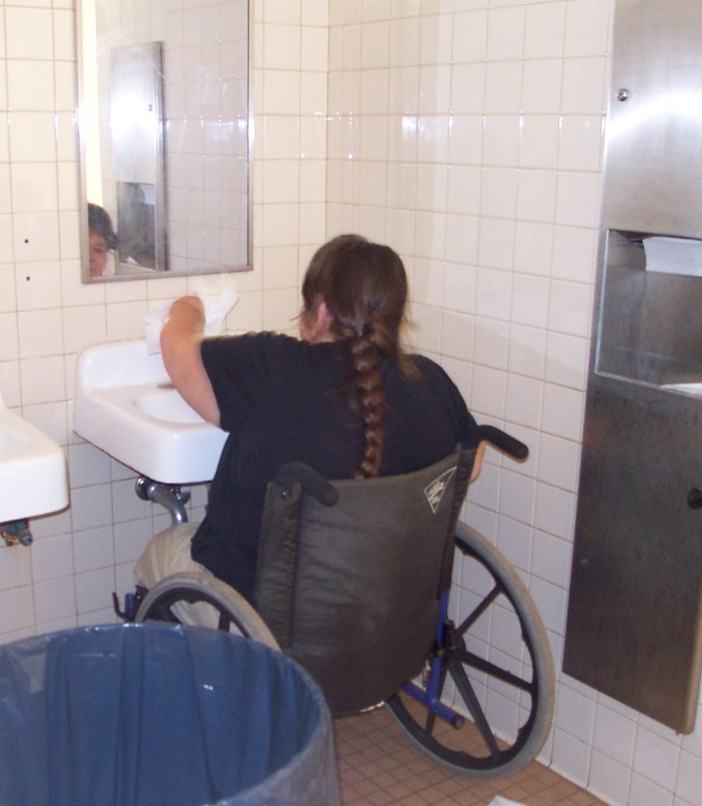
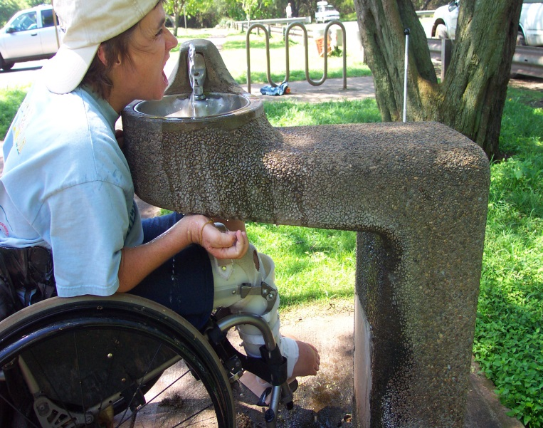
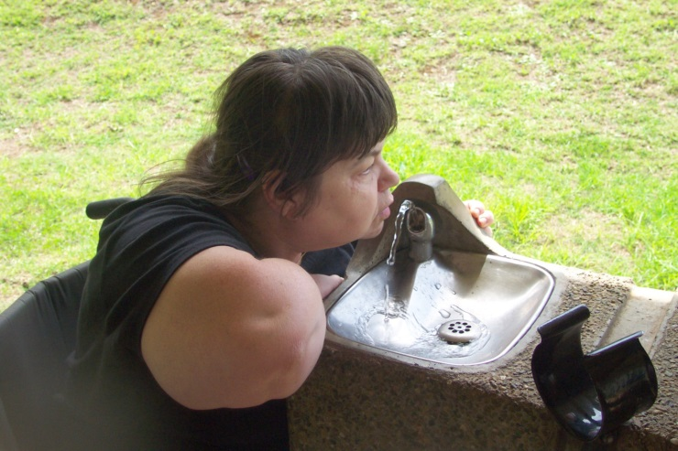
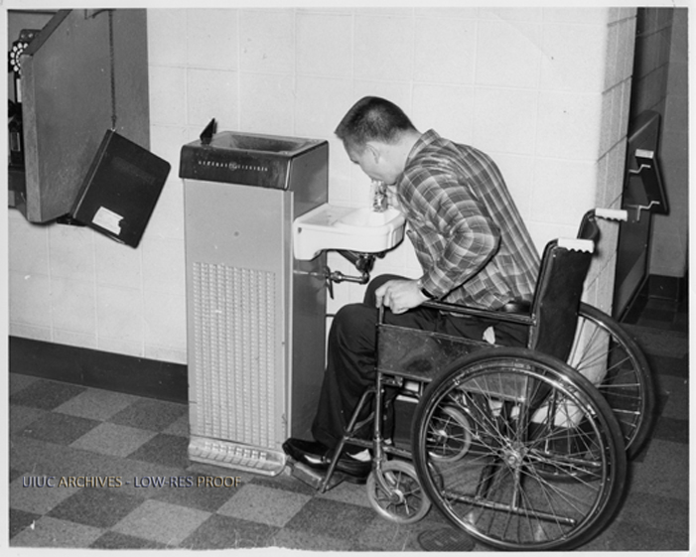

References for the placement of Dining plates distance from the edge of the table:

http://www.dummies.com/how-to/content/how-to-set-your-holiday-table.html

Illustration of plate placement with measurement.

http://www.bing.com/images/search?q=proper+plate+placement&view=detailv2&&id=DAB54D0FCC44BC457E8A5D28587DCE4AFA3FB6D2&selectedIndex=0&ccid=tSiumZgA&simid=608021461157151499&thid=JN.xARudqP88DQCmtlbpgIyKA&ajaxhist=0

Illustration by Kohlscorporation.com of dinnerware placement at 2" from the edge of the table.

http://etiquettescholar.com/dining_etiquette/table_setting/place_setting/dinnerware/placing_dinnerware.htm

Large plates, such as the dinner plate and luncheon plate, are laid about 1 inch in from the edge of the table. The exception is the service plate, a capacious plate aligned flush with the edge of the table.

https://www.lifetimebrands.com/How-Do-I-Set-a-Table%3F/How-To-Set-A-Table,default,pg.html

Place settings should sit one inch from the edge of the table.

http://allrecipes.com/howto/table-setting-101/?mxt=t06dda
Plates and Bowls
•Dinner plates should be placed approximately 2 inches from the table's edge, centered on the placemat (if using placemats) or squarely in front of each chair.

Codes Regulation Document Center - Claudia's Notes:
When it comes to making buildings accessible to all people, no matter what their mobility issues, we have ICC/ANSI A117.1 to thank for setting the standards used throughout the United States. It's hard to believe, but the standard has been around since 1961 and covers both new and existing facilities.
Let’s keep us being thankful to the ICC/ANSI A117.1 for promoting accessibility.

Jean Tessmer, RME, ASID

24B.2015.03
Comment Submitted by: Laurel Wright, Representing North Carolina

#24B (6-37-12 PC1) Lavatory Basin Setback

Laurel joined with others who previously provided support for the PMI concept of a mixture of a 5 inch setback with a 3.5 inch setback in specific locations.

