

PRELIMINARY REPORT
EDITORIAL TASK GROUP

January 3, 2014
The attached items have been found by the Task Group
during editorial review.
The Task Group requests direction from the full
A117.1 Committee

ICC/ANSI A117.1 STANDARD
DEVELOPMENT - 2014 EDITION

The issues contained in this report will be
Considered by the A117.1 Committee.
January 21 – 24, 2014.
U.S. Access Board Conference Room
Washington, DC.

Item #1

302 Floor Surfaces
302.1 General. Floor surfaces shall be stable, firm, and slip resistant, and shall comply with Section 302.
Changes in level in floor surfaces shall comply with Section 303.

EXCEPTIONS:
1. Within animal containment areas not exempted by Section 1001.2.1, floor and ground
surfaces shall not be required to be stable, firm, and slip resistant. (3-1-12)
2. Within areas of sports activity exempted in Chapter 10, the floor and ground surfaces
shall not be required to comply with this section. (3-1-12)

Item #2

403.5.3 Clear Width at 90 Degree Turn. Where an accessible route makes a 90 degree turn the clear widths approaching the turn and leaving the turn shall be one of the following sets of dimensions:

1. Both legs of the turn shall be 40 inches (1016 mm) minimum in width and the width of each leg of the turn shall be maintained for 28 inches minimum from the inner corner

2. Where the interior corners of the turn are chamfered for 8 inches minimum (205 mm) along both walls, both legs of the turn shall be 36 inches (915 mm) minimum in width. (4-9-12)

403.5.3 Clear Width at 90 Degree Turn. Where an accessible route makes a 90 degree turn, the clear width shall be 40 inches (1015 mm) minimum. The width of each leg of the turn shall be maintained for 28 inches minimum from the inner corner. (4-10-12)

EXCEPTIONS:
13. Where one leg of the turn is 42 inches (1065 mm) minimum in width, the other shall be permitted to be 38 inches (965 mm) minimum in width. (4-10-12)
24. Where one leg of the turn is 44 inches (1115 mm) minimum in width, the other shall be permitted to be 36 inches (915 mm) minimum in width. (4-10-12)

Item #3

KCR – Two versions of 404.3.2 need to be merged.

404.3.2 Maneuvering Clearances. Maneuvering clearances at power–assisted doors and gates shall comply with Section 404.2.3. Clearances at swinging automatic doors and gates without standby power and serving an accessible means of egress shall comply with Section 404.2.3. (4-30-12)(4-11-12)

EXCEPTION: Where automatic doors and gates remain open in the power-off condition, compliance with Section 404.2.3 shall not be required. (4-30-12)

404.3.2 Maneuvering Clearances. Maneuvering clearances at power-assisted doors shall comply with Section 404.2.3. Maneuvering clearances shall be provided on the egress side of low-energy automatic doors and full power automatic doors that serve as part of the accessible means of egress and shall comply with Section 404.2.3.

EXCEPTIONS:
1. Low-energy automatic doors and full power automatic doors that have standby power or battery back-up shall not be required to comply with this section.
2. Low-energy automatic doors and full power automatic doors that remain open in the power-off condition shall not be required to comply with this section.
3. Full power automatic sliding doors that include a break-away feature shall not be required to comply with this section. (4-31-12)

Item #4

604.9Wheelchair Accessible Compartments.

604.9.1 General. Wheelchair accessible compartments shall comply with Section 604.9.

604.9.2 Size. Toilet compartments shall comply with Section 604.9.2.1 or, 604.9.2.2, or 604.9.2.3 as applicable.

605 Urinals

605.1 General. Accessible urinals shall comply with Section 605.

605.2 Height and Depth. Urinals shall be of the stall type or shall be of the wall hung type with the rim at 17 inches (430 mm) maximum above the floor. Wall hung Urinals shall be 13 ½ inches (345 mm) minimum in depth measured from the outer face of the urinal rim to the wall. (6-24-12)

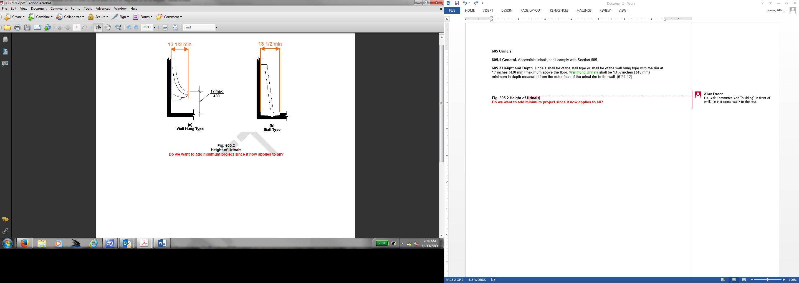

Fig. 605.2 Height of Urinals
Do we want to add minimum project since it now applies to all?

Item #5

606.5 Basin Location. The interior edge of the rim of the lavatory basin shall be located 3 inches (75 mm) maximum from the front edge of the fixture or countertop. (6-37-12)

Item #6

703.5.3.1 Nonglare Finish. The glare from coverings and the finish of pictograms and their fields shall not exceed 19 glare units (gu), as measured on a 60-degree gloss meter. (7-1-12)

703.5.3.2 Contrast. The Light Reflectance Value (LRV) contrast of pictograms and to their fields shall contrast be not less than 70 percent minimum as determined in accordance with Equation 7-1 Section 702. The lighter surface shall have a LRV light reflectance value of not less than 45. (7-1-12)

Item #7

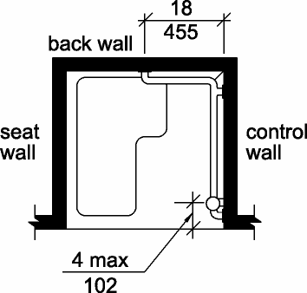

Fig. 608.3.1 Grab Bars in Transfer-Type Showers
608.3.2.1 Back wall grab bar. In standard roll-in type showers, a grab bar shall be provided on the back wall beginning at the front edge of the seat. The grab bars shall not be provided above the seat. The back wall grab bar shall extend the length of the wall and extend within 6 inches (150 mm) maximum from the adjacent side wall opposite the seat. The grab bars shall not extend above the seat. (6-55-12)

Item #8
904.3.1 Vertical separation Barriers. At service windows or service counters, any vertical separation barrier between service personnel and customers shall be at a height of 43 inches (1090 mm) maximum above the floor. (9-10-12)

Item #9

1001.2.3 General. Floor surfaces shall be stable, firm, and slip resistant, and shall comply with Section 302. Changes in level in floor surfaces shall comply with Section 303.

Item #10

1001.2.4 1001.2.3 Exercise Machines and Equipment. Exercise machines and exercise equipment shall not be required to comply with Section 309. (Relocate to with exercise equipment)

Item #11

1006.2 Accessible Routes. Accessible routes serving teeing grounds, practice teeing grounds, putting greens, practice putting greens, teeing stations at driving ranges, course weather shelters, golf car rental areas, bag drop areas, and course toilet rooms shall comply with Chapter 4. Exterior routes and shall be 48 inches (1220 mm) minimum in width. Where handrails guards, barriers or rails are provided, accessible exterior routes shall be 60 inches (1525 mm) minimum in clear width between obstructions. (11-9-12) (11-8-12)

Item #12

1102.9 Operable Parts. Lighting controls, electrical panelboards, electrical switches and receptacle outlets, environmental controls, appliance controls, operating hardware for operable windows, plumbing fixture controls, and user controls for security or intercom systems shall comply with Sections 1102.9 and 309. (5-22-12) (10-6-12) (10-10-12)

EXCEPTIONS:

1. Receptacle outlets serving a dedicated use.

2. In a kitchen, where two or more receptacle outlets are provided in a kitchen above a length of counter top that is uninterrupted by a sink or appliance, [only] one receptacle outlet shall not be required to comply with Section 309. (10-8-12)

Item #13

1103.9 Operable Parts. Lighting controls, electrical panelboards, electrical switches and receptacle outlets, environmental controls, appliance controls, operating hardware for operable windows, plumbing fixture controls, and user controls for security or intercom systems shall comply with Section 309. (5-22-12) (10-6-12)

EXCEPTIONS:
1. Receptacle outlets serving a dedicated use.

2. In a kitchen, where two or more receptacle outlets are provided in a kitchen above a length of counter top that is uninterrupted by a sink or appliance, [only] one receptacle outlet shall not be required to comply with Section 309. (10-8-12)

Item #14

1003.13 Windows. Operable windows shall comply with Section 1103.13. (5-22-12)

EXCEPTIONS:
1. Windows in kitchens are not required to comply with this section 1103.13.
2. Windows in bathrooms are not required to comply with this section 1103.13.

Item #15

1104.11.3.1.3.3 Shower Compartment. If a shower compartment is the only bathing facility, the shower
compartment shall have dimensions of 36 inches (915 mm) minimum in width and 36 inches (915 mm) minimum in depth. A clearance of 48 inches (1220 mm) minimum in length, measured perpendicular from
the shower head wall, and 30 inches (760 mm) minimum in depth, measured from the face of the shower
compartment, shall be provided. Reinforcing for a shower seat is not required in shower compartments
larger than 36 inches (915 mm) in width and 36 inches (915 mm) in depth. (10-30-12)

EXCEPTION: A shower compartment with dimensions of 30 inches (760 mm) minimum in depth and
44 inches (1120 mm) minimum in width shall be permitted. (10-31-12)

A new figure for this new exception??
Fig. 1104.11.3.1.3.3
Transfer-Type Shower Compartment in
Type B Units

