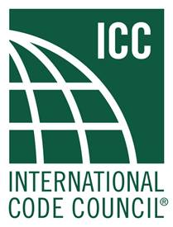
ICC ASC (A117.1) STANDARD –

PUBLIC COMMENT MODIFICATION FORM

Name: |  |  |  |  |  | Date:
Jurisdiction/Company:
Submitted on Behalf of:
Phone: |  |  | Ext: | e-mail:

2) *Signature: ______________________________________________________
* I hereby grant and assign to the ICC all rights in copyright I may have in any authorship contributions in any proposal or comment I make to the ICC. I understand that I will have no rights in any ICC publications that use such contributions in the form submitted by me or another similar form and certify that such contributions are not protected by the copyright of any other person or entity.

3) Indicate the Public Comment Proposal Number that is being addressed by modification: ___________
This is a further revision ____. This is a total replacement.______

The amendment either shows the additional revisions only, or it is a total replacement. If this is a further revision, show the original proposal as it would appear if it is accepted.
Example of original proposal. This is a new idea that replaces old text.
Example of modification: This is a new and exiting idea.

Show the proposed NEW or REVISED or DELETED TEXT in legislative format:
Line through text to be deleted. Underline text to be added.

4) Indicated proposed modification:

5) Reason statement (State purpose and reason for the modification only, and provide substantiation to support proposed revisions):

PLEASE USE SEPARATE FORM FOR EACH COMMENT
SUBMITTAL AS A DOCUMENT ATTACHMENT TO AN E-MAIL IS PREFERRED
e-mail: kaittaniemi@iccsafe.org Phone: (888) 422-7233 x4205 Fax: (708) 799-0320

